Unit 1: Investigation 2 (3 Days)

Vectors and Translations

Common Core State Standards

- G-CO.1. Know precise definitions of angle, circle, perpendicular line, parallel line, and line segment, based on the undefined notions of point, line, distance along a line, and distance around a circular arc.
- G-CO.2. Represent transformations in the plane using, e.g., transparencies and geometry software; describe transformations as functions that take points in the plane as inputs and give other points as outputs. Compare transformations that preserve distance and angle to those that do not (e.g., translation versus horizontal stretch).
- G-CO.4. Develop definitions of rotations, reflections, and translations in terms of angles, circles, perpendicular lines, parallel lines, and line segments.
- G-CO.5. Given a geometric figure and a rotation, reflection, or translation, draw the transformed figure using, e.g., graph paper, tracing paper, or geometry software. Specify a sequence of transformations that will carry a given figure onto another.

Overview

This is an investigation that gets into the first of the three main geometric transformations. In order to understand what a translation represents, students are first introduced to the concept of vectors. They will learn the vector notation of [run, rise] or $〈{run \atop rise}〉$and will use the vectors to describe translations. Additionally, the concept of parallel lines will be discussed as students see that if we take lines parallel to a vector, we can translate them on to themselves and other parallel lines. Finally, students will get experience translating objects in Geogebra, or a different dynamic software package.

Assessment Activities

Evidence of Success: What Will Students Be Able to Do?

- Translate a polygon by a given vector

Assessment Strategies: How Will They Show What They Know?

- Exit Slip 1.2.1 asks students to explain what applying a translation of a figure by a vector of [1,5] would do to the original figure and to translate a polygon by a given vector.
- Exit Slip 1.2.2 asks students to translate polygons using mapping rules.
- Journal Entry asks students to use the concept of translation to describe parallel lines.

Launch Notes

The launch for this investigation represents a review of an important Algebra 1 concept, as well as the distance formula from the previous investigation. Begin by giving each student graph paper and having them plot the points (1,3) and (5,6). Ask them to tell you everything they can about the relationship between the two points. You may want to have them talk with a partner to accomplish this. Since the distance formula should be fresh in their minds, most students should be able to determine the distance between the points (5). Some students will also remember from Algebra 1 that the slope between the points is ¾. For those students that don’t remember slope, quickly review slope as $\frac{rise}{run}$ or $\frac{y_{2}-y_{1}}{x_{2}-x_{1}}$. Make sure they can visualize starting at the point (1,3) and moving a horizontal distance of 4 units and a vertical distance of 3 units to arrive at the second point, (5,6). Explain that, while writing slope as a ratio of the rise to the run, a more geometric way to list the slope is as a vector [run, rise]. So, in this case, the slope could be listed as the vector [4,3]. It is also important for them to recognize that the magnitude or size of this vector is five.

Teaching Strategies

To begin Activity 1.2.1 Understanding Vectors, give students graph paper and ask them to graph the triangle with vertices (1,1), (5,1), and (2,4). Now have them create a new triangle by moving each vertex up 4 units and over 2 units.

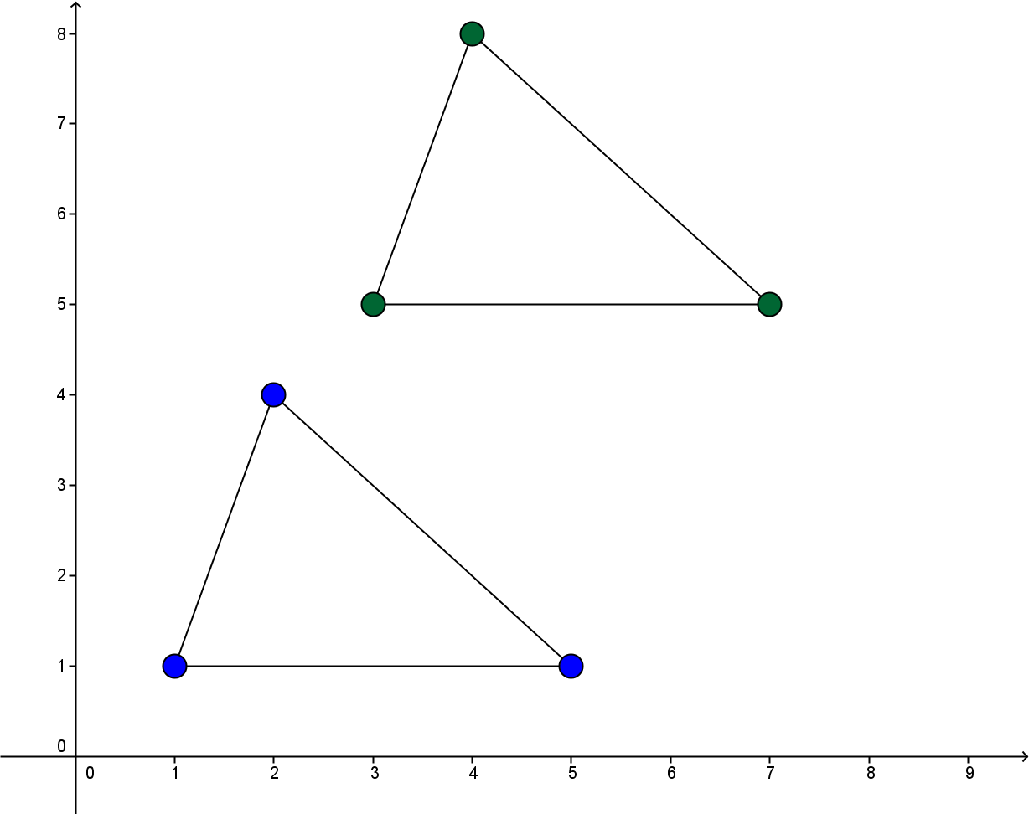
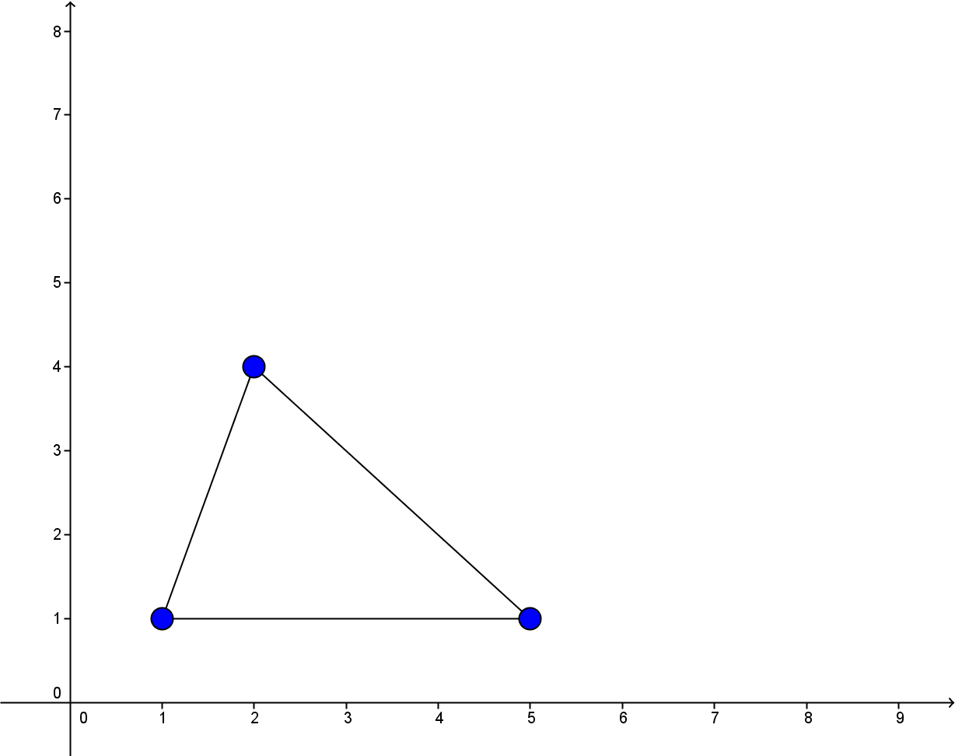

Ask students to comment on the two triangles. They should notice that the triangles are congruent (Note: even though the term congruent is not defined until Unit 2, students may be familiar with the term. Others will say they are identical or have the same shape. That is acceptable for now). Explain that the second triangle is a translation of the first and that every translation is identified by a vector that explains what direction and how far to translate. In this case, the vector would be [2,4]. Students will learn that every vector has a direction and a magnitude. So, if we have starting point and we know the rise and the run, we can determine its direction and its magnitude. We can pick a point and its translated point and then use the distance formula to find the length or the magnitude of the vector. If we choose (1,1) and (3,5) and apply the distance formula, we get a magnitude of $\sqrt{20}$

Activity 1.2.2 Describing Straight Objects builds upon the previous activity by relating the notion of the magnitude and direction of vectors to that of lines, rays, and segments. Students will explore whether these objects have magnitude and direction.

Before students engage in this activity you may need to review or introduce some vocabulary. In our geometry course “point,” “line,” and “plane” are undefined terms. Lines and planes are sets of points. A segment is a subset of a line consisting of two points (called “endpoints”) and all points on the line that are between them. “Betweenness” is also undefined.

A ray is a subset of a line consisting of one point (called its “endpoint”) and all points on the line that lie on the same side of the endpoint. Students should be able to visualize what is mean by “lying on the same side.” A more formal definition would be: ray $\overset{⃡}{PQ }$is the subset of a line consisting of an endpoint P, another point Q and all points R such that either R lies between P and Q or Q lies between P and R.

The Line Separation Postulate states: “Every point on a line divides the line into two rays with only their endpoint in common.” These two rays are called “opposite” rays.

If you have time and want students to see a real-world application of vector magnitude and direction, use the following link: http://illuminations.nctm.org/activity.aspx?id=3536. You can have students move the boat around the water by changing the magnitude and direction of the boat's speed (blue vector) or the magnitude and direction of the water current (red vector). Haven them try to land the boat on the island — but be careful not to hit the walls. As they alter the location of the boat remember to think of the boat’s speed, current of the water, and the result arrow in context of vectors.
In Static mode, try to do three things:
- Direct the boat to the island in just one shot with the red vector (water) turned off.
- Direct the boat to the island in just one shot with the red vector (water) turned on. To do this, it may be helpful to turn on the result vector. How does the result vector relate to the boat and water vectors?
- Set the magnitude and direction for both the boat and water vectors so the boat remains stationary. To accomplish this, what is the relationship between the boat and water vectors?

At the end of the first day you may give Exit Slip 1.2.1, which asks students to explain what applying a translation of a figure by a vector of [1,5] would do to the original figure.

To start the second day and Activity 1.2.3 Matching Pre-Images and Images, show students the rectangle with coordinates A(–5,5), B(–1,5), C(–1,2), and D(–5,2) either on the board or using technology. Now ask students to think about what a translation by the vector [6,4] would look like. Have students turn and talk to discuss and then show them the translated rectangle A’B’C’D’.

Group Activity 1.2.3 Matching Pre-Images and Images has students working together to find matching sets. A third of the students are given a starting polygon, another third are given a vector, and the final third are given the translated polygon. Students have to work together to determine a correct set of the polygon, the vector, and the ensuing translated polygon.

After students have examined performing translations on paper, Activity 1.2.4 Translations Using Technology has those exploring translations in Geogebra. The steps will be listed for creating animated translations. They will also see how you could import any picture into the software and translate that.

Differentiated Instruction (For Learners Needing More Help)
The directions for creating animated translations can be tricky for some students. Therefore, some will need one-on-one guidance.

To begin day 3, students are presented with Activity 1.2.5 Translation Mapping Notation, which begins with a review of translating a polygon by a given vector. They are then introduced to translation notation: (x, y) (x + h, y + k) and asked to apply mapping rules.

The next activity in the investigation, Activity 1.2.6 Translating Lines deals with the relationship between translations and parallel lines. There are two forms of the student activity sheet—one using paper-and-pencil constructions and one using Geogebra. Notice that neither worksheet has the word parallel in the title. The intent is for students to recognize the notion of parallel in their translated lines.

In the next unit, we define parallel lines as two lines in the same plane that do not intersect. With this definition, we can think of parallel vectors as vectors that lie along the same line and point in the same direction.

Differentiated Instruction (For Advanced Learners)
Although the idea of opposite vectors are touched upon in this activity, you may want to delve deeper. An example of opposite vectors is [2, –6] and [–2, 6]. These two vectors point in opposite directions. If they lie on two different lines, those lines will also be parallel. (In both cases the slope is –3).

The following journal entry acts as a summary.

Journal Entry: How can you use translations to describe the concept of parallel lines? Look for students to recognize that for most lines the image under a translation is parallel to the pre-image. The exception occurs when the line contains the translation vector.

The final activity, Activity 1.2.7 Midpoints, introduces students to the Midpoint Formula. In the coordinate plane the midpoint is the point whose coordinates are the averages of the coordinates of the endpoints. We can also find the midpoint by translating an endpoint with the vector that is ½ the vector from one endpoint to another.

At the end of the third day you may give Exit Slip 1.2.2, which asks students to translate a polygon by a given vector.

Closure Notes

This was an investigation that introduced students to the concept of vectors and then used those vectors to describe translations. It is important for students to recognize that performing a translation does not change the size or orientation of a figure. It is simply just a slide—a term used in elementary grades to describe translations. Students also need to understand the notations we use—both with vectors and translations.

At this point you should also mention that translations are one of several transformations we will study in this unit. Transformations map pre-images onto images. When figures are represented in the coordinate plan, a mapping rule can be used to find the coordinates of the image given the coordinates of the pre-image.

Vocabulary

vector
rise
run
parallel (lines)
parallel vectors
opposite vectors.
Translation
Transformations
Mapping rule
Pre-image
Image
midpoint
endpoint

Resources and Materials

Activities:
Activity 1.2.1 Understanding Vectors
Activity 1.2.2 Describing Straight objects
Activity 1.2.3 Matching Pre-images and Images (group activity)
Activity 1.2.4 Translations Using Technology
Activity 1.2.5 Translation Mapping Notation
Activity 1.2.6a Translating Lines (hands-on)
Activity 1.2.6b Translating Lines (Geogebra)
Activity 1.2.7 Midpoints

Graph paper for Launch and Activity 1.2.1
Geogebra for Activity 1.2.4 and 1.26b

