**Unit 1: Investigation 1 (2 Days)**

**The Pythagorean Theorem and the Distance Formula**

***Common Core State Standards***

* G-GPE.7. Use coordinates to compute perimeters of polygons and areas of triangles and rectangles, e.g., using the distance formula.

**Review:**

* 8.G.6. Explain a proof of the Pythagorean Theorem and its converse.
* 8.G.7. Apply the Pythagorean Theorem to determine the unknown side lengths in right triangles in real-world mathematical problems in two and three dimensions.
* 8.G.8. Apply the Pythagorean Theorem to find the distance between two points in a coordinate system.

**Overview**

Students should have been exposed to the Pythagorean theorem in 8th grade. For some students, however, this will be their first time seeing it. This investigation will quickly review the theorem and students will get to see a dissection proof for it. We will then use the Pythagorean theorem to derive the Distance Formula and use this to find the perimeter of polygons.

**Assessment Activities**

**Evidence of Success: What Will Students Be Able to Do?**

* Use the Pythagorean theorem to solve for a given side of a right triangle.
* Use the Distance Formula to find the distance between any two points in the coordinate plane.
* Use the Distance Formula to find the perimeter of a given polygon.
* Explain the relationship between the distance formula and the Pythagorean Theorem.

**Assessment Strategies: How Will They Show What They Know?**

* **Exit Slip 1.1.1** asks students to solve a real-world problem using the Pythagorean theorem
* **Exit Slip 1.1.2** asks students to use the distance formula to find the perimeter of a given polygon.
* **Journal Entry** asks students to explain how the distance formula is related to the Pythagorean Theorem.

**Launch Notes**

If your class is made up largely of students who you feel pretty confident were exposed to the Pythagorean theorem previously, you can show this quick NBC Sports video to review it:

<http://www.nbclearn.com/nfl/cuecard/51220>. The video shows how the Pythagorean theorem can be used to examine aspects of football.

**Teaching Strategies**

Ask students what kind of problems we can solve with the Pythagorean Theorem. They may respond with a “naked” problem such as “If one leg of a right triangle is _ and the hypotenuse is _, what is the length of the other leg?”; or they may remember a word problem such as “If a _-ft. ladder is set up _ feet from a wall, how high will it reach on the wall”?

Explain to students that the theorem is extremely important beyond just being able to solve real-world or contrived textbook problems.

**Activity 1.1.1** **Using the Pythagorean Theorem** is a quick review of applying the Pythagorean Theorem to real-world problems.

**Differentiated Instruction (For Learners Needing More Help)**

For some students, using *a*, *b*, and *c* can add a level of complexity and abstraction that can take away from the formula. For these students, you may want to stress that the formula is simply leg12 + leg22 = hypotenuse2

Once students have practiced using the Pythagorean Theorem, explain that a significant aspect of geometry is proof. Throughout the course they will be proving a variety of different theorems. With that in mind, the first, informal, proof to be examined will be that of the Pythagorean Theorem.

**Activity 1.1.2** **Pythagorean Theorem Proofs** will lead students through a dissection proof of the theorem like the one below:





A more formal proof of the Pythagorean Theorem will be given in Unit 4.

**Differentiated Instruction (Enrichment)**

For students who quickly understand the proof, show them other proofs such as the one discovered by President Andrew Garfield (<http://math.kennesaw.edu/~sellerme/sfehtml/classes/math1112/garfieldpro.pdf>) )

**Differentiated Instruction (Enrichment)**

Some students may be fascinated with the extension of the Pythagorean Theorem to the work done by Fermat who examined the equation *xn* + *yn* = *zn* and conjectured that for non-zero integers, *x*, *y*, *z*, and *n*, there are no non-zero solutions when *n* is greater than 2. This result, which was finally proved in the 1990s, is often referred to as Fermat’s Last Theorem. Find more info here: <http://mathworld.wolfram.com/FermatsLastTheorem.html>

Now that students have seen problems involving the Pythagorean Theorem and have seen a proof of it, they may use the theorem to derive the Distance Formula.

Students should be familiar with the coordinate plane from the Algebra 1 course. In that course they learned to find the slope of a line by finding the rise, $y_{2}-y_{1}$, and the run $, x_{2}-x_{1}$. These same differences appear in the distance formula.

To begin, have them plot the points (1,3) and (4,7) and ask them how far apart they are. When students struggle to answer, ask if they can think of any possible ways of determining the answer. It may be that no one will have an idea. On the other hand some student may think of creating a right triangle and using the Pythagorean Theorem. Either way, model that on the board:

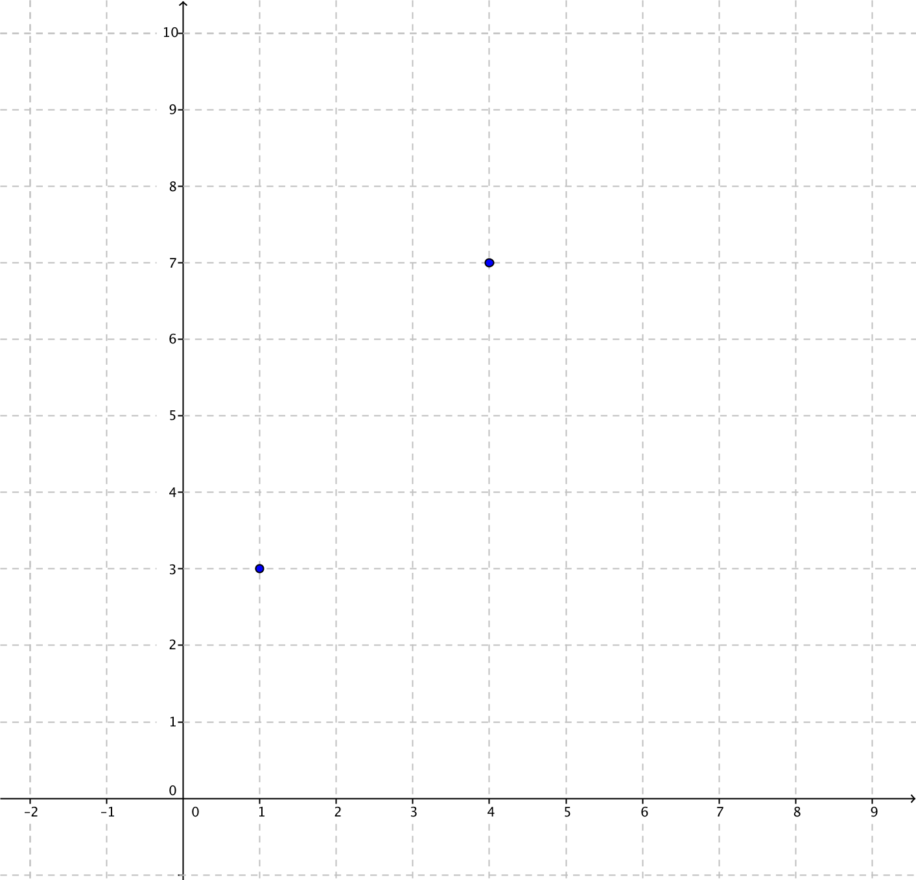



It may be obvious to some students, but be sure to show how we get an *x*-distance of 3 units and a *y*-distance of 4 units. Once they see the values of the two legs it should be apparent that the Pythagorean theorem can be used to solve for the distance between the two points, which is the hypotenuse of the triangle that is formed.

Explain that we can generalize to use for any occasion.

Leading students through an explanation of the derivation of the distance formula is **Activity 1.1.3 Deriving the Distance Formula**. The subscripts we assign to the *x*- and *y*-values can be difficult to keep track of for some students so it is important to go slowly.

In Part 2 of the activity sheet, you can use this file: <http://tube.geogebra.org/student/m708437>to walk students through the process of calculating the distance between two points with known coordinates. Additionally, this file: <http://tube.geogebra.org/student/m708443> walks students through the process of deriving a formula in the general case where the coordinates are (*x*1, *y*1) and (*x*2, *y*2).

Distances obtained from the distance formula often involve radical expressions. At this point we are not asking students to simplify these expressions but either to leave a result in “radical form,” e.g. $\sqrt{50}$, or give a decimal approximation, e.g. $\sqrt{50}$ ≈ 7.07. The need to express results in “simple radical form” will arise in Unit 4 at which point this skill will be taught.

**Differentiated Instruction (For Learners Needing More Help)**

For some students it will be necessary to do another example of the distance formula with numbers before going to the algebraic proof. For more advanced learners the past example will be enough and they will be ready to understand the algebraic symbols.

**Activity 1.1.4** **Using the Distance Formula** involves using the distance formula to find the lengths of segments. In this activity there are also some examples of vertical and horizontal line segments.

In the final activity, **Activity 1.1.5 Finding Perimeters** students use the distance formula to find the perimeter of polygons. This provides additional practice with the distance formula but also addresses the standard G-GPE 7, in which students are asked to find perimeters. Introduce the activity by giving students the following polygon in the coordinate plane and ask them how we can find its perimeter.

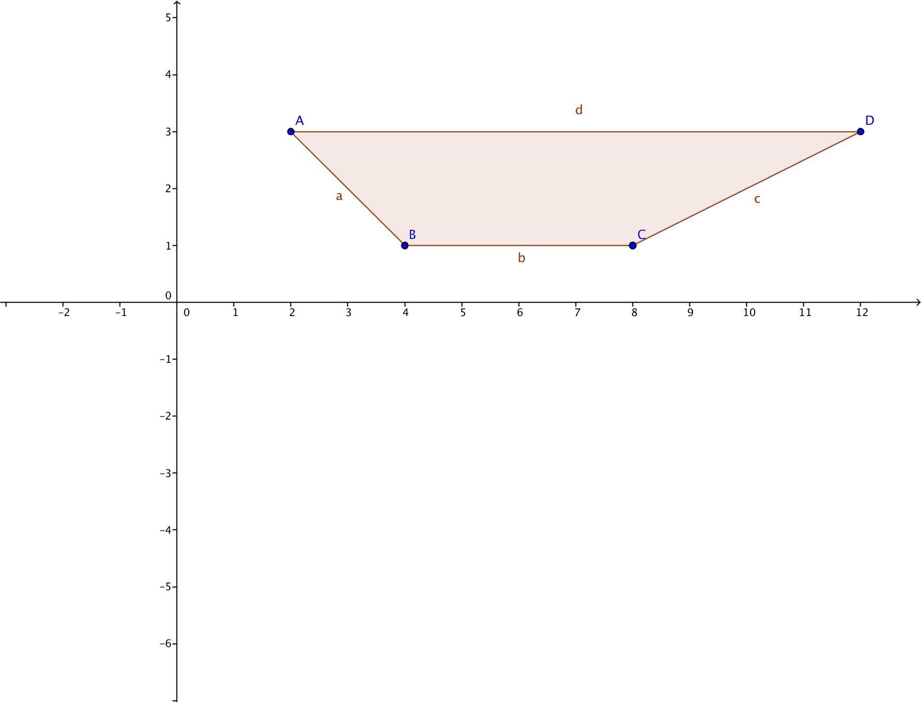

**Group Activity 1.1.5**

Have students work in small groups to complete the “Finding Perimeters” activity. This is a good group activity because each member of the group can take a different side to find the length of. Group members can then check each other’s work and then work together to find the perimeter.

**Closure Notes**

There are a number of key points that students should take away from this investigation. One is the idea of proof. You want to stress that these are the first two proofs they will see and that they will become more intuitive as the class goes on. Another key point to stress is the importance of the Distance Formula. Students should recognize the power of being able to use it to find the distance between any two points in the coordinate plane.

**Journal Entry**

How is the Distance Formula related to the Pythagorean Theorem? Look for students to recognize the role a right triangle plays in determining the rise and run (for lines other than vertical or horizontal).

**Vocabulary**

coordinate plane

distance

hypotenuse

leg

perimeter

point

polygon

right triangle

side (of polygon)

triangle

**Postulates and Theorems**

**Pythagorean Theorem:** In any right triangle the square of the length of the hypotenuse is equal to the sum of the squares of the lengths of the legs.

**Distance Formula:** If the coordinates of two points in a plane are (*x*1, *y*1) and (*x*2, *y*2), then the distance between the two points is equal to $\sqrt{{(x_{2}-x_{1})}^{2}+{(y_{2}-y_{1})}^{2}}$.

**Resources and Materials**

Activities:

Activity 1.1.1 Using the Pythagorean Theorem

Activity 1.1.2 Pythagorean Theorem Proofs

Activity 1.1.3 Deriving the Distance Formula

Activity 1.1.4 Using the Distance Formula

Activity 1.1.5 Finding Perimeters

Web sites

Geogebra software download: <http://www.geogebra.org/download>

Interactive Distance Formula site: <http://www.mathwarehouse.com/algebra/distance_formula/interactive-distance-formula.php>

Pythagorean Theorem videos:

<http://www.nbclearn.com/nfl/cuecard/51220>

<http://vimeo.com/56785102> (until 3:12)

<https://www.khanacademy.org/math/geometry/right_triangles_topic/pyth_theor/v/pythagorean-theorem>

Videos

<http://tube.geogebra.org/student/m708437>

<http://tube.geogebra.org/student/m708443>

tes

Concrete materials depending upon what the activities require: graph paper at a minimum. Scissors are required for the dissection proof in Activity 1.1.2.