Activity 2.7.3 Construction of a Line Perpendicular to a Line
at a Point on the Line
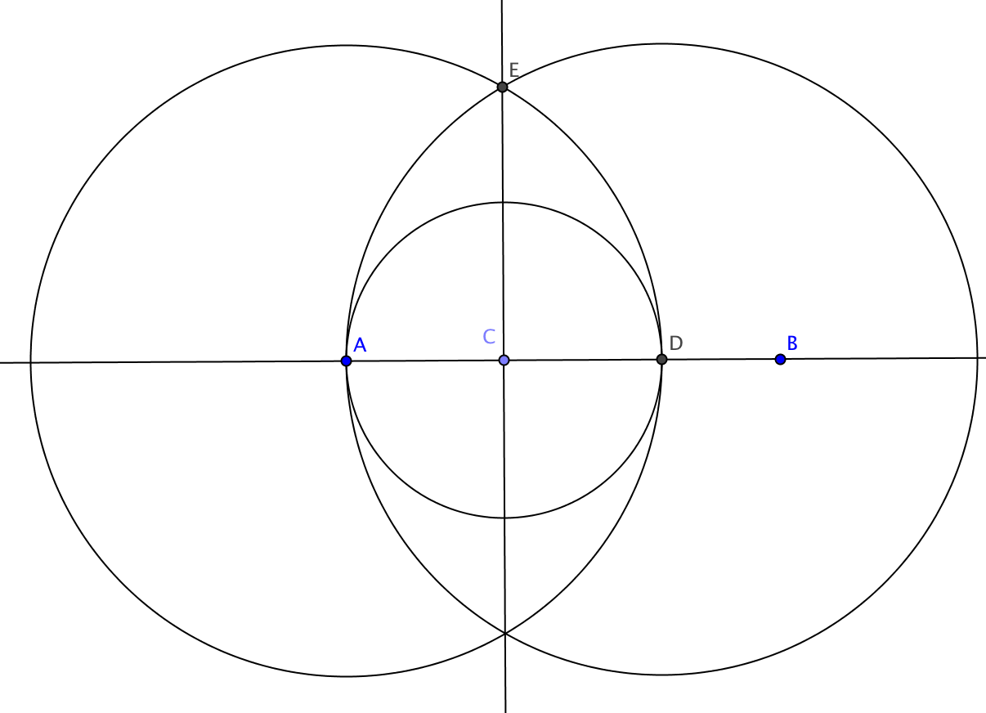
Construction

Given: Point C lies on $\overset{⃡}{AB}$.

To construct: a line through C that is
perpendicular to $\overset{⃡}{AB}$.

Steps in the construction:

- Construct the circle with center C passing through A.
- Label the other point where the circle intersects $\overline{AB}$ as point D.
- Construct the circle with center A passing through D.
- Construct the circle with center D passing through A.
- Label point E, one of the points where these last two circles intersect.
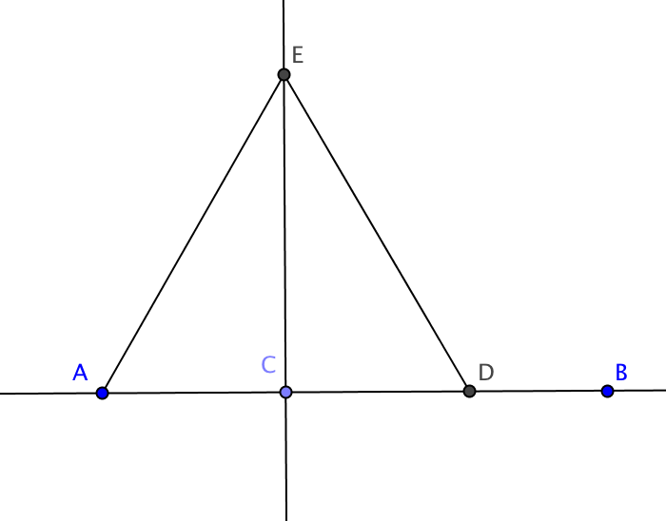
- Draw the line through C and E.

Claim: $\overset{⃡}{CE}$ $⊥$ $\overset{⃡}{AB}$

Proof

- Construct segments $\overline{AE}$ and $\overline{DE}$.
- CA = CB because ____________________
- AD = AE because ____________________
- DA = DE because ____________________
- From step 3 and step 4 we conclude that AE = DE. Why?
- CE = CE because of the _______________ property
- From steps 2, 5, and 6 we can show that ∆ACE $≅$ ∆DCE using the _______ Congruence Theorem.
- $∠ACE$ $≅$ $∠DCE$ because ___________________________________________
- $Explain why step 8 allows us to conclude that \overset{⃡}{CE}$ $⊥$ $\overset{⃡}{AB}$

