Activity 2.5.3 – Parabolic Behavior

Parabolic behavior is all around us. It can be seen in the motion of objects traveling under the influence of gravity, in the architecture and design of buildings and bridges, and in natural forms present in the natural world.

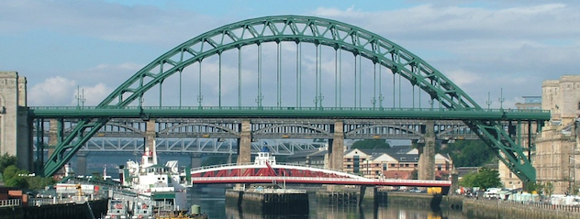
Tyne Bridge – Newcastle Upon Tyne, England

In this activity we will use Geogebra to model the parabolic behavior of a parabola in a digital image. Your teacher will either provide you a digital image or ask you to create or retrieve a digital image.

Geogebra Instructions:

- Open up the ParabolicBehavior.ggb document in Geogebra. This document is preloaded with sliders for the parameters (a, h, k) of a quadratic function $y=a{(x-h)}^{2}+k$.
- Insert the digital image that contains an image of a parabola by clicking Edit Insert Image from File.
- Move the digital image so that it is positioned above the horizontal axis.
- Move the sliders for the parameters (a, h, k) until the red curve fits the parabolic image.

- What quadratic function best models the parabolic image?

- Explain how you adjusted the sliders to fit the curve to the image. How well does the curve fit the image?

- Convert the function from vertex form to standard form $y=ax^{2}+bx+c$.

- Use the vertex formula to find the vertex of the parabola.

