Activity 2.5.3 Identifying Angle Pairs

AB is a transversal intersection line $\overset{⃡}{CE}$ at B and line $\overset{⃡}{HD}$ at A. Use the figure below to answer these questions:

- $∠EBA$ and $∠_________$are a pair of corresponding angles.
- $∠FBC$ and $∠_________$ are a pair of vertical angles.
- Name another pair of vertical angles.
- $∠CBA$ and $∠_________$ are a pair of alternate interior angles.
- $∠BAD$ and $∠_________$ are a linear pair of angles.
- Name one pair of same side interior angles.
- Name an angle that must be congruent to angle $∠GAH.$
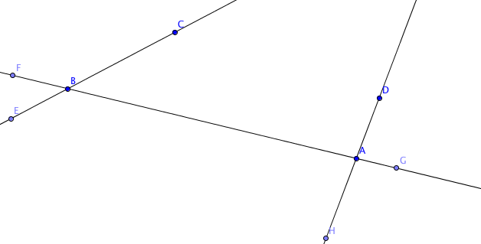

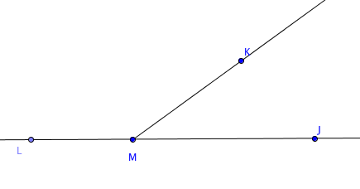
In this figure, M is a point on $\overset{⃡}{JL}$
- Suppose m$∠KMJ=55°.$ Find m$∠LMK.$
- Suppose m$∠LMK$ is twice the size of m$∠KMJ.$ Find the measure of each angle.
- Suppose m$∠KMJ$ is 80° less than m$∠LMK$. Find the measure of each angle.
- Do you agree or disagree with this statement “If $∠KMJ$ is an acute angle, then m$∠LMK$ must be an obtuse angle”? Explain your reasoning.

