Areas of Equilateral Triangles

What is the relationship between the length of a side and area of an equilateral triangle? We will investigate this question by collecting data on many equilateral triangles using Geogebra. To form equilateral triangles, we will use a construction that involves the radii and intersection point of two circles.

Geogebra Instructions:

- Open up a blank document in Geogebra.
- Click on Circle with Center through Point tool. Insert a circle (Center is at Point A; Point B is on circle).
- Insert a second circle centered at Point B that has Point A on the circle.
- Click on the Point tool. Insert a point at one of the points where the two circles intersect (Point C).
- Click on the Polygon tool. Create a triangle by clicking on Point A, Point B, Point C, and Point A again.
- Click on the Angle tool to see the submenu. When the submenu appears, click on Area. Then click on a point in the triangle; this will cause the Area label to appear.
- Click on the Move tool. (You can remove the labels of the conics and line segments.) Your image should look similar to the image below.

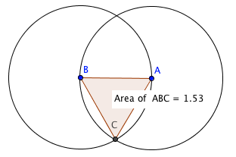

When you move Point A (or Point B) the size of the circles and triangle change. This allows you to record the area of the equilateral triangle for various lengths.

- Choose four side lengths that vary between 2 and 8. Find the corresponding areas and enter the ordered pairs in the table below.

x (side length)
y (area)

- What type of relationship exists between side length and area?

- Using the points in the table, develop a quadratic regression function for area of the triangle in terms of side length.

- Given an equilateral triangle with side length x, algebraically create an equation for the area of the triangle y. Draw a diagram to represent the equilateral triangle.

- Plot the equations from Questions 3 and 4 on the same coordinate plane. How do the graphs compare?

