Activity 2.5.2 The Vertical Angles Theorem
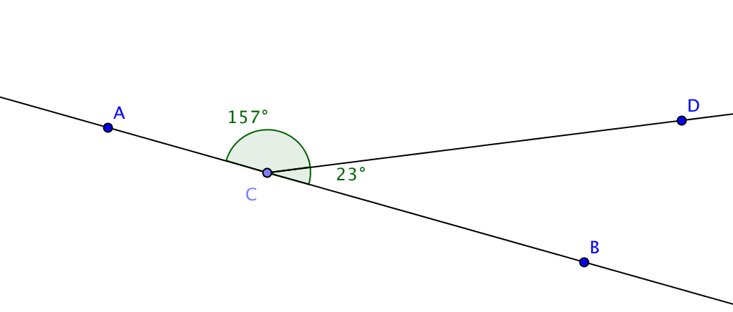
The Linear Pair Postulate

- In the figure at the right, C lies between points A and B on $\overset{⃡}{AB }$. Name the linear pair of angles.

- Find the sum of the measures of the linear pair.
- With pencil and straightedge or software draw another linear pair of angles.

- Measure the two angles you have drawn and find their sum.

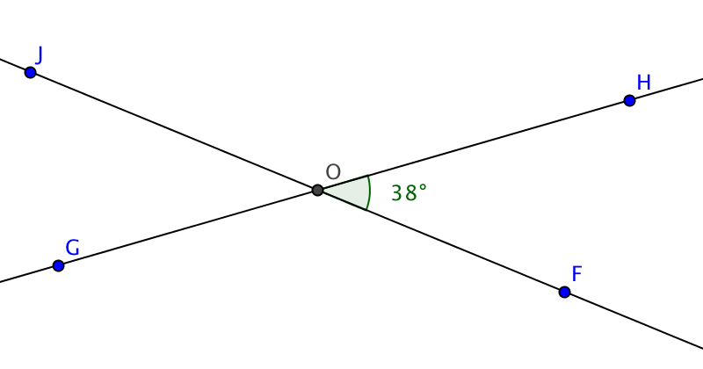
- A pair of angles is called supplementary if the sum of their measures is 180°.
The Linear Pair Postulate states that if two angles form a linear pair, then they are __________________.
Applying the Linear Pair Postulate
- In the figure at the right m$∠FOH$ = 38°. Use the Linear Pair Postulate to find
m$∠HOJ$ = _____
m$∠JOG$ = _____
m$∠GOF$ = _____
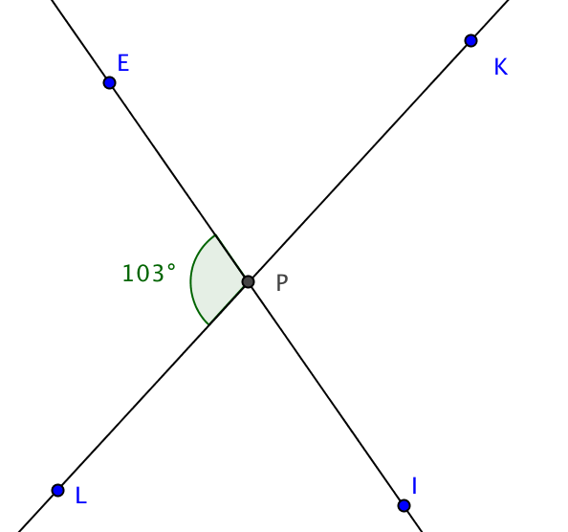
- Name two pairs of vertical angles in the figure above.
What do you notice about their measures?

- In the figure at the right m$∠EPL$ = 103°. Use the Linear Pair Postulate to find
m$∠LPI$ = _____
m$∠KPE$ = _____
m$∠IPK$ = _____
- Name two pairs of vertical angles in the figure above. What do you notice about their measures?

- Write a conjecture about vertical angles:

On the previous page you may have conjectured that every pair of vertical angles are congruent. Now you can prove this conjecture as a theorem. Give a justification for each step.
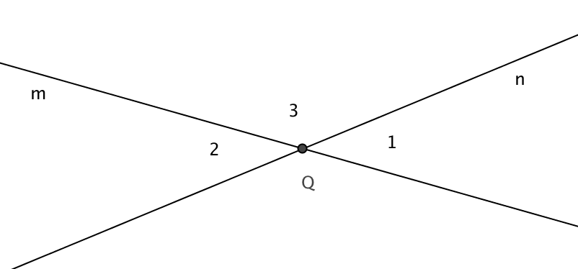
The Vertical Angles Theorem: If two lines intersect, then a pair of vertical angles formed are congruent.
Given: Lines l and m intersect at Q. $∠1$ and $∠2$ are a pair of vertical angles.
Prove: m$∠1$ = m$∠2$.
Proof:
1. m$∠1$ + m$∠3$ = 180° Why?

2. m$∠2$ + m$∠3$ = 180° Why?

3. m$∠1$ + m$∠3$ = m$∠2$ + m$∠3$ Why?

4. m$∠1$ = m$∠2$ Why?

