Activity 2.5.1 Angle Relationships

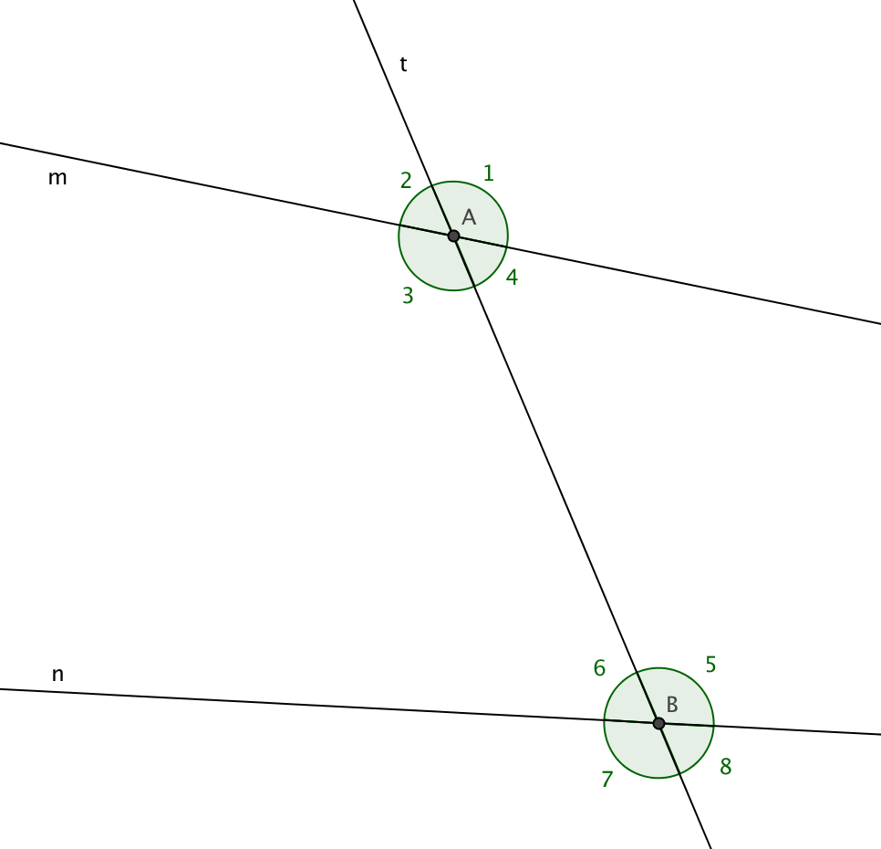
Lines m and n are intersected by transversal t creating 8 angles as shown.

Pairs of Angles at One Vertex

1. Vertical angles are formed by two intersecting lines. They share only a vertex, not a common side.

- Name two pairs of vertical angles at vertex A.

- Name two pairs of vertical angles at vertex B.

2. A linear pair of angles share a vertex and a side. The other sides form a straight line. $∠$3 forms a linear pair with two other angles. Name them.

Pairs of Angles at Two Vertices

3. When two lines are intersected by a transversal, the angles between the lines are called interior angles. Name the four interior angles in this figure.

4. The angles outside the two lines are called exterior angles. Name the four exterior angles in this figure.

5. If two angles, one at each vertex, lie on opposite sides of a transversal, they are “alternating.”
Name two pairs of alternate interior angles.

6. Name two pairs of alternate exterior angles.

7. $∠$4 and $∠$5 are called same side interior angles. Name the other pair of same side interior angles.

8.Name two pairs of same side exterior angles.

9. When two lines are intersected by a transversal, two angles, one at each vertex, are called corresponding angles if one is an interior angle and the other an exterior angle. $∠$1 and $∠$5 are a pair of corresponding angles. Name three other pairs of corresponding angles.
Experiments with pairs of angles.

- On a sheet of lined paper or graph paper draw two parallel lines at least 4 inches apart.
- Draw one transversal that intersects both of the parallel line obliquely, that is, not perpendicular to either of the lines.
- Use a protractor to measure special pairs of angles as shown. Write down their measurements and your observations.

10. Measure a pair of vertical angles. What are the measurements? What do you notice?

11. Measure a linear pair of angles. What are the measurements? What do you notice?

12. Measure a pair of alternate interior angles. What are the measurements? What do you notice?

13. Measure a pair of alternate exterior angles. What are the measurements? What do you notice?

14. Measure a pair of same side interior angles. What are the measurements? What do you notice?

15. Measure a pair of same side exterior angles. What are the measurements? What do you notice?

16. Measure a pair of corresponding angles. What are the measurements? What do you notice?

17. Discuss your findings with other students. You may have different measurements, but do you notice any patterns in common?

18. With other students in your class write some conjectures about the angle relationships you have observed.

