Activity 2.4.5 Using the SSS Triangle Congruence Theorem

Warmup From the six abbreviations below, pick the valid congruence theorems and summarize them below.

ASA SAS SAA SSA SSS AAA

_____ __________________________________________________________________
__________________________________________________________________
__________________________________________________________________

_____ __________________________________________________________________
__________________________________________________________________
__________________________________________________________________

_____ __________________________________________________________________
__________________________________________________________________
__________________________________________________________________

In this activity you will use the congruence theorems to make claims about pairs of triangles.

Section 1: Use the SSS Congruence Theorem to prove that the triangles shown are congruent
 | Triangle #1 | Triangle #2 | Proof
1. | 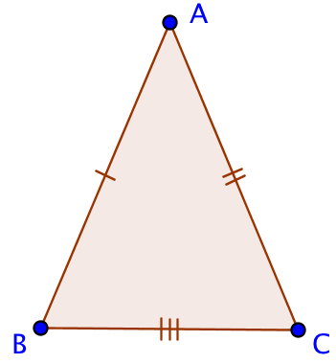 | 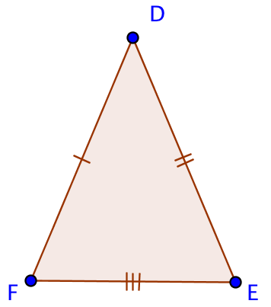
2. | 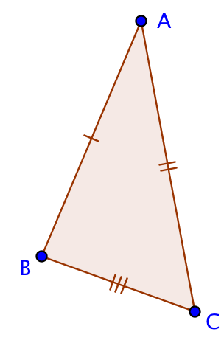 | 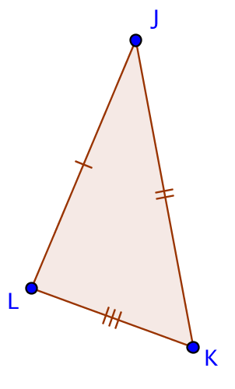
Section 2: Use the appropriate congruence theorem to prove that the triangles are congruent.
 | Triangle #1 | Triangle #2 | Proof
5. | 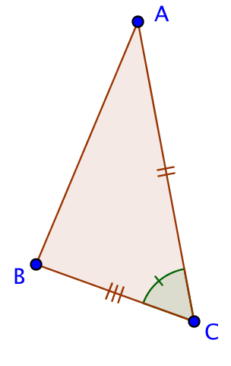 | 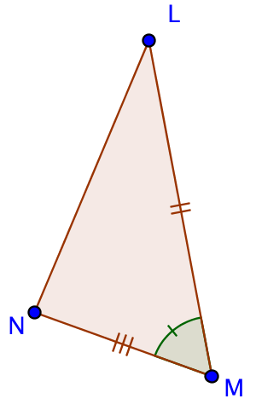
6. | 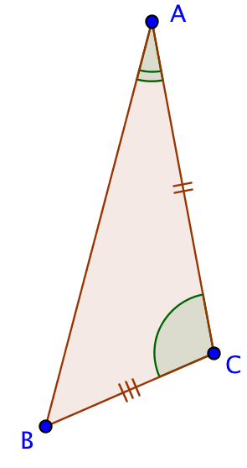 | 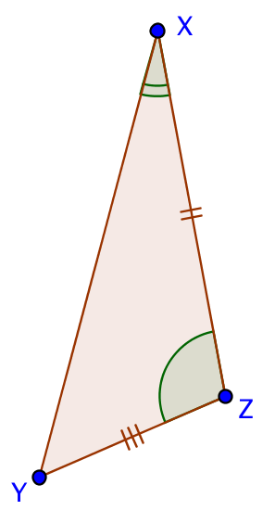
7. | 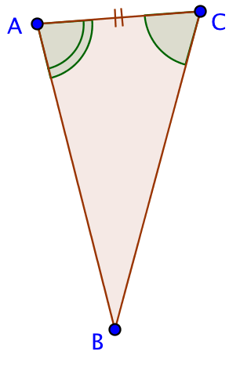 | 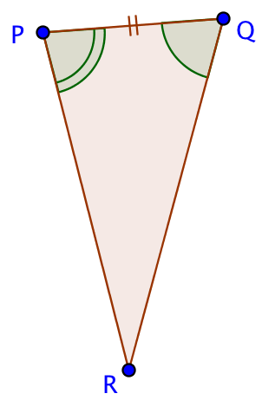
8. | 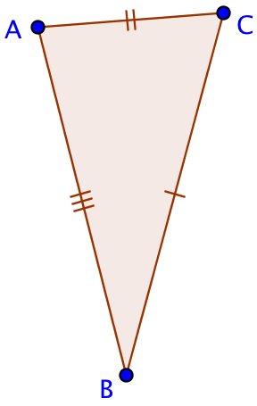 | 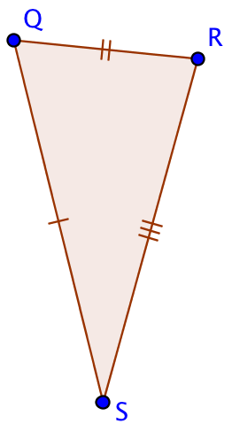
Section 3: If possible, prove that the specified angles or segments are congruent.

 | Triangle #1 | Triangle #2 | Proof
9. | 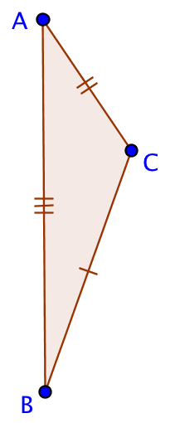 | 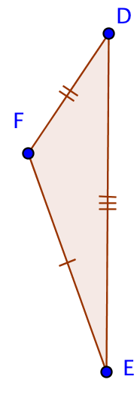 | Prove: $∡ABC≅∡DEF$
10 | 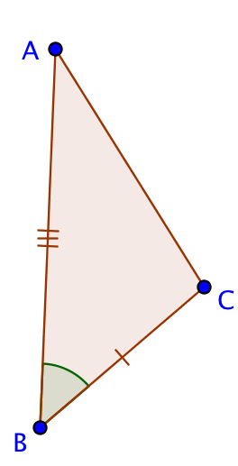 | 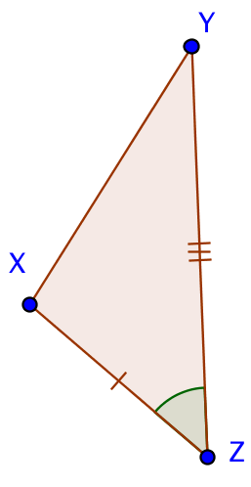 | Prove: $\overline{AC}≅\overline{XY}$
11 | 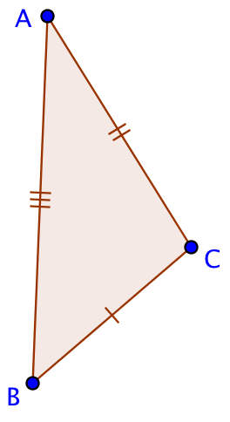 | 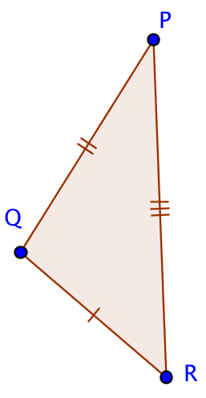 | Prove: $∡BAC≅∡RPQ$
12 | 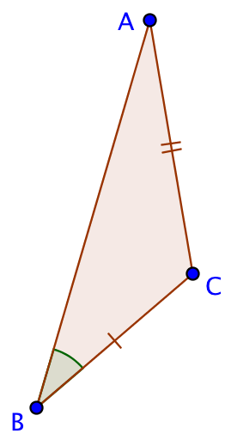 | 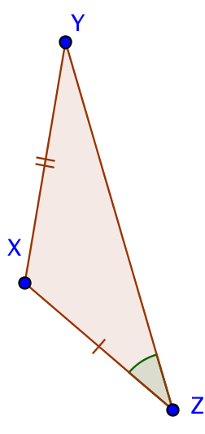 | Prove: $\overline{AB}≅\overline{YZ}$

