Activity 2.4.4 Rigid Structures

In this activity you will discover which polygons are used in constructing rigid shapes. By experimenting and creating different shapes, you will come to a conclusion about which shape
is the strongest.

Recall: Activity 1.3.2 from the Common Core Algebra 1 curriculum
Note how the truss bridges were built.

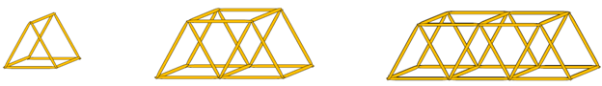
Get a partner and let’s explore the strength of some shapes!

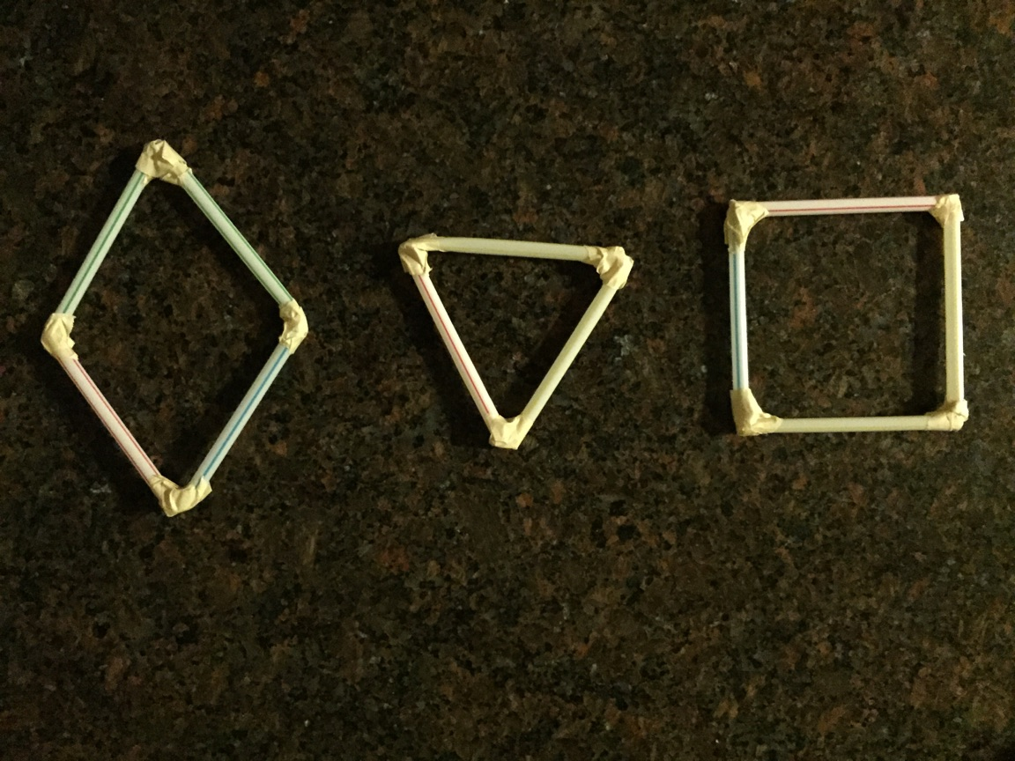
Experiment 1
Materials needed:
Tape and straws
Or
Toothpicks and mini-marshmallows (will need to let marshmallows harden overnight after structures are built)

1. Create, using the materials, a triangle, a square, and a rhombus as shown.

2. Once you have all three shapes constructed, try to push down with the same strength with one finger on each one while they are standing up.

a. What do you notice happens to the square when you push down?
Sketch what the shape looks like after you press down:

b. What do you notice happens to the rhombus when you push down?
Sketch what the shape looks like after you press down:

c. What do you notice happens to the triangle when you push down?_
Sketch what the shape looks like after you press down:

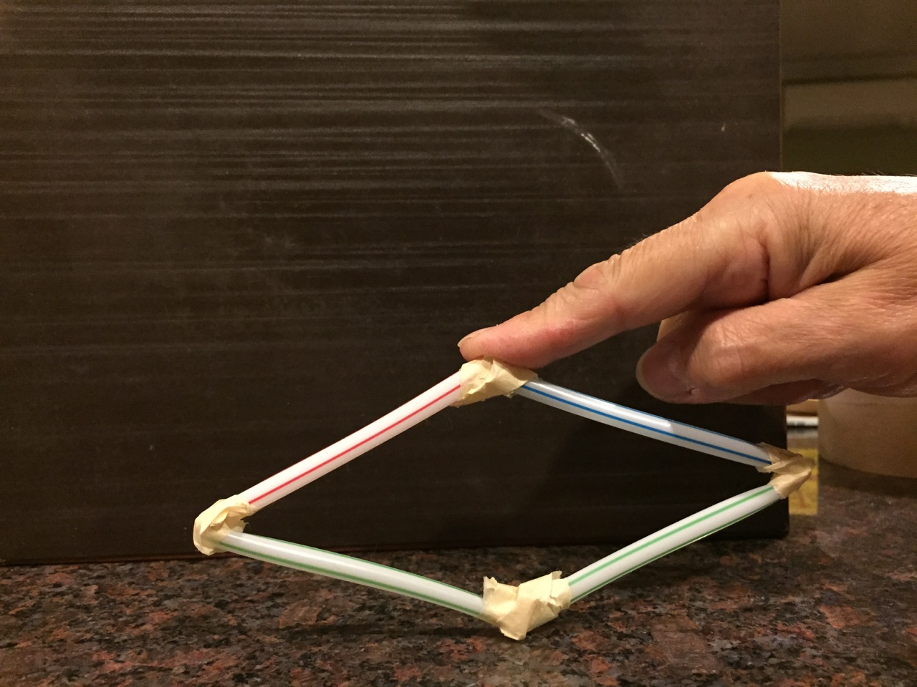
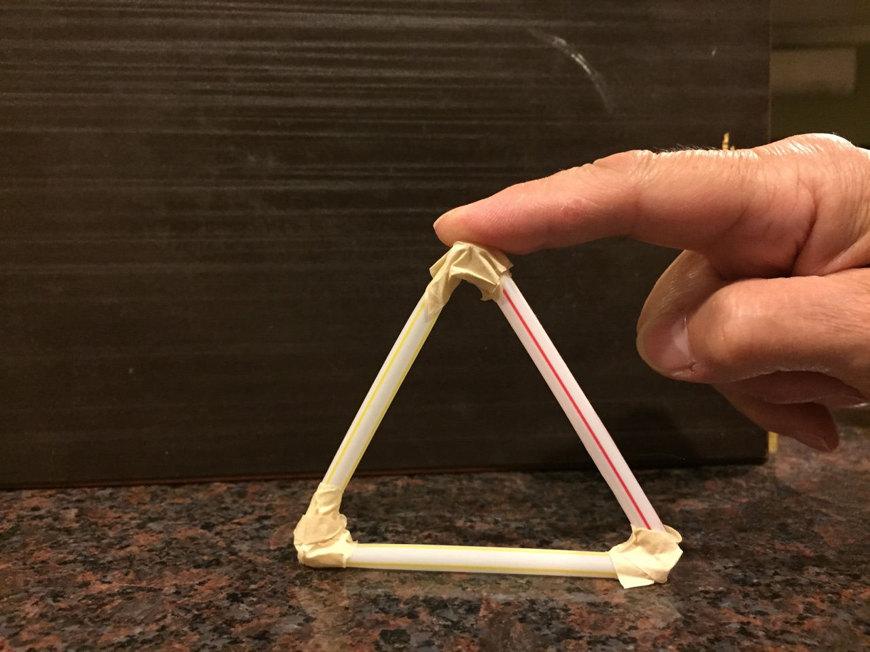
TRIANGLE DIAMOND (rhombus)

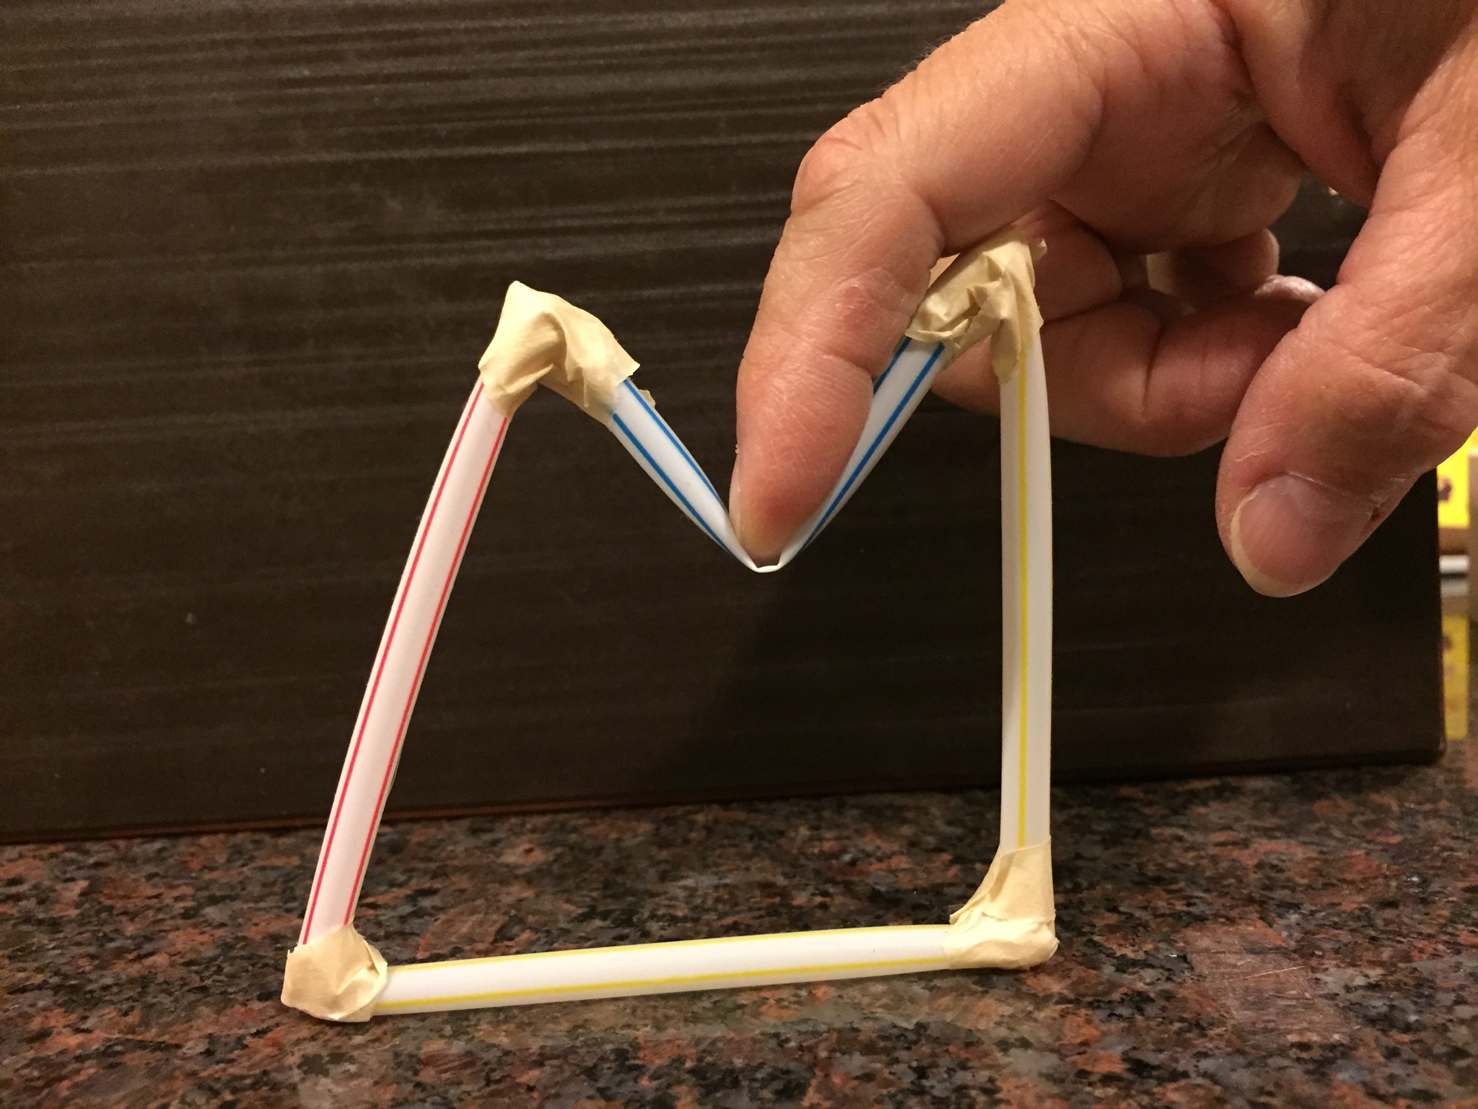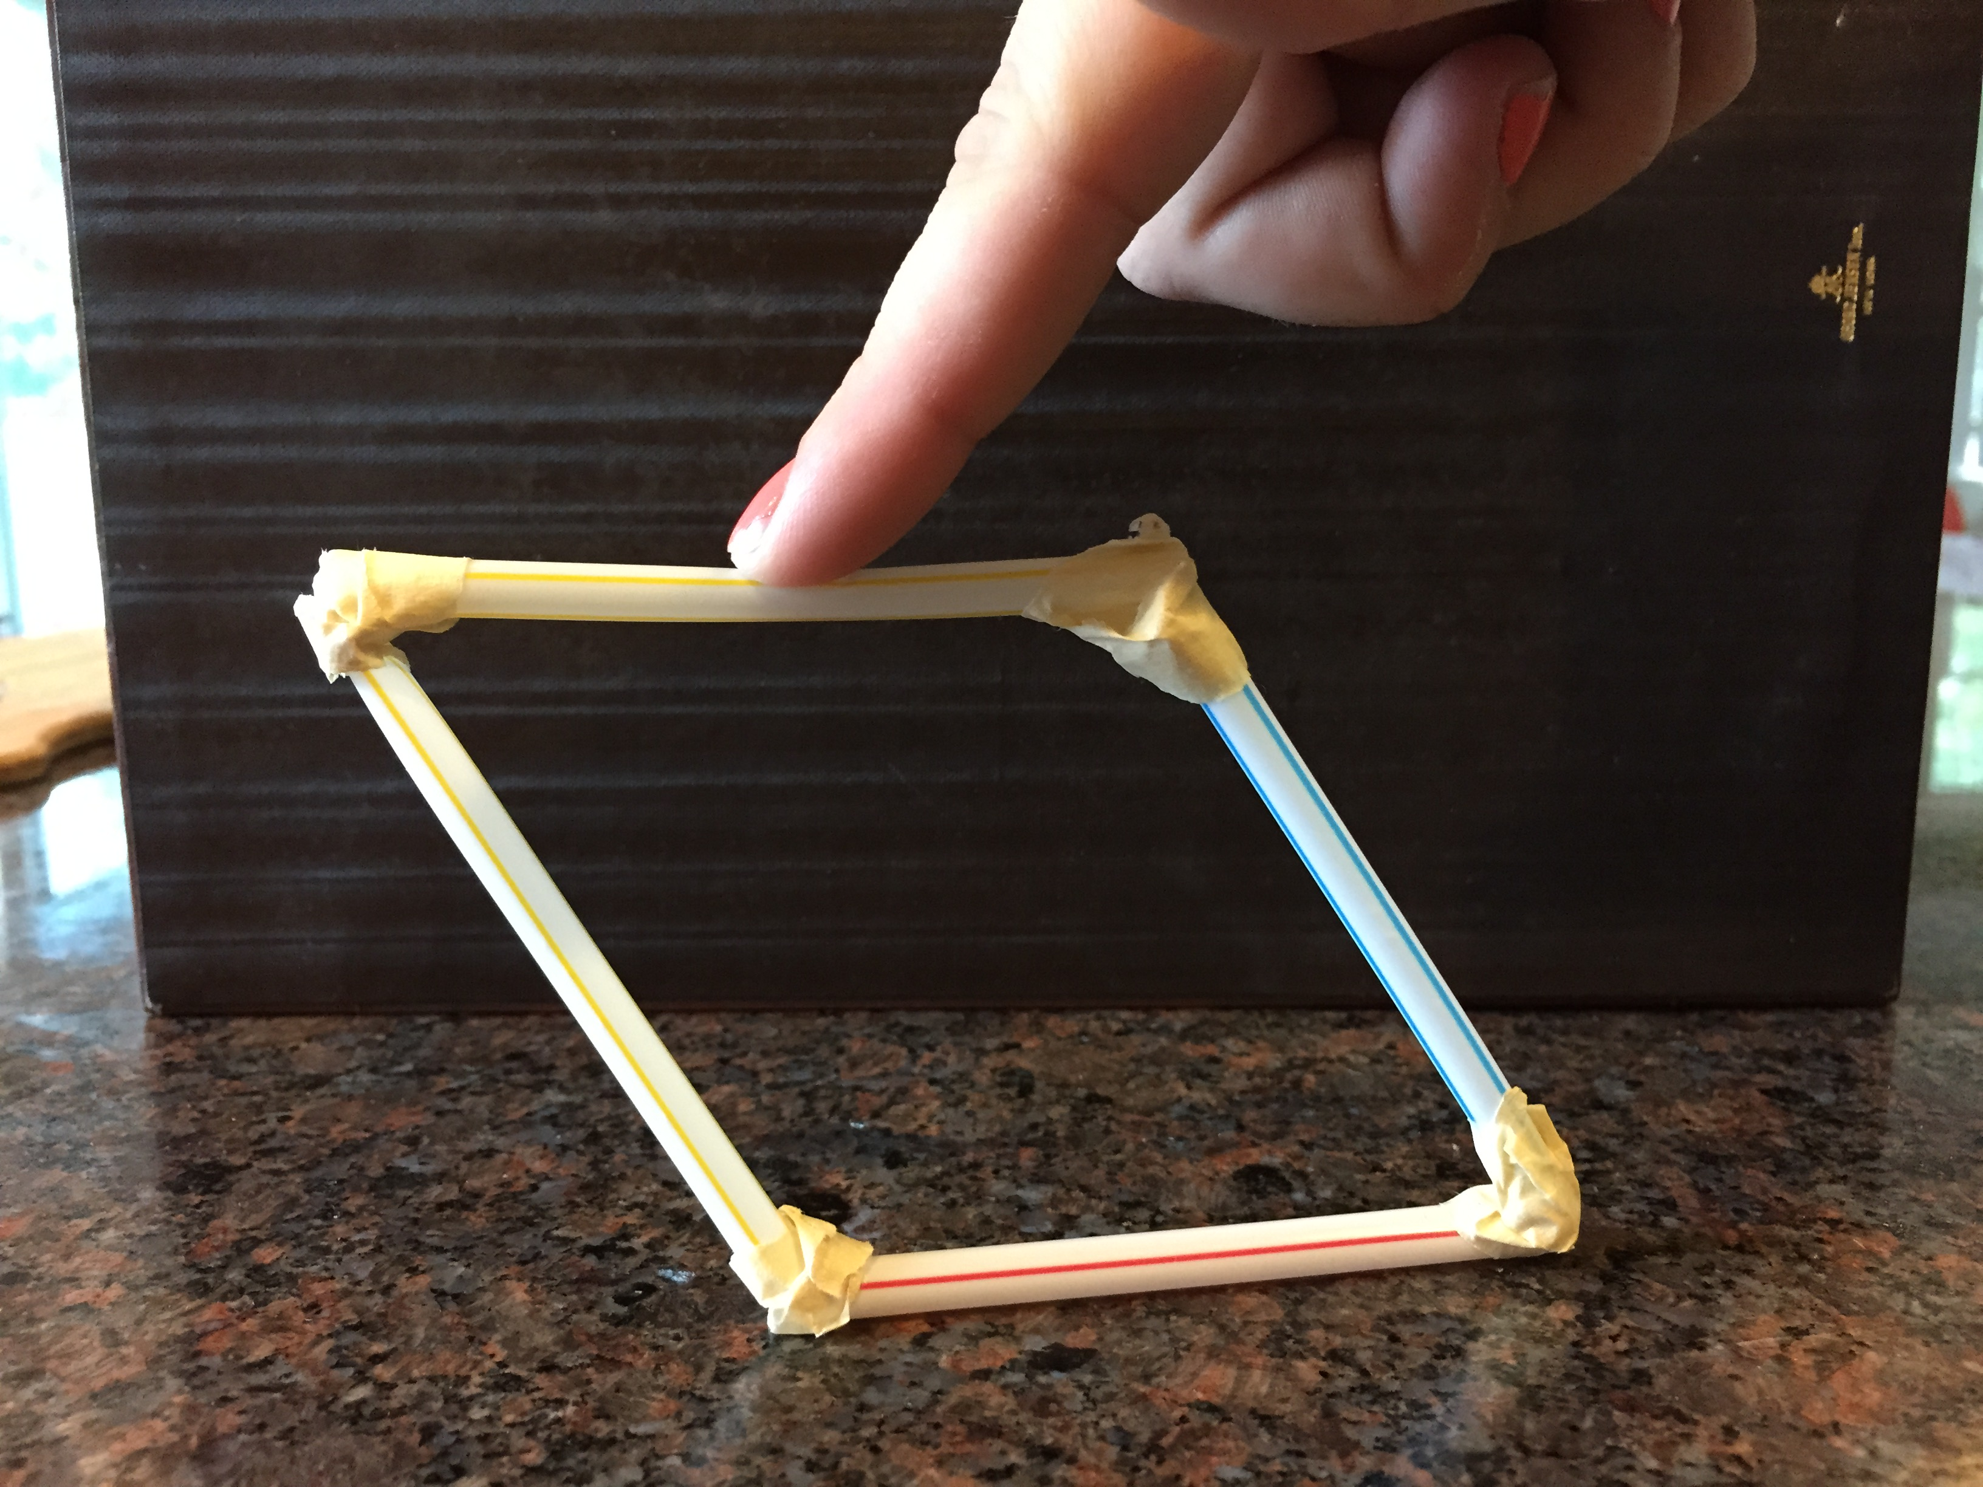
SQUARE SQUARE
3. How could you make the square and the rhombus stronger?
Try using another piece of straw or toothpick to attach to the existing figure to make it stronger.
Once you have made your modifications to the two shapes, try the experiment again and see if you made the shape stronger.

Sketch your new shape below.

Record your results.

Try and come up with other ways to try and test the strength of the shapes.

View the following power point to get a better understanding of which shapes are used to make structures stronger.
https://www.teachengineering.org/collection/cub_/lessons/cub_trusses/cub_trusses_lesson01_presentation_v5_tedl_dwc.pptx

Experiment 2

This is an experiment to test the strength of a triangular structure.

1. First we need to accordion fold a sheet of construction paper or printer paper. The folds look like a little triangular shape that will act as a bridge.
2. Use two books as supporters and put the paper on top of them.

3. Now, we put a load on it. You can even try to increase the load and push down on the book and see what happens.

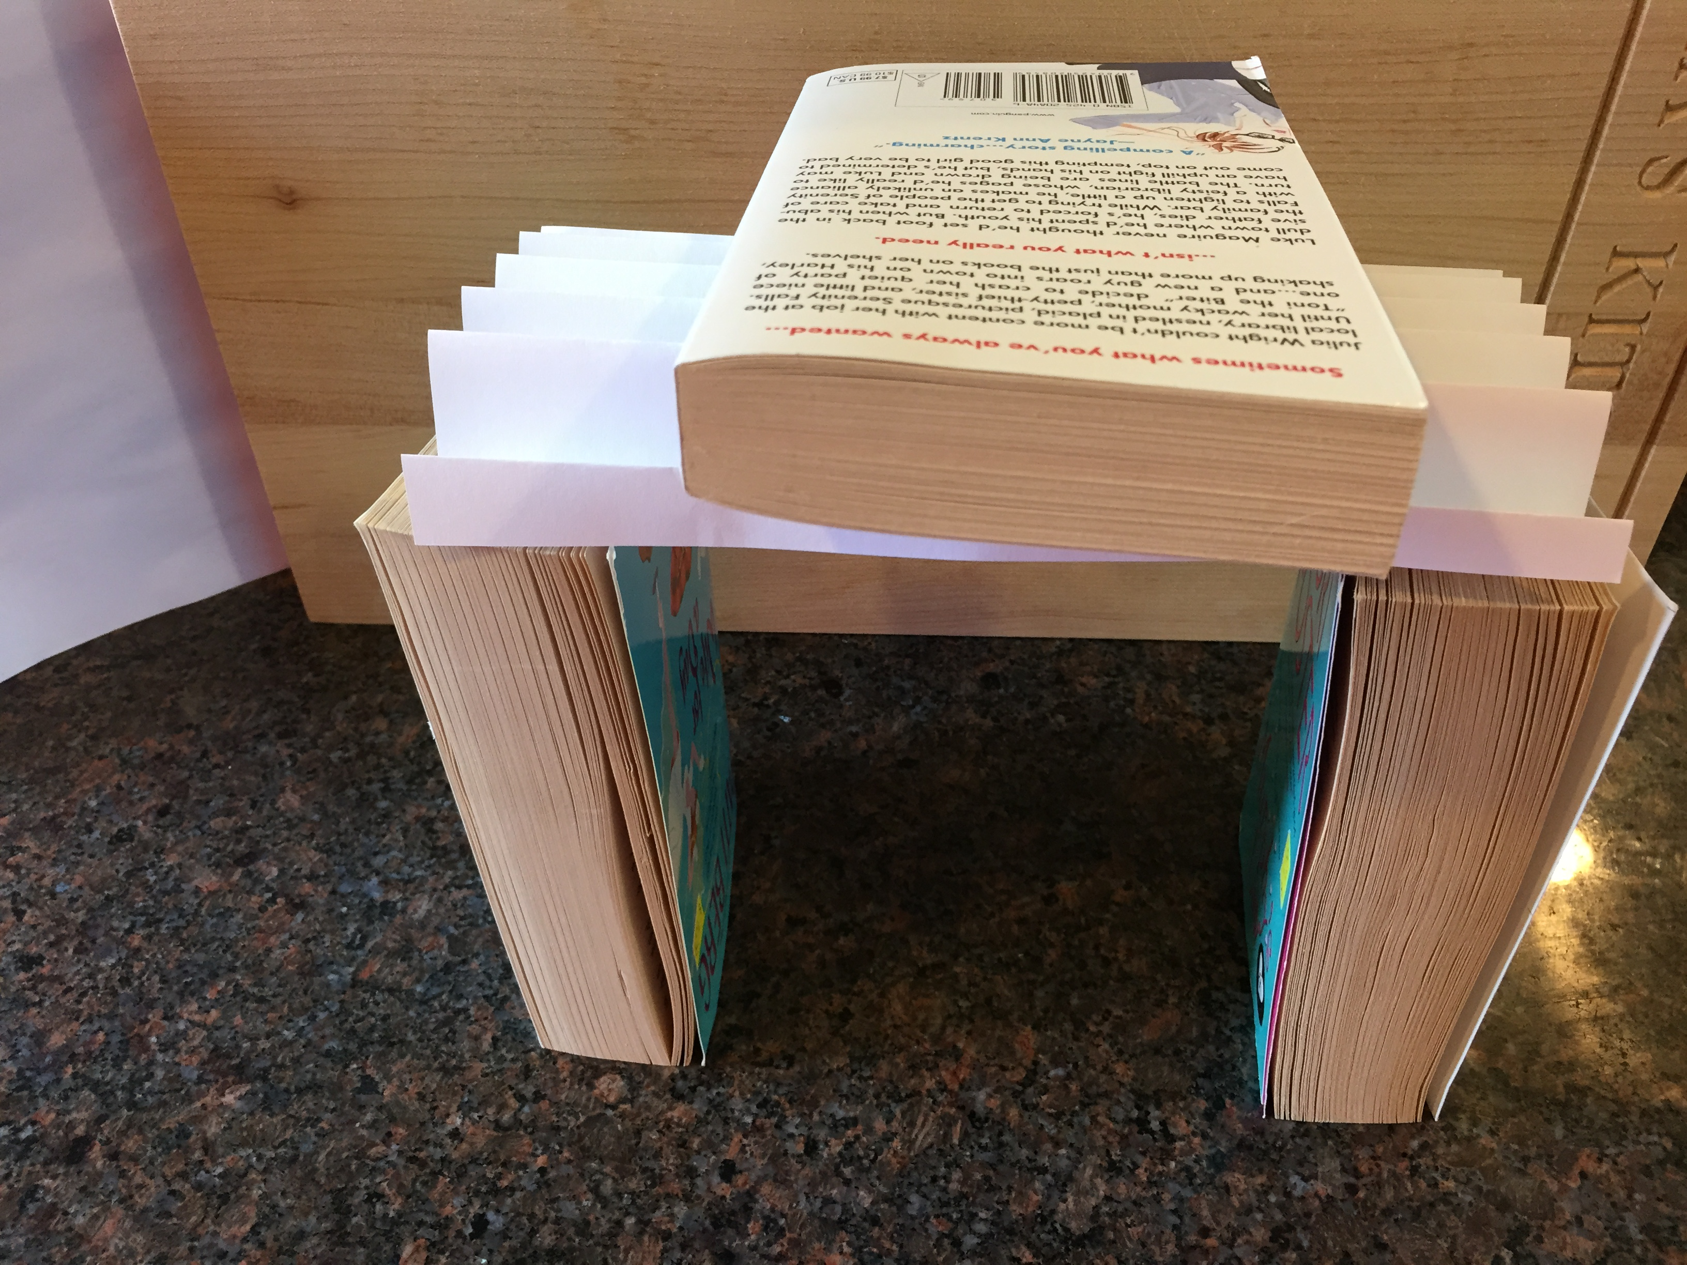
4. Record your observations.

5. Now try this same experiment with a square shaped fold. What do you think will happen?

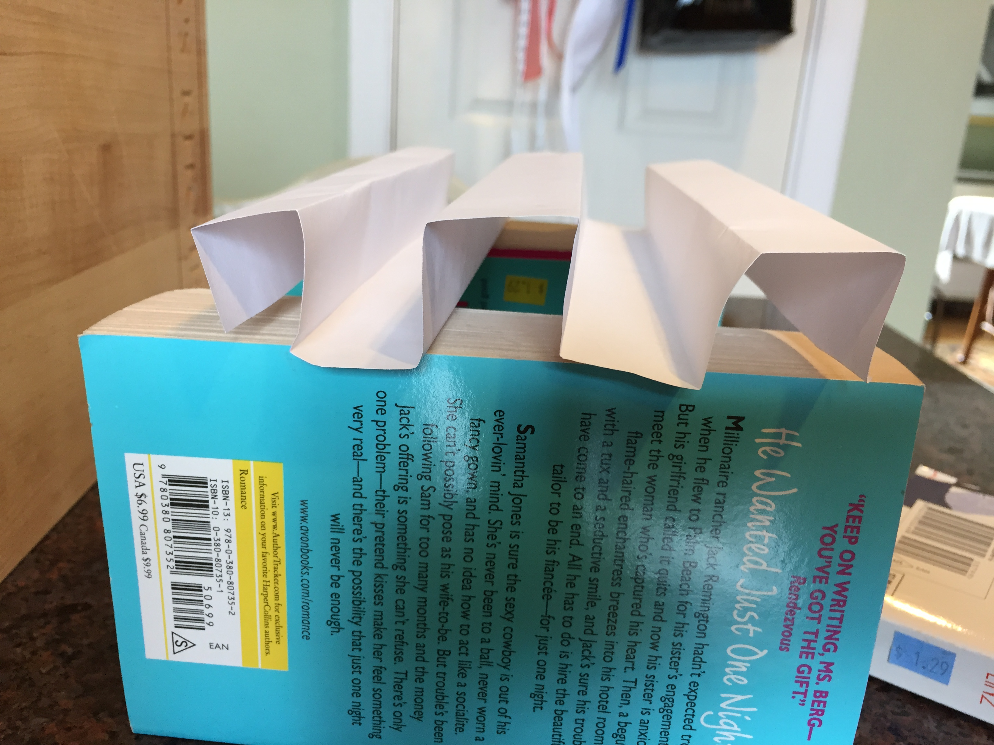

Conclusions

1. Explain below why you think triangles are used in constructing rigid structures.

2. Why do you think polygons with more than 3 sides may collapse?

3. How is the strength of a triangular structure related to the SSS Congruence Theorem?

4. Based on your observations do you think there is an SSSS Congruence Theorem for quadrilaterals? Explain.

