Activity 2.4.1 Making Kites

A kite is a quadrilateral with two pairs of consecutive sides that are congruent. On page 3 you are given 4 pairs of congruent triangles.

Cut out the triangle pairs and place them together to try and make a kite and any other figure you can think of. While you and your group are exploring different shapes with these pairs of triangles, you can trace the new shapes created into your notebook or on a separate piece of paper.

1. First Pair: Acute Scalene Triangles
How many ways can you make a kite? _____________
What other shape can you create with the two triangles together? _____________________
How many ways can you make this other shape? ____________
2. Second Pair: Right Scalene Triangles
How many ways can you make a kite? _____________
What other shape can you create with the two triangles together? _____________________
How many ways can you make this other shape? ____________
There is one more shape you can make with these two triangles. What is it? _________________
How many ways can you make this shape? __________________
3. Third Pair: Obtuse Scalene Triangles
How many ways can you make a kite? _____________
What other shape can you create with the two triangles together? _____________________
How many ways can you make this other shape? ____________
There is one more shape you can make with these two triangles. It is called a dart. The dart is a non-convex shape.

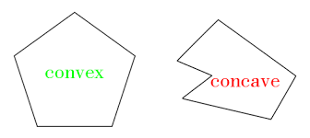
A convex polygon is a polygon that has all interior angles less than 180°.

A non-convex polygon, also known as concave, is a polygon with one or more interior angles greater than 180°.

How many ways can you make this concave polygon called a dart? __________________

4. Fourth Pair: Acute Isosceles Triangles
This set of triangles can make only 3 possible figures.
If the two triangles share legs, they can create a __________________and_________________.
If the two triangles share their bases, they create a ________________, which is a special type of kite as well as a special type of parallelogram.
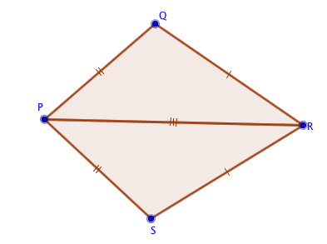
5. Diagonals of Kites.
a. Here is kite PQRS with diagonal $\overline{PR}$ drawn. What can you say about ∆PQR and ∆PSR?

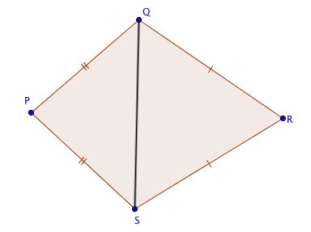
b. Here is kite PQRS with diagonal $\overline{QS}$ drawn. What can you say about ∆QPS and ∆QRS?

6. As a group try to come up with a conclusion about different pairs of triangles and kites.
a. Can you make a kite out of two congruent triangles?
b. Can you make a kite out of triangles that are not congruent?
c. What is the most ways to make a kite out of a pair of congruent triangles?
d. What is the least amount of ways to make a kite out of a pair of congruent triangles?

7. Summarize what you have learned:

Given two congruent triangles, there is at least __________ way to make a _____________.

Acute Scalene Triangles
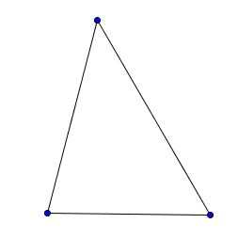

Right Scalene Triangles
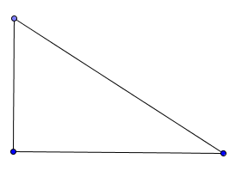

Obtuse Scalene Triangles
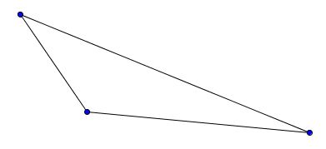

Acute Isosceles Triangles
