Activity 2.3.6 Equilateral Triangles

Recall these definitions:

Equilateral triangle: A triangle in which all three sides are congruent.
Isosceles triangle: A triangle with at least one pair of congruent sides.
Scalene triangle: A triangle with no pair of congruent sides.

From these definitions, it is clear that equilateral triangles can also be classified as isosceles triangles. The same way that a square is a special type of rectangle, the equilateral triangle is a special type of an isosceles triangle.

Let’s use the Isosceles Triangle Theorem and its Converse to discover properties of equilateral triangles.
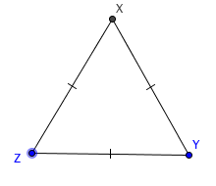
- Given ∆XYZ is equilateral; that is XY = YZ = ZX.
a. Choose two sides of $∆XYZ$. ___________ and _____________

What must be true about the angles opposite these sides?
_____________________________________________________

Why? (state the theorem or express in your own words)

______________________________________________________

b. Now choose two different sides of $∆XYZ.$ ______________ and ______________

What must be true about the angles opposite these sides? ______________________________

Why? _______________________________________________________________________

c. What is true about the angles of an equilateral triangle? _____________________________

2. Given ∆ LMN with m$∠NLM$= m$∠LMN$ = m$∠MNL$. Since the measures of the angles are equal, we could call this triangle “equiangular.”

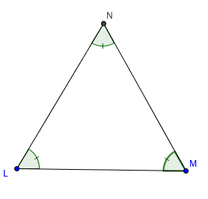
a. Choose two angles from $∆LMN$. ____________ and ____________

What must be true about the sides opposite these angles?
_________________________________________________________

Why? ____________________________________________________

b. Now choose two different angles from $∆LMN.$ ______________ and _______________

What must be true about the sides opposite these angles? ________________________________

Why? ________________________________________________________________________

c. What is true about the sides of an equiangular triangle? _______________________________

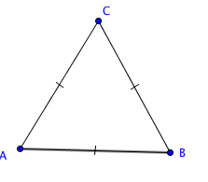
3. Fill the missing reasons in the proof of the Equilateral Triangle Theorem

Given: $\overline{AB}$ $≅$ $\overline{AC}$ $≅$ $\overline{BC}$
Prove: $∠A ≅∠B ≅ ∠C$

Statements Reason

- $\overline{AB}$ $≅$ $\overline{AC}$ 1. Given
- $∠C≅∠B$ 2. ____________________Theorem
- $\overline{AC}$ $≅$ $\overline{BC}$ 3. ________________
- $∠B≅∠A$ 4. ________________
- $∠C≅∠A$ 5. ______________ Propetry
- $∠A ≅∠B ≅ ∠C$ 6. Summarizing lines 2, 4, and 5

Fill in the blanks to complete the Equilateral Triangle Theorem:
If all __________ ____________ of a triangle are _______________, then all ____________
_____________ are _______________.
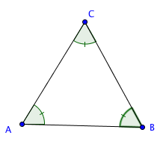
4.. Fill the missing reasons in the proof of the Equilateral Triangle Converse.

Given: $∠A ≅∠B ≅ ∠C$
Prove: $\overline{AB}$ $≅$ $\overline{AC}$ $≅$ $\overline{BC}$

Statement Reason
- $∠A ≅∠B$ 1. _______________________________
- $\overline{BC} ≅ \overline{AC}$ 2. _______________________________
- $∠B ≅ ∠C$ 3. _______________________________
- $\overline{AC}$ $≅$ $\overline{AB}$ 4. _______________________________
- $\overline{AB}$ $≅$ $\overline{BC}$ 5. _______________________________
- $\overline{AB}$ $≅$ $\overline{AC}$ $≅$ $\overline{BC}$ 6. _______________________________

Fill in the blanks to complete the Converse of the Equilateral Triangle Theorem
If all __________ ____________ of a triangle are _______________, then all ____________
_____________ are _______________.

