Activity 2.3.4a Proving the Isosceles Triangle Converse

Fill in the blanks in this proof.
Given ∆ABC with m$∠$ABC= m$∠$ACB

Prove AB = AC

Step 1. Reflect ∆ABC over line AC.
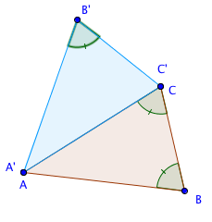
Step 2. In ∆ABC and ∆ACB’
m$∠$ABC= m$∠$AB’C Why? _________________
m$∠$ABC= m$∠$ACB Why? _________________
Therefore m$∠$ACB = m$∠$AB’C Why? _________________
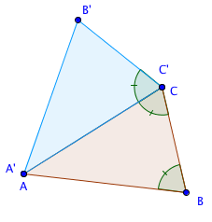
Step 3. Show that m$∠$ABC = m$∠$ACB’
m$∠$_____= m$∠$______ Why? ____________
m$∠$_____= m$∠$______ Why? ____________
Therefore, m$∠$ABC = m$∠$ACB’ Why? ____________
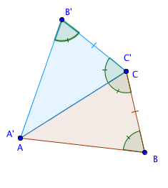
Step 4. BC = B’C Why? ________________

Step 5. From Steps 2, 3, and 4 we can prove that ∆ABC and ∆ACB’ are congruent, by the _______ Congruence Theorem.

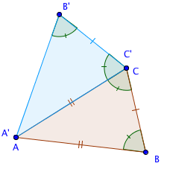

Step 6. AB = AC since corresponding parts of congruent triangles are _______________.

