Activity 2.3.3a Proving the Isosceles Triangle Theorem
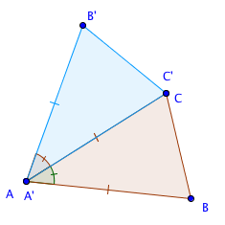
Fill in the blanks in this proof.
Given ∆ABC with AB = BC

Prove m$∠$ABC= m$∠$ACB

Step 1. Reflect ∆ABC over line AC.

- What is another name for point A? ______
- What is another name for point C? ______
Step 2. In ∆ABC and ∆ACB’
3. AB = AC Why? _________________
4. AB = AB’ Why? _________________
5. AC = AB’ Why? _________________
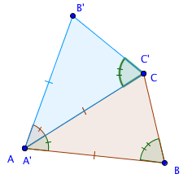
6. m$∠$BAC= m$∠$CAB’ Why? _________________

Step 3. From lines 3, 4, and 6 above we can prove that ∆ABC and ∆ACB’ are congruent, by the _______ Congruence Theorem.

Step 4. m$∠$ABC = m$∠$ACB’ since corresponding parts of congruent triangles are _______________.

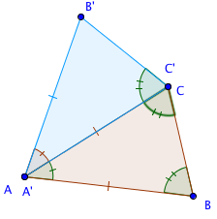
Step 5. m$∠$ACB’ = m$∠$ACB since reflections preserve _____________measure.

Step 6. m$∠$ABC = m$∠$ACB by the ___________ property of equality.

