Activity 2.1.4 Areas and Perimeters of Congruent Figures

Formulas you should remember: Rectangle: Area = length x width
Parallelogram: Area = base x altitude; Triangle: Area = ½ base x altitude
Circle: Area = πr², Circumference = 2πr.
1. Parallelogram A’B’C’D’ is the image of Parallelogram ABCD under a translation.
a. Write the transformation rule: (x, y) (___, ___)

b. Explain why the two parallelograms are congruent.
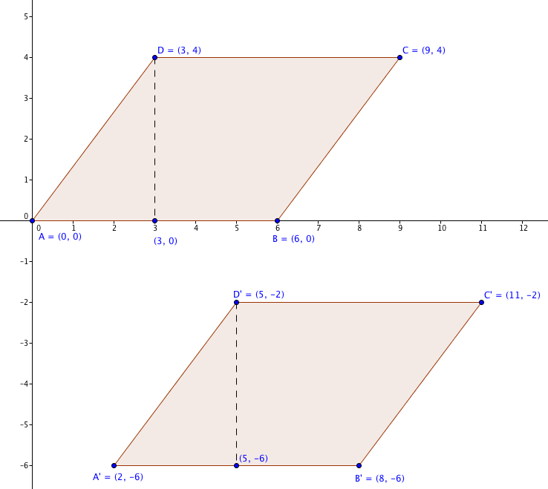

c. Find the area of parallelogram ABCD.

d. Find the area of parallelogram A’B’C’D’.

e. Find the perimeter of parallelogram ABCD.

f. Find the perimeter of parallelogram A’B’C’D’.

2. ∆A’B’C’ is the image of ABC under a reflection.
a. Write the transformation rule: (x, y) (___, ___)

b. Explain why the two triangles are congruent.
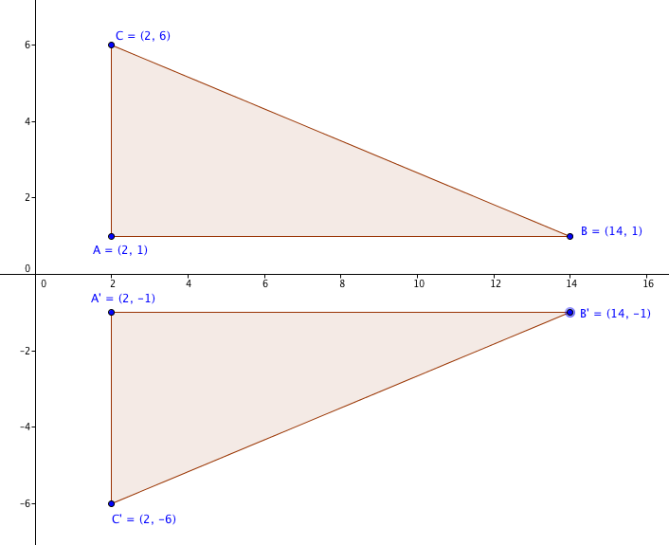

c. Find the area of ∆ABC.

d. Find the area of ∆A’B’C’.

e. Find the perimeter of ABC.

f. Find the perimeter of ∆A’B’C’.

3. Rectangle ABCD $≅$ Rectangle MNOP. AB = 4 units and BC = 6 units.
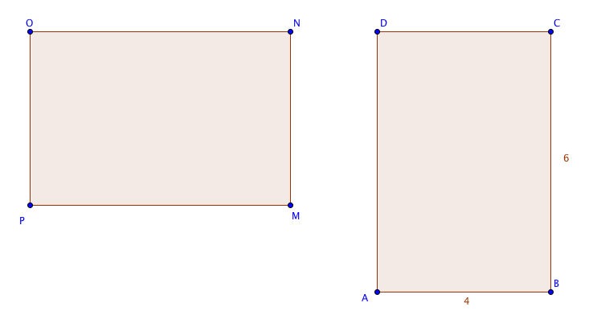

a. Find the area of each rectangle.

b. Find the perimeter of each rectangle.

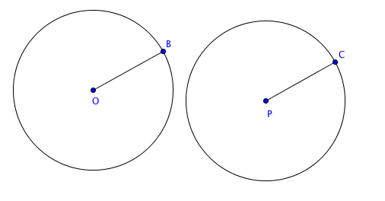
4. Given circle O $≅$ circle P.
The radius of the first circle, OB = 5 inches.
a. Find the area of each circle to the nearest 0.1 square inch. (Use π ≈ 3.14)

b. Find the circumference of each circle to the nearest 0.1 inch.

5. Based on your answers to question 1-4, if two figures are congruent, what can you say about their areas and perimeters?

