Activity 2.1.3 Congruent Polygons
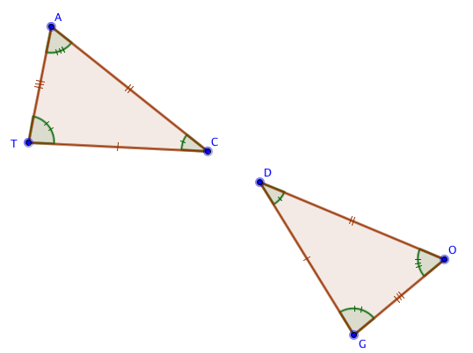
Triangles CAT and DOG have congruent corresponding parts as marked.
1. Name pairs of corresponding parts:
a. $\overline{CA}$ $≅$ ______ b. $\overline{AT}$ $≅$ ______
c. $\overline{TC}$ $≅$ ______ d. $∠$ TCA $≅$ ______
e. $∠$ CAT $≅$ ______ f. $∠$ ATC $≅$ ______
2. There are six ways to state that the triangles are congruent. Name them.
a. ∆CAT $≅$ ______ b. ∆ATC $≅$ ______
c. ∆TCA $≅$ ______ d. ∆ACT $≅$ ______
e. ∆CTA $≅$ ______ f. ∆TAC $≅$ ____________
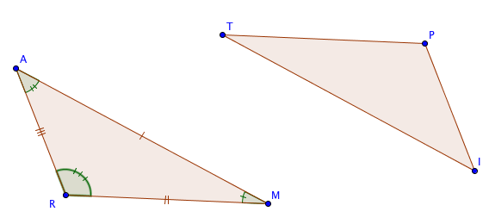
3. ∆RAM $≅$ ∆PIT. Name pairs of corresponding parts:
a. $\overline{RA}$ $≅$ ______ b. $\overline{AM}$ $≅$ ______
c. $\overline{MR}$ $≅$ ______ d. $∠$ AMR $≅$ ______
e. $∠$ MRA $≅$ ______ f. $∠$ RAM $≅$ ______

4. Now label the sides and angles of ∆PIT with tick marks to show the corresponding parts.

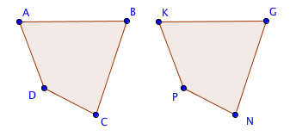
5. Given: Quadrilateral ABCD $≅$ Quadrilateral KGNP.
Fill in the blanks:

a. $∠$ KGN $≅ ___________$ b. $\overline{DC}$ $≅ _______________$

c. NG = ____________ d. m$∠$ CBA = ___________

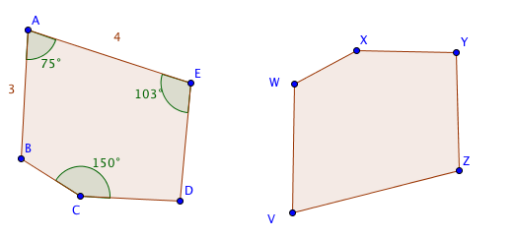
6. Pentagon ABCDE $≅$ Pentagon VWXYZ.
The lengths of some sides and the measures of some angles are shown.
- Which angle in VWXYZ has a measure of 150°? _____________
- Which side in VWXYZ has a length of 4 units? ___________
- Which angle is congruent to $∠$ XYZ?

- Do we have enough information to find the length of $\overline{WX}$?______ Explain.

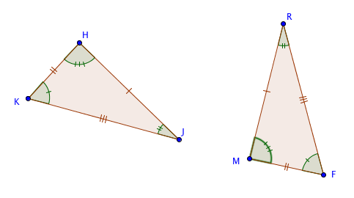
- Another way to name the first pentagon is DCBAE. If we name it that way,
then Pentagon DCBAE $≅$ Pentagon ____________.

7. The two triangles shown are congruent, with corresponding sides and angles marked on the figure. Which of the following are correct statements about the congruence? If the statement is incorrect, explain why.

a. ∆MFR $≅$ ∆HKJ b. ∆RFM $≅$ ∆JHK c. ∆HJK $≅$ ∆MFR d. ∆KJH $≅$ ∆FRM

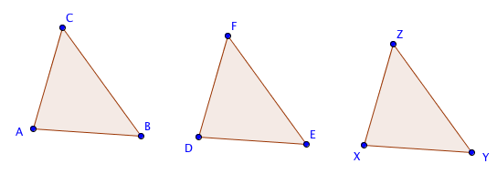
8. Suppose we know that ∆ABC $≅$ ∆DEF and ∆DEF $≅$ ∆XYZ. What can we conclude about ∆ABC and ∆XYZ? Explain your thinking.

