Activity 2.1.2 Properties of Congruence
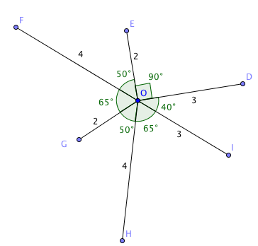
- In the diagram at the right distances and angle measures are given:

a. Name pairs of congruent segments:

$\overline{OI }≅$ _______ $\overline{OH}$ $≅$ _______

b. Name pairs of congruent angles:

$∠$ FOE $≅$______ $∠$HOI $≅$_____

c. Find equal measures:

OE = _________

m $∠$ GOH = m $∠$ ______
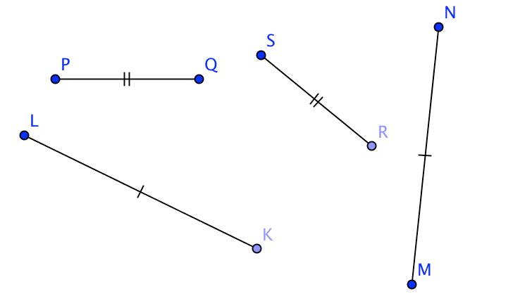

- Fill in the blanks:

a. If KL = MN
then _______ $≅$________

b. If $\overline{PQ}$ $≅ \overline{RS}$
then _______ = __________

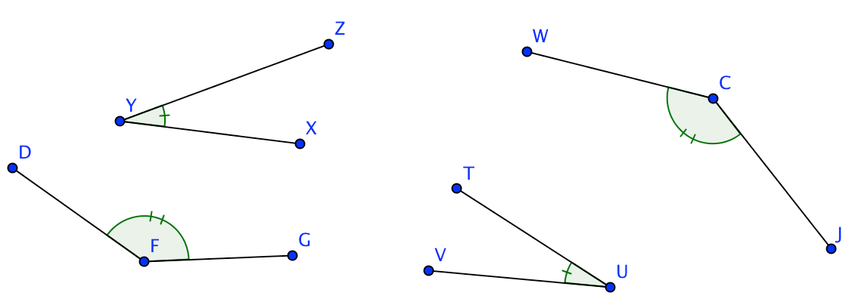

c. If m $∠$ XYZ = m $∠$TUV
then ________ $≅$_________

d. If $∠$DFG $≅$ $∠$WCJ
then _______ = _____

- The Reflexive Property: Any number is equal to itself, that is a = a.
- Does the reflexive property apply to congruent segments?
Is it true that $\overline{AB}$ $≅$ $\overline{AB}$? Explain.
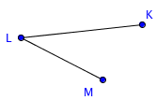

- Does the reflexive property apply to congruent angles?
Is it true that $∠$KLM $≅$ $∠$KLM? Explain.

- The Symmetric Property: We can switch the expressions on the left and right sides of an equation, that is if we know that a = b, then we can conclude that b = a.
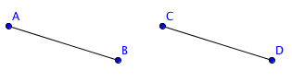
- Does the symmetric property apply to congruent segments? Is it true that if $\overline{AB}$ $≅$ $\overline{CD},$
then $\overline{CD}$ $≅$ $\overline{AB}$? Explain.

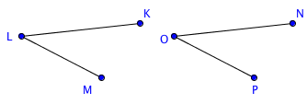
- Does the symmetric property apply to congruent
angles? Is it true that if $∠$KLM $≅$ $∠$NOP,
then $∠$NOP $≅$ $∠$KLM? Explain.

- The Transitive Property: Two things equal to the same thing are equal to each other, that is if we know that a = b and that b = c, then we can conclude that a = c.

- Does the transitive property apply to congruent segments? Is it true that if $\overline{AB}$ $≅$ $\overline{CD},$
and $\overline{CD}$ $≅$ $\overline{EF}$, then $\overline{AB}$ $≅$ $\overline{CD}$? Explain.

- Does the transitive property apply to congruent angles? Is it true that if $∠KLM≅∠NOP,$
and $∠$NOP $≅$ $∠$QRS, then $∠KLM≅∠QRS$? Explain.
