Activity 2.1.1 Congruent Segments and Angles

- Use your ruler to measure segment $\overline{AB}$. Then draw another segment $\overline{CD}$ with the same length as $\overline{AB}$. Make sure that the two segments are not parallel to each other.

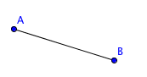

- Describe transformations that will map $\overline{CD}$ onto $\overline{AB}$.

- Use your protractor to measure$∠KLM.$ Then draw another angle $∠RST$ with the same measure as$∠KLM$. Make sure that the sides of the two angles are not parallel to each other.

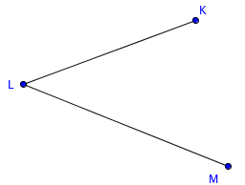

- Describe transformations that will map $∠RST$ onto $∠KLM.$

