Activity 1.7.3: Tuning Up

Have you ever wondered how a piano tuner is able to tune every piano to the same pitch? Piano tuning is actually based on some pretty sophisticated mathematics. Sound moves in waves (you will learn more about the kind of waves that sound makes later in Algebra 2). The pitch a sound makes is usually measured in hertz (Hz), where one hertz is one cycle or one wave per second. When we hear two musical notes that vary by one octave, like “middle C” and “upper C” on a piano, one of them is double the hertz of the other one.

If you study the theory of music, you will run across the phrase “A = 440” or “A440” at some point in your studies. One of the standard ways to tune a piano is to set “concert A,” the A above “middle C,” to be 440 Hz. That means that the A above “concert A” is 880 Hz and the A below “concert A” is 220 Hz. But what about the other keys on a piano? They are tuned according to root functions.

Here’s the layout of a standard piano keyboard; the blue key is “middle C” and the yellow key is “concert A”:

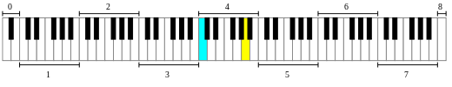

Let’s investigate how root functions are used in tuning a piano. According to what is written above, “concert A” is set at 440 Hz and the A above “concert A” is set at 880 Hz. Each step from a white key to a black key, or from a black key to a white key, is called a half-step. If you locate the A above “concert A” on the keyboard above, you can count that there are 12 half-steps between “concert A” and A above “concert A.” We want the ratio between the hertz for the keys making up each half-step to be the same.

1. If we go up the scale by 12 half-steps, we double the Hz. If we write this as an equation, with a as the ratio for each half-step, we get a × a × a × … × a = 2, with 12 a’s on the left hand side. Solve this equation for a.

2. Using the value for a from question #1, complete the following table. (Make sure that if you multiply the last value for the note G♯/A♭by $2^{\frac{1}{12}}$, you actually do get 880!)

x-coordinate | Note | Hertz (Hz)
0 | Concert A | 440
1 | A♯/B♭ | 440 × $2^{\frac{1}{12}}$ = 466.16
2 | B | 466.16 × $2^{\frac{1}{12}}$ = 493.88
3 | C
4 | C♯/D♭
5 | D
6 | D♯/E♭
7 | E
8 | F
9 | F♯/G♭
10 | G
11 | G♯/A♭
12 | A | 880

3. On the axes below, plot the x-coordinates and the hertz Hz from your table from question #2, and draw a smooth curve between the points.

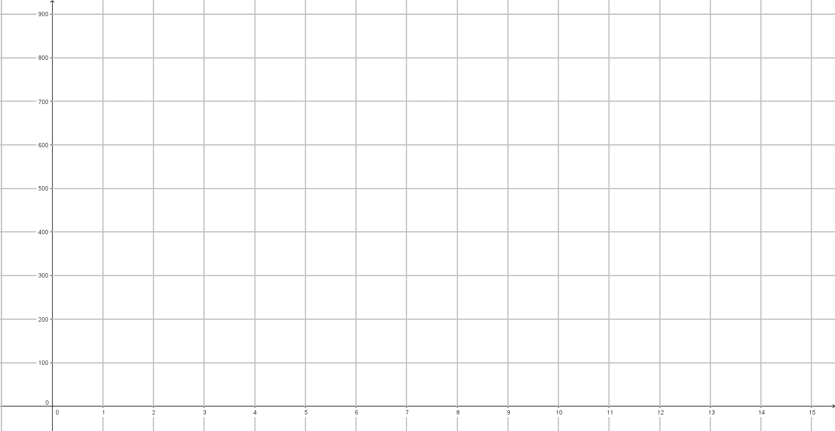

4. Is the relationship between x-coordinate and hertz (Hz) a function? Explain why or why not.

5. In the table in question #2, we found the hertz (Hz) for all the half-notes in the octave above “concert A.” Now let’s go the other direction, down to the A below “concert A.” The idea is the same, but now instead of multiplying by $2^{\frac{1}{12}}$ and making the hertz increase, we want to divide by $2^{\frac{1}{12}}$ so that the hertz decrease (remember, the A below “concert A” is 220 Hz). Complete the following table (you might find it easiest to start with “concert A” and complete the last column in the table from bottom to top). Again, make sure your table will give the correct value for the first note A!

x-coordinate | Note | Hertz (Hz)
0 | A | 220
1 | A♯/B♭
2 | B
3 | C (middle C)
4 | C♯/D♭
5 | D
6 | D♯/E♭
7 | E
8 | F
9 | F♯/G♭
10 | G | 415.30 ÷ $2^{\frac{1}{12}}$ =
11 | G♯/A♭ | 440 ÷ $2^{\frac{1}{12}}$ = 415.30
12 | Concert A | 440

6. Find the hertz for the following keys (remember, every octave higher will double the number of hertz):
a. C below middle C
b. the lowest A on the piano (Hint: Count how many octaves it is below “concert A”)
c. the highest note on the piano

7. Some musicians think that music sounds better when it is tuned such that “concert A” is 432 hertz instead of 440. Below is a copy of the table from question #2 except that “concert A” is set to 432 hertz instead of 440. Complete the missing entries in the table. Check to make sure the A above “concert A” has the correct value. (Hint: you should know what that one will be without filling in the rest of the table!)

x-coordinate | Note | Hertz (Hz)
0 | Concert A | 432
1 | A♯/B♭
2 | B
3 | C
4 | C♯/D♭
5 | D
6 | D♯/E♭
7 | E
8 | F
9 | F♯/G♭
10 | G
11 | G♯/A♭
12 | A

8. Suppose that every musician changed from “A = 440” to “A = 432” tomorrow. What is the percentage change in hertz for “concert A” if we do that?

9. Is the “percentage change” you found in question #8 the same for all the other notes in the table? Find the percentage change for at least one other note in your tables and explain why the change is or is not the same for all of the other notes.

