Activity 1.7.1 Some New Transformations

You will need graph paper for this activity.

- You have already encountered four types of transformations. You have also seen that in the coordinate plane, transformations may be represented by mapping rules. Match each mapping rule with the type of transformation it represents.
Chose from these transformations: (One of the transformations will have two matches)
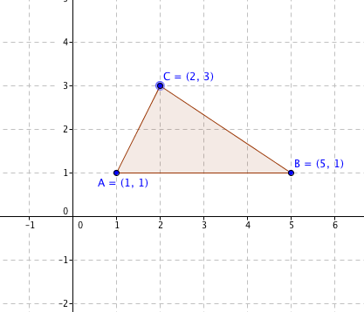
Translation Suggestion: Apply the transformation to this
Rotation figure in the coordinate plane to check your
Reflection answers.
Glide Reflection
- (x, y) (–x, y)
- (x, y) (–x, –y)
- (x, y) (x, –y)
- (x, y) (x + 3, –y)
- (x, y) (x – 2, y + 4)

- Now take the same triangle shown above, with A(1,1), B(5,1), and C(2,3), and apply this mapping rule: (x, y) (2x, 2y). Sketch the image triangle ∆A’B’C’ in the coordinate plane and compare it with the pre-image ∆ABC.
- In what ways are the two triangles alike?
- In what ways are the two triangles different?
- On a new set of axes take the same triangle shown above, with A(1,1), B(5,1), and C(2,3), and apply this mapping rule: (x, y) (3x, y). Sketch the image triangle ∆A’B’C’ in the coordinate plane and compare it with the pre-image ∆ABC.
- In what ways are the two triangles alike?
- In what ways are the two triangles different?

- On a new set of axes take the same triangle shown above, with A(1,1), B(5,1), and C(2,3), and apply this mapping rule: (x, y) (x, 3y). Sketch the image triangle ∆A’B’C’ in the coordinate plane and compare it with the pre-image ∆ABC.
- In what ways are the two triangles alike?
- In what ways are the two triangles different?

- A dilation is a transformation that changes the size of a figure but not the shape. Which of the transformations in questions 2, 3, and 4 is a dilation?
- A stretch is a transformation that expands or contracts a figure in only one direction.
a. Which of the transformations in questions 2, 3, and 4 could be called a vertical stretch?
b. Which of the transformations in questions 2, 3, and 4 could be called a horizontal stretch?
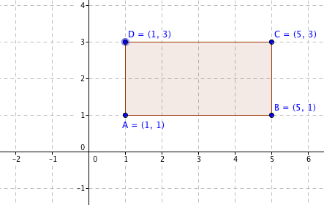
- Predict the effect of this dilation: (x, y) ($\frac{1}{2}$x, $\frac{1}{2}$y).
Then test your prediction with the ∆ABC we have been using in this activity. Was your prediction accurate?

- Another type of transformation is called a shear. An example is the transformation with mapping rule: (x, y) (x + y, y).
- Apply the rule (x, y) (x + y, y) to rectangle ABCD shown at the right. Write the coordinates of the image in the spaces below:
A’ (____, _____) B’ (____, _____) C’ (____, _____) D’ (____, _____)
- Describe the image A’B’C’D’. What kind of quadrilateral is it?
- How does the area of A’B’C’D’ compare to the area of ABCD? Explain your reasoning.

