Activity 1.5.4 Composition –Two Translations

Construction Steps

In this activity you will draw the image of a triangle under a translation by carrying out the steps that follow. Draw all resulting images on the graph provided below.

- Draw the image of $∆ABC$under a translation by the vector $\left[3,1\right]$ and label the image $∆A'B'C'$.
- Draw the image of $∆A'B'C'$ under a translation by the vector $\left[-8,-2\right]$ and label the imgage $∆A^{''}B^{''}C^{''}.$

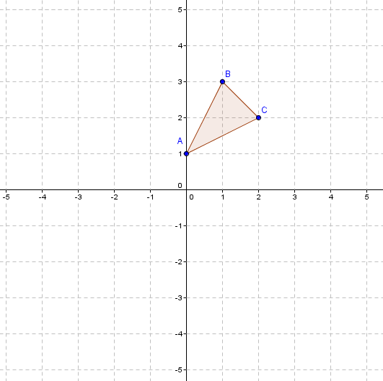

Comprehension Comments/Questions
- Comment on the horizontal and vertical distance between the corresponding vertices of $∆ABC$and $∆A''B''C''$.

- Comment on any relationship between the location of $∆A''B''C''$ and the location of $∆ABC$ under a translation by the vector $\left[-5,-1\right]$.

- Explore by translating objects by different compositions of translations.
Compare the pre-image of the object to the final image just you did for $∆ABC$. Record your observations here.

- Based on what you have observed, make a conjecture about how the translation by the vector $\left[a,b\right]followed$by the translation by the vector $\left[c, d\right]$has the same effect as a single translation. What vector would be associated with that translation?

