Activity 1.5.3b Composition –Two Rotations

Construction Steps

In this activity you will construct a triangle and draw the image under a $120°$ counterclockwise rotation by carrying out the steps that follow for Drawing a Rotation Image.

Step 1

Construct $∆ABC$and Point P (center of rotation) on a sheet.

Step 2  Draw a segment connecting vertex A and the center of rotation point P. | 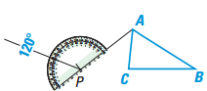  Step 3  Use a protractor to measure a 120° angle counterclockwise and draw a ray.
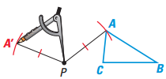  Step 4  Place the point of the compass at P and draw an arc from $A to locate A^{'}$ | Step 5  Repeat Steps 1–3 for each vertex. Connect the vertices to form the image.

Exploration Steps and Comprehension Questions
- Choose two positive integers whose sum is 120.
Record your integer values: $n_{1}= ______{ n}_{ 2 }= ______$

Draw all of the rotation images that result from the steps below on the same sheet of paper you used to complete the Construction Steps. Use the steps outlined on the previous page for Drawing a Rotation Image to complete step b and c.

- Rotate $∆ABC$ counterclockwise around P by an angle measure equal to $n_{1}$. Draw the image that results.

- Rotate the figure that resulted from step b counterclockwise around P by an angle measure equal to $n_{2}$. Draw the image that results.

- Comment on any relationship you observe between the two smaller rotations and the larger rotation.

e. Compare your results with those of your fellow students who may have chosen different values for n₁ and n₂.

