Activity 1.5.2 Composition – Two Reflections II
Construction Steps
- Open a new GeoGebra file and set labeling to New Points Only.
Hint: (Options/Labeling/New Points Only)
- Hide the algebra window and the axes. | 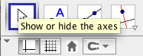
- Use the Polygon tool and click on the graphics window to create $∆ABC$  Hint:(Create Point A, then B, then C, then back to A) | 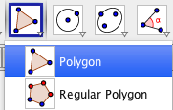
- Use the Line tool (select two points) and click on the graphics window to the right of $∆ABC$ to create $\overset{⃡}{DE}$. | 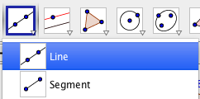
- Use the Point tool and click to the right of $\overset{⃡}{DE}$ to create F. | 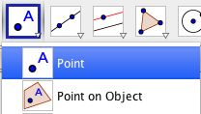
- Again, use the Line (select two points) tool and click on point E and the graphics window to create $\overset{⃡}{EF}$.  $\overset{⃡}{DE}$ and $\overset{⃡}{EF}$ are the intersecting lines you will reflect $∆ABC$ over. | 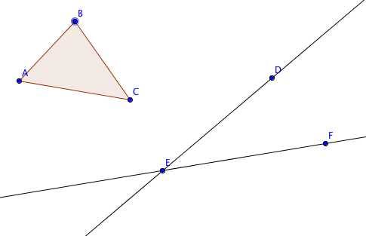
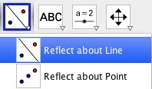
- Use the Reflect about Line tool and click on $∆ABC$ and $\overset{⃡}{DE}$ to create $∆A'B'C'$.
- Use the Reflect about Line about line tool and click on $∆A'B'C'$ and $\overset{⃡}{EF}$to create $∆A''B''C''$.
Exploration Steps and Comprehension Questions
In the previous activity you found that reflecting a figure over intersecting lines yields the same result as a rotation about the intersection point. Using GeoGebra you will experiment rotating $∆ABC$ to understand this concept in more depth.
- Using the Segment tool, connect point E to a pair of corresponding vertices on the original figure ($∆ABC$) and the final image ($∆A''B''C''$).

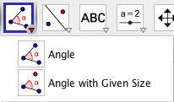
- Using the Angle tool, measure and record the following:
- the acute angle formed by connecting point E to a pair of corresponding vertices from the pre-image and final image
- the acute angle $∠DEF$ formed by the intersecting reflection lines $\overset{⃡}{DE}$ and $\overset{⃡}{EF}$.
Record Angle Measurements Here:

- Measure of angle formed by vertices pre-image and the final image: ____________

- Measure of angle formed by intersecting lines: ____________
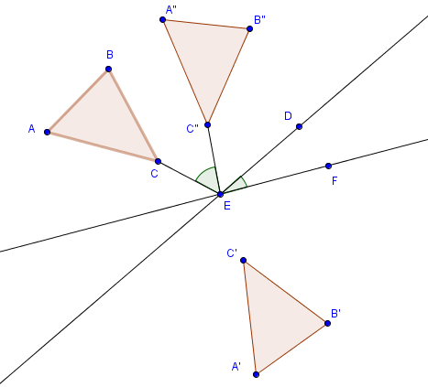
(An example of a possible scenario is shown below)

- What do you notice about the measure of the angle formed by the intersecting reflection lines $\overset{⃡}{DE}$ and $\overset{⃡}{EF}$ and the angle formed by connecting point E pair of corresponding vertices from the pre-image and the final image (the angle measured in part b).

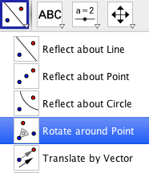
- Using the Rotate around Point tool, rotate $∆ABC$ clockwise about point E (intersection point of $\overset{⃡}{DE}$ and $\overset{⃡}{EF}$)) by the degree equal to the angle formed by connecting point E pair of corresponding vertices from the pre-image and the final image (the angle measured in part b).

- Comment on any relationship you observe between:

- The location of $∆ABC$ rotated about point E (the intersection of reflection lines $\overset{⃡}{DE}$ and $\overset{⃡}{EF}$) by the degree equal to the angle formed by connecting point E pair of corresponding vertices from the pre-image and the final image (the angle measured in part b).
AND

- The location of $∆ABC$ as a result of reflecting it over intersecting lines $\overset{⃡}{DE}$ and $\overset{⃡}{EF}$

- What do you notice about the measure of the angle formed by the intersecting reflection lines $\overset{⃡}{DE}$ and $\overset{⃡}{EF}$ and the rotation that maps $∆ABC$ directly onto $∆A''B''C''$.

