Activity 1.5.1 Composition – Two Reflections I

Directions for Intersecting Lines

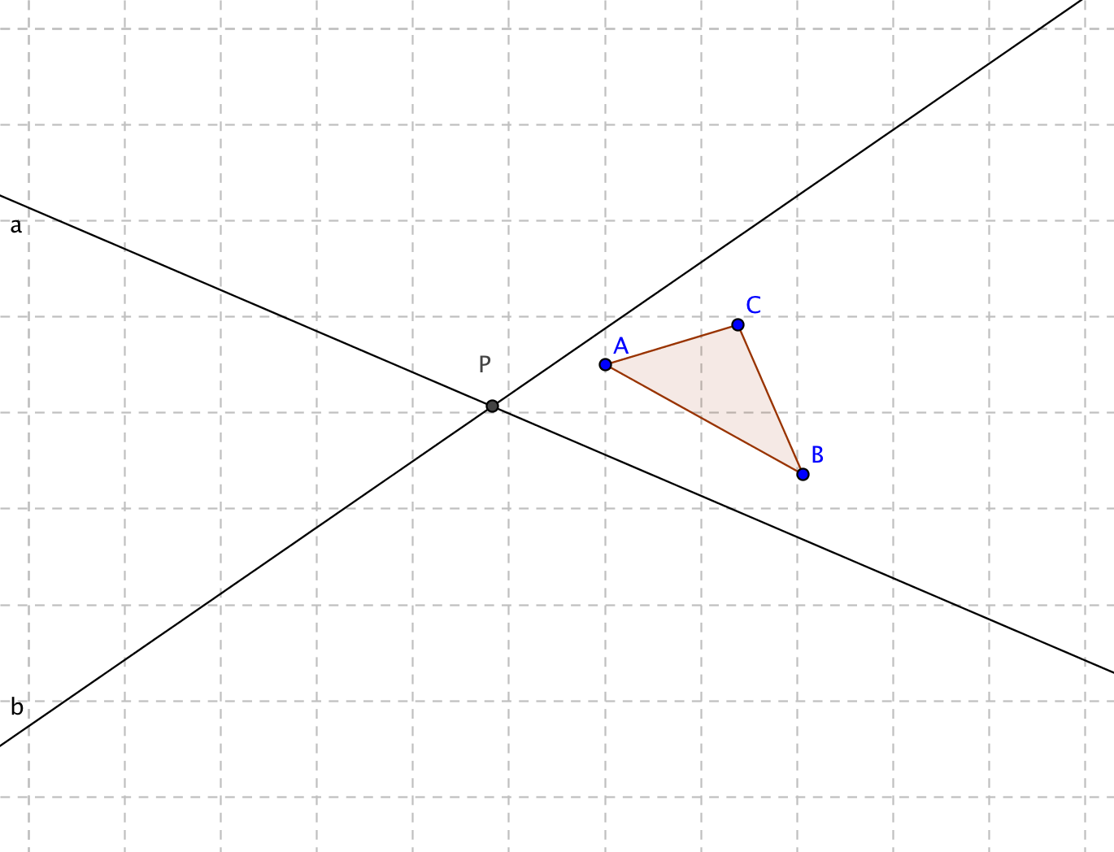
- On a piece of graph paper, draw intersecting lines a and b. Plot a point where the lines intersect and label it P. These lines will be used as lines of reflection.

- Draw $∆ABC$ in between the intersecting lines.

- Place a piece of tracing paper over $∆ABC$. Use a straightedge to help you trace $∆ABC$ and line a.

- Flip the tracing paper over and move it so that line a lies on top of itself.

- Trace the image of $∆ABC$ on the tracing paper. Press firmly to make an impression on the graph paper.

- Lift the tracing paper and draw the image of $∆ABC$ and label its vertices as $A'B'C'$.

- Repeat steps 3-6 to reflect $∆A'B'C'$ across the line b and label its vertices as $A''B''C''$.

- Find the measure of $∠APA''$ and measure the acute angle formed by lines a and b.

- Make a conjecture about the relationship between $∠APA''$ and the acute angle formed by lines a and b.

- Describe a single transformation that maps $∆ABC$ directly onto $∆A''B''C''$.

Directions for Parallel Lines

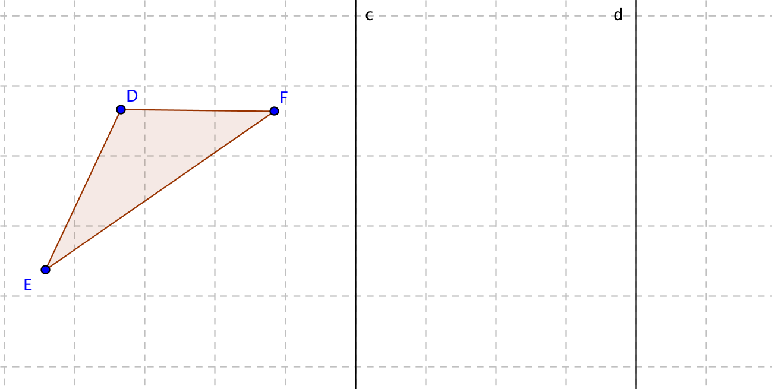
- On a piece of graph paper, draw two vertical parallel lines. Name the line farthest to the left line c and the one farthest to the right line d.

- Draw $∆DEF$ to the left of the first line.

- Place a piece of tracing paper over $∆DEF$. Use a straightedge to help you trace $∆DEF$ and line c.

- Flip the tracing paper over and move it so that the line lies on top of itself.

- Trace the image of $∆DEF$ on the tracing paper. Press firmly to make an impression on the graph paper.

- Lift the tracing paper and draw the image of $∆DEF$ and label its vertices as $D'E'F'$.

- Reflect $∆D'E'F'$ across the line d and label its vertices as $D''E''F''$.

- Measure the distance between lines c and d, and the lengths of $DD^{''}, EE^{''}and FF^{''}. .$

- Make a conjecture about the relationship between the distance between lines c and d, and the lengths of $DD^{''}, EE^{''}and FF^{''}. .$

- What do you notice about $\overline{DD^{''}}, \overline{EE^{''}}$and $\overline{FF^{''}}$?

- Describe a single the transformation that maps $∆DEF$ to $∆D''E''F''$.

- How is the distance between lines c and d related to the transformation that maps $∆DEF$ to $∆D''E''F''$?

