Activity 1.3.3 Slope and Perpendicular Lines

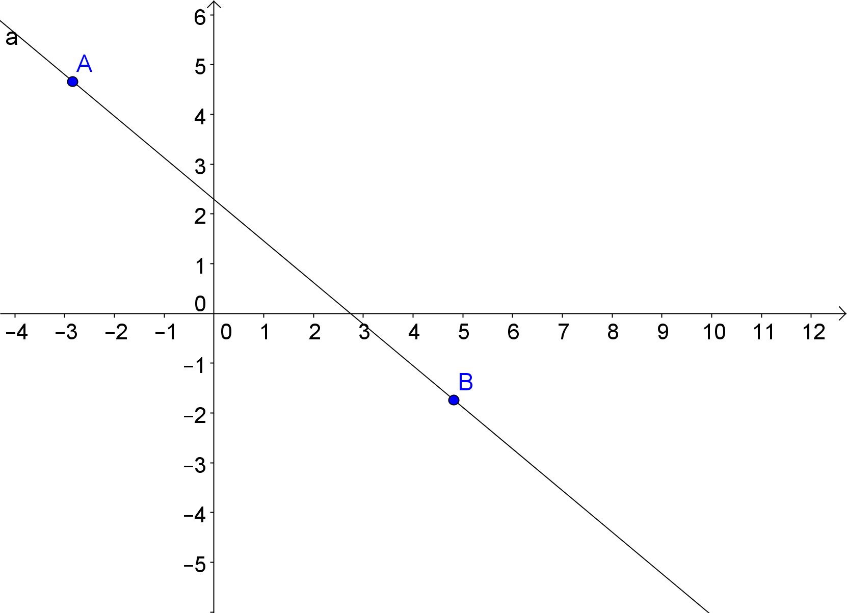
Open Geogebra. In the Graphics view, make sure the coordinate axes is on. If not, click on the icon.

Start by creating a line $\overset{⃡}{AB}$.

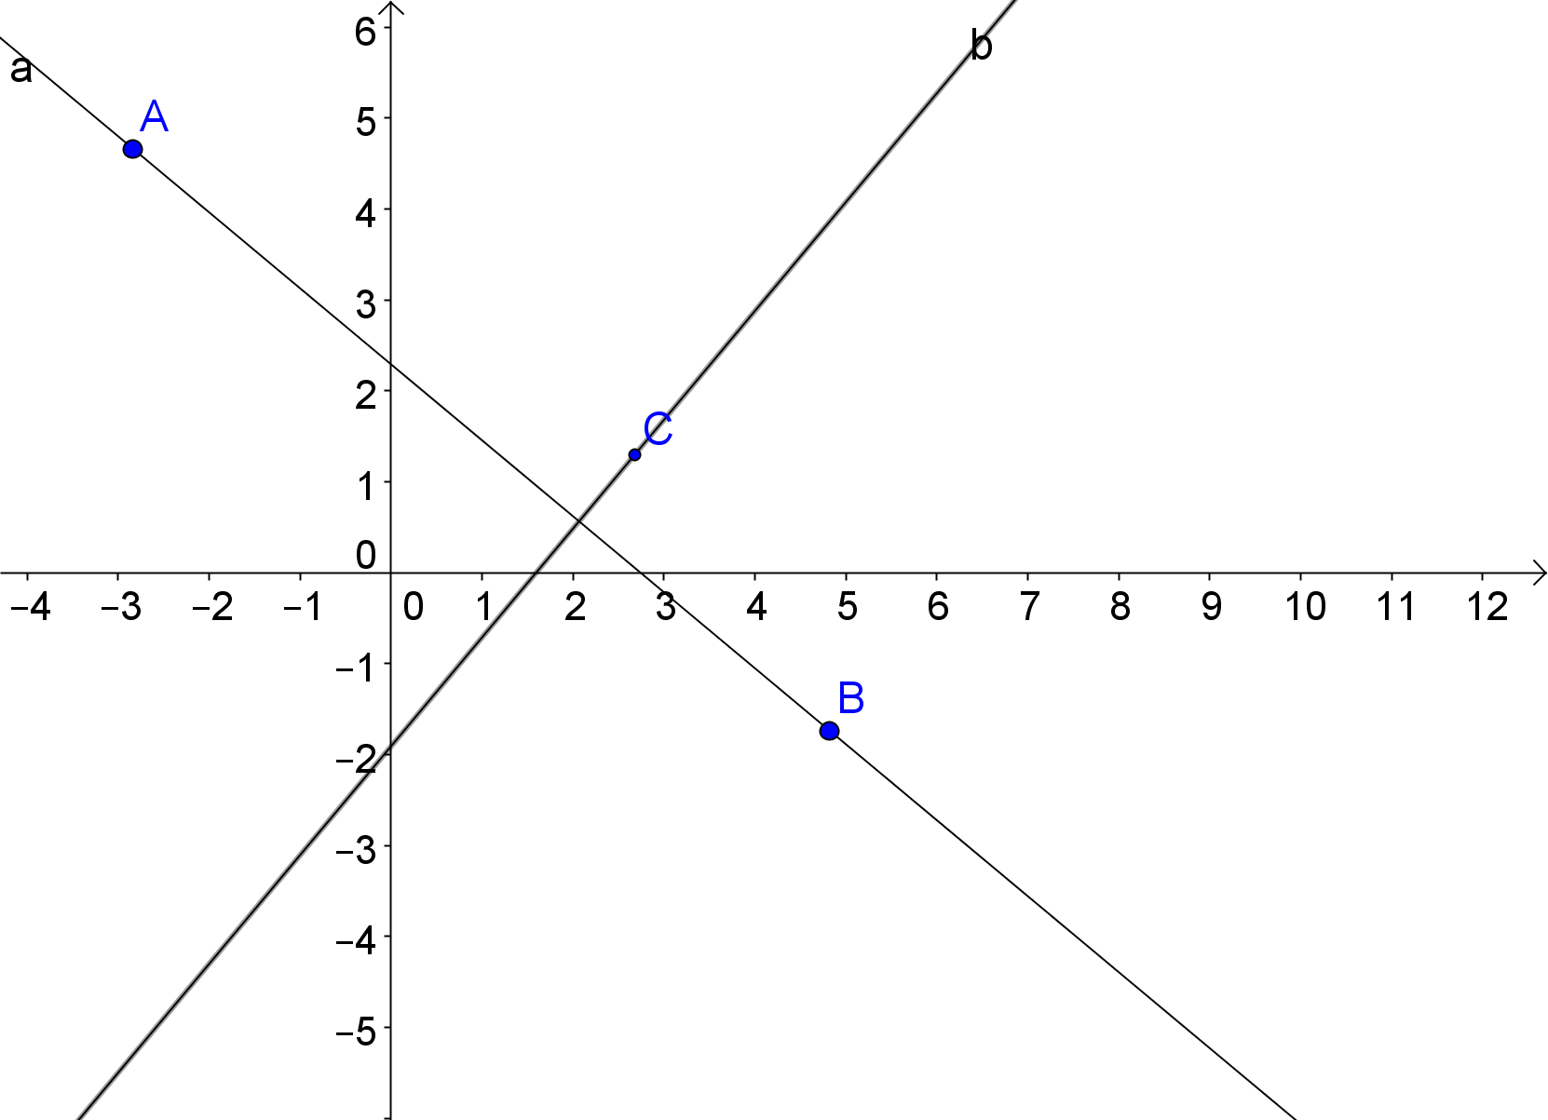
Then place a point C in the plane but not on $\overset{⃡}{AB}$.

Use Perpendicular Line tool 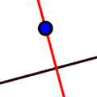 to construct a line through C that is perpendicular to $\overset{⃡}{AB}$.

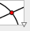
Use the Intersect tool to label the point where the two lines intersect as point D.

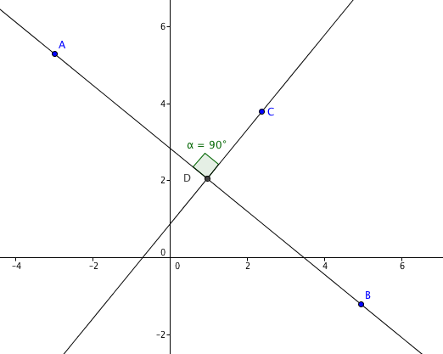
Now measure $∠CDA$. (Remember Geogebra measures in the counter-clockwise direction)

- What kind of angle is $∠CDA$?

- This should not be surprising since __________________ lines always form ___________________ angles.

We can also use coordinate geometer to show that these lines are perpendicular.
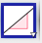

To measure the slope of each line, choose the slope tool that is found under the
Angle menu. Click on the first line, then choose slope again and click on the second line.

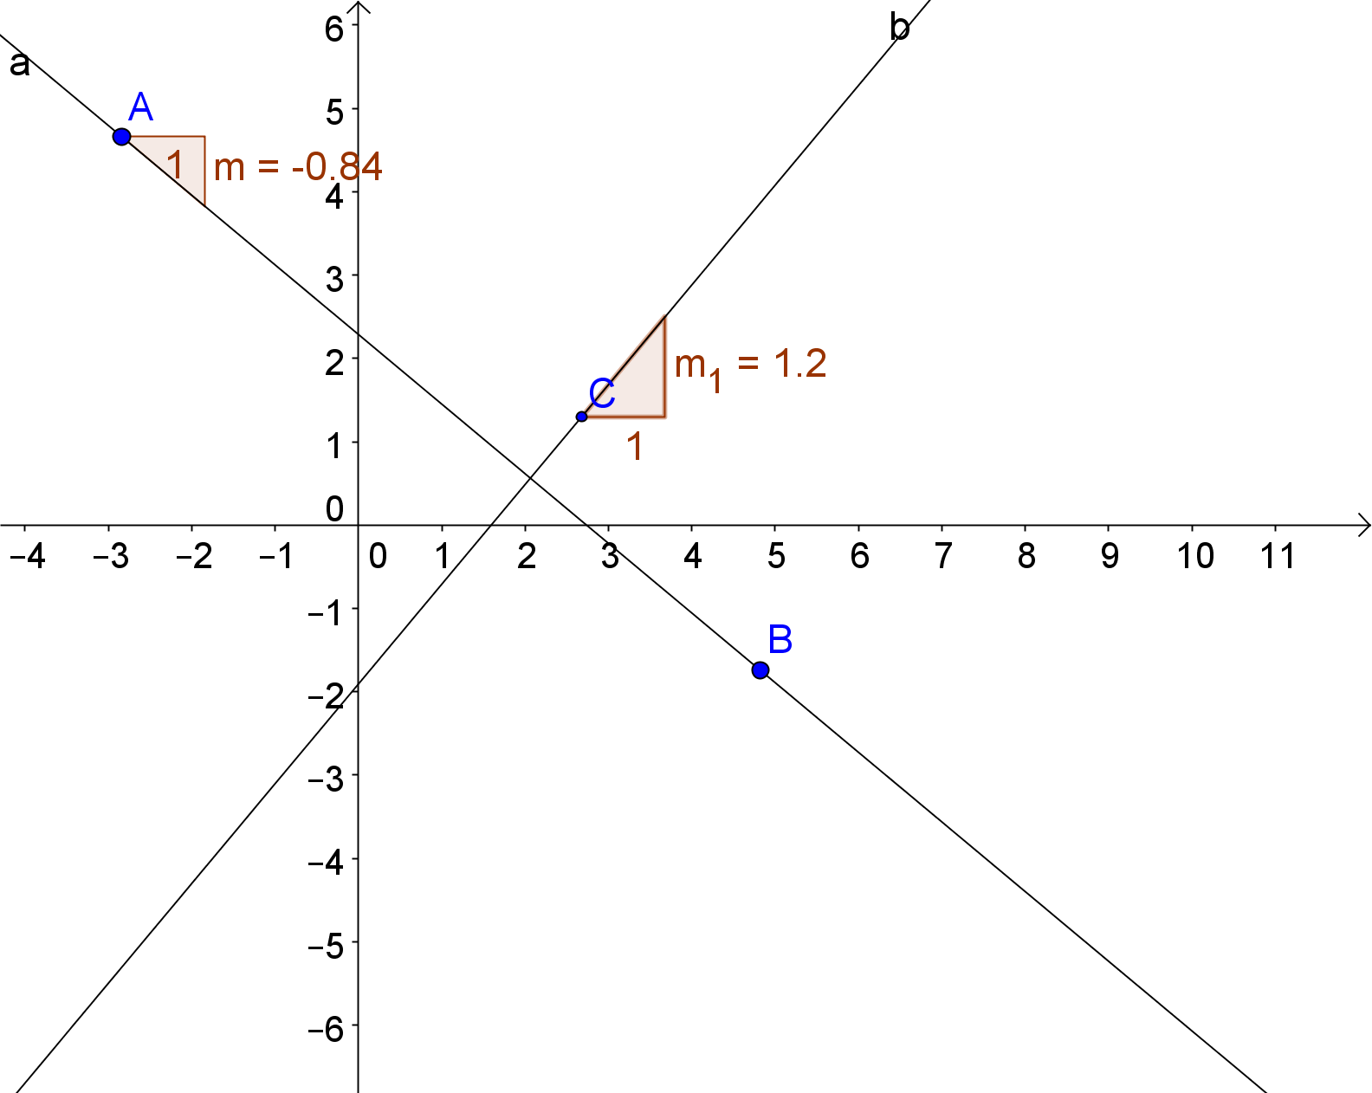

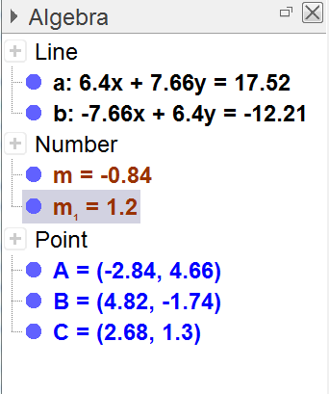

In the algebra window, the slopes appear as m and m₁

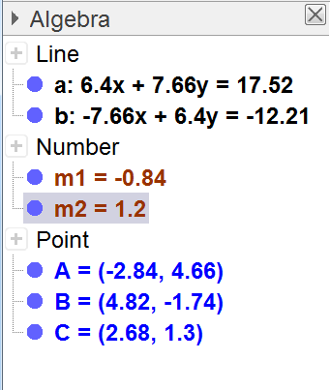
We can change the names to m1 and m2 by double clicking first on m and selecting object properties and then under basic change the name to m1. Do the same for the other line to change the label to m2.

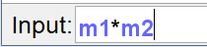
Now in the input bar type m1*m2 and hit enter

3. What value did you get for c in the algebra window? Compare with the values found by other students (who probably have different values for m₁ and m_{2.} What can you conclude?

- Move point A.
a. How does this affect the slopes of the two lines?
b. How does this affect the value of c?

5. If you had the equations of two lines, how can you determine if they are perpendicular?

