Activity 1.3.2 Measuring Angles in Geogebra

Open Geogebra. In the Graphics view, remove the coordinate axes by clicking on the icon.

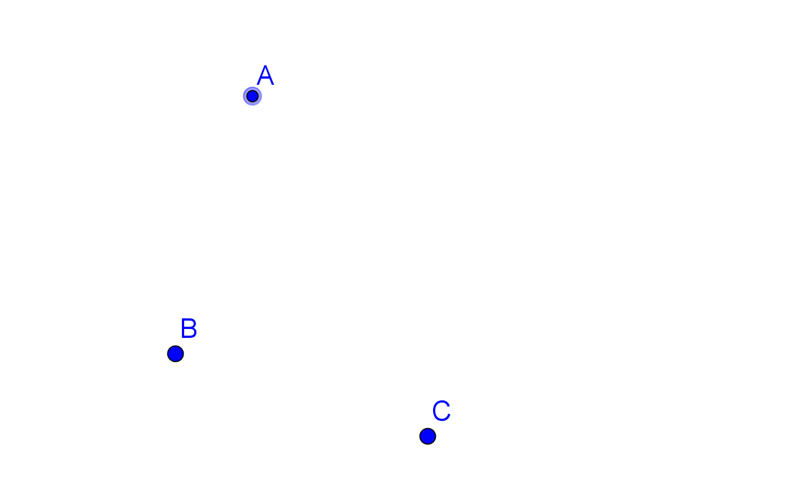
To begin, click on the POINT icon 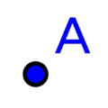 and click in graphics view to create three points.

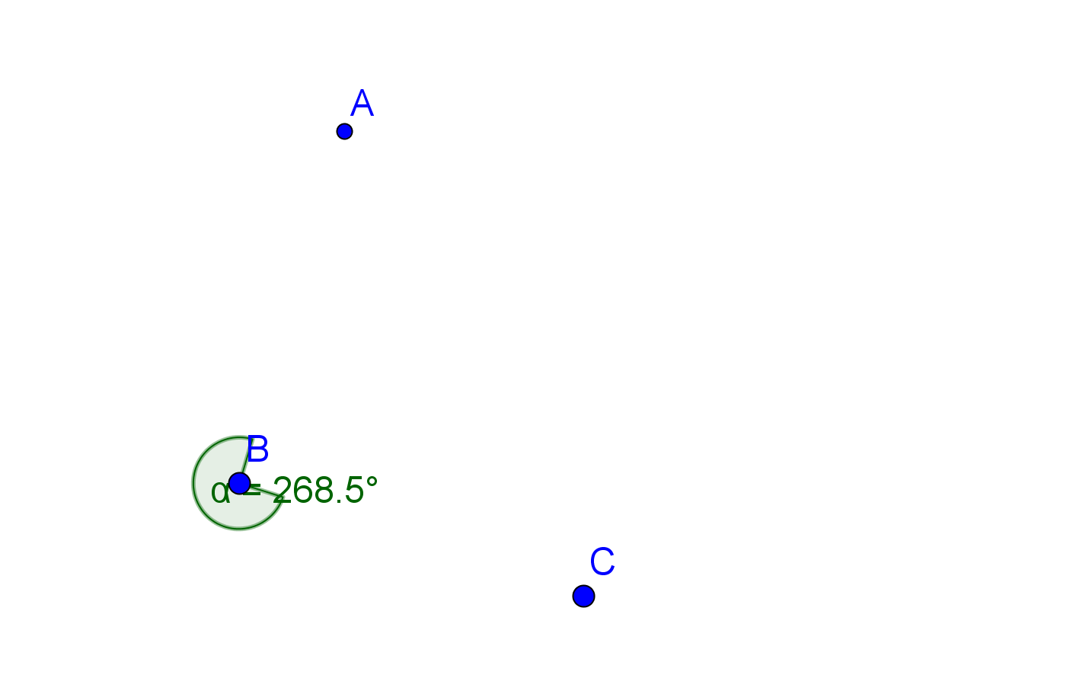

Now create an angle by clicking on the angle icon 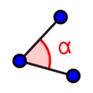 and then clicking on A, then B, then C. Geogebra will draw in an angle in green.

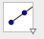
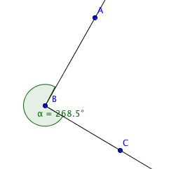
To see the angle that Geogebra just measured, use the ray tool to construct rays $\overset{⃑}{BA}$ and $\vec{BC}$. These rays are the sides of angle $∠$ABC.

Notice that in this example, the measure of $∠$ABC was 268.5°. It is important to know that Geogebra measures the counter-clockwise rotation. In this case, that is the reflex angle. If we want the obtuse angle, we need to click C, then B, then A.

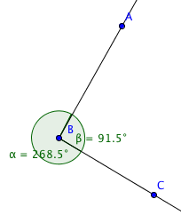
Notice that in this case, it looks like the two angles together make a circle. How many degrees are in a circle?

We can use the input bar at the bottom of the Geogebra screen to add the two angles together. To do that, notice that Geogebra named the two angles α (alpha) and β (beta). So, in input bar, select the α button all the way to the right. This allows us to enter symbols. Click α, then type in a plus sign, then click the alpha button again and this time select β. When you hit enter, you should get γ = 360° in the Algebra window. To make it more user friendly, double click on the γ in the Algebra window and then click on Object properties. In the name box, type sum and hit enter. Now in our Algebra window it will read, sum=360°

Now click on the move icon and then either point A or C and move it around.

1. What do you notice about the values for α and β?

2. What do you notice about the value for sum?

3. Now, open a new window and create three new points.

What are the coordinates of the three points you created?

A __________ B __________ C __________

4. What is the measure of the acute, right, or obtuse angle you created __________

5. What is the measure of the reflex angle you created __________

6. What is the sum of the measures of the two angles __________

7. Make a conjecture about the two measures that are associated with any angle.

8. How would you define the word “angle.”?

9. How would you define the “measure” of an angle?

