Activity 1.3.1 Examining Angles in Runways

On the next sheet of paper is a map of the JFK airport runway. The number of each runway has been replaced by a letter.
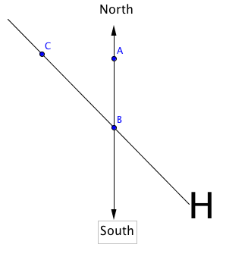
Look at Runway H. Use your ruler to draw a line segment that is parallel to the North-South line and intersects the runway. Try to be as precise as possible. Now place a point on this segment that is on the North side of the runway and label this point A. Now place a point where the North-South segment and the runway intersect and label this point B. Finally, place a point, C, on the runway on the opposite side of $\overline{AB}$ from H. Rays $\overset{⃑}{BC}$ and $\vec{BA}$ now form the angle we call $∠$ABC. See the figure at the right.

You should notice that two angles are formed . There is an acute angle (less than 90°) and a reflex angle (greater than 180° and less than 360°).

We want the angle formed by going clockwise from point A to point C. So, in this case it is the reflex angle we want. How can you use a protractor to measure this?

Now find the runway number. (Do you remember, from class discussion, how that is related to the angle measured clockwise from North? )

1. Find the runway numbers for the rest of these runways:

C ______ I ________
F ______ J ________
G ________ K________
H __32____ L ________

2. How are the numbers at the opposite ends of a runway related? Explain why this is so.

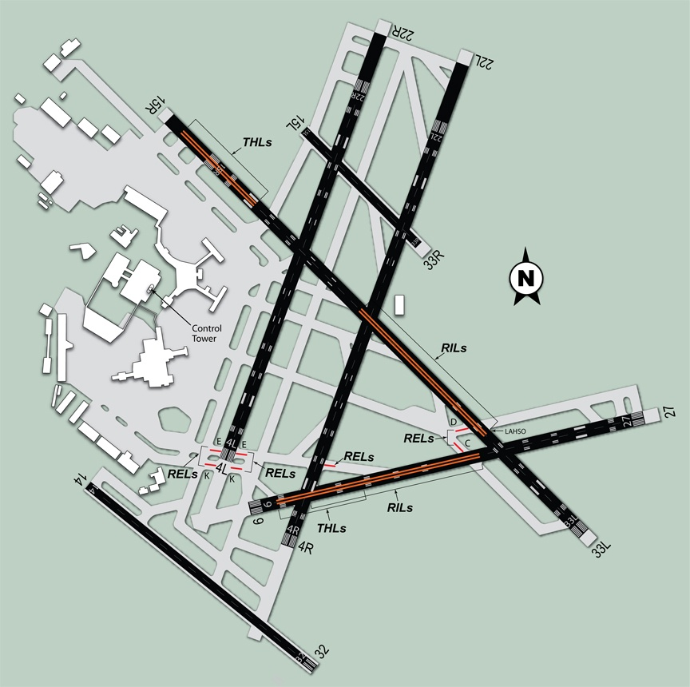
JFK Runway Map
E

L
K
J
I
H
G

F
D
C
B
A

