Activity 1.2.4 Translations Using Technology

1. Open GeoGebra and select the Algebra & Graphics view from the Perspectives menu.

2. Display the grid by selecting the Move icon and clicking the drop down arrow by Graphics as shown below.
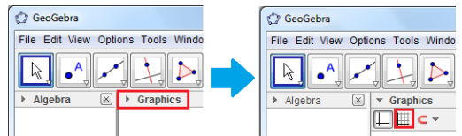

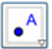  3.  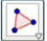 | Click the New Point tool and place the points on the coordinates given: A on (2,3), B on (4,1) and C on (5,2).
4. | Next, draw triangle ABC using the Polygon tool. To do this, click the Polygon tool and click the points in the following order: point A, point B, point C and point A again to close the polygon.
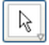  5. | To display the label and the coordinates of the points, right click the points then click Object Properties to display the Preferences dialog box.
6. In the Basic tab of the Preferences dialog box, check the Show label check box, and choose the Name & Value option in the drop-down list box, and then close the window. Your drawing should look like the figure below: (Note: If you do not turn off automatic labeling the sides may be labeled with lower case letters).
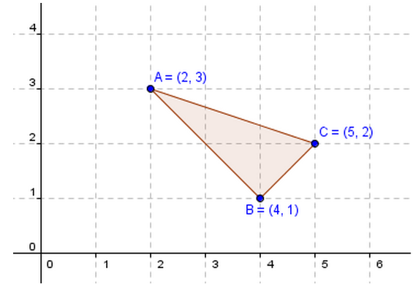

7. The only remaining part of this construction is the vector tool. To construct vector DE, select the Vector between Two Points tool by right clicking, the Line menu and selcting vector as shown below and this click the origin and click the coordinate (1,2). After this step, your drawing should look like the one shown on the graph below.

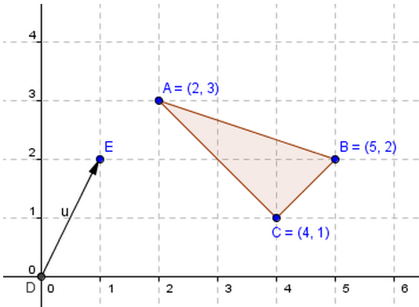
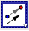  8. | To translate the object using the vector, select the Translate Object by Vector tool from the Transform menu, click on the triangle and then click on the vector. Notice that a translated triangle appears after clicking on the vector.
9. What can you say about the original triangle object and the translated triangle

10. If the coordinates of the vertices of the translated triangle are not displayed, display them using the steps we have done in step 5 and 6.

11. How are the coordinates of the vertices of the original triangle and the translated triangle related?

12. Experiment by moving any vertex of ∆ABC What happens?

13. Experiment by moving points D and E to change the vector. What happens?

14. As shown below, click on the Measure menu and select “distance or length”to measure and record the following distances:
AA'=
BB'=
CC' =

DE' (length of the vector) =

What do you notice about the segment lengths?

