Activity 1.2.2
What’s Reasonable?

Directions: Determine whether or not each of the following situations can be described by a function. Then for each situation, answer the following question.
a. If you think the situation CAN BE described by a function, define a reasonable domain and range for the function. (Note: for most of these situations there is not one “correct answer”; there may be many answers that are reasonable.)
b. If you think the situation CANNOT BE described by a function, explain why not.
(Hint: It may help you to write the equation that represents the problem.)

- Jonas just got his first after-school job and can work up to 20 hours each week. He will earn $9.25 per hour. How much money can Jonas earn each week?

Is “money earned per week” a function of “number of hours worked per week”? (yes/no)

Give a reasonable domain and range, OR describe why it is not a function.

- The band is holding a spaghetti dinner fundraiser to buy uniforms. Instead of selling tickets, they are accepting donations and have decided that every donation will receive two dinners. They can make up to 300 dinners. How many dinners will Joe receive for his donation?

Is “number of dinners received” a function of “amount of donation”? (yes/no)
Give a reasonable domain and range, OR describe why it is not a function.

- Your math teacher asks you to draw a circle on a sheet of paper that has a radius of at least 3 inches. What is the area?

Is “area of a circle” a function of “radius of the circle”? (yes/no)
Give a reasonable domain and range, OR describe why it is not a function.

- In science class you created a spreadsheet with everyone’s age and height. What is the height of someone who is 14?

Is “height at 14” a function of “age”? (yes/no)
Give a reasonable domain and range, OR describe why it is not a function.

- The principal decided to let us go to Camp Horizon for a day to get to know everyone in the freshmen class. There will be up to 85 people going (including teachers). The parking fee is $60 total for the three buses and it costs $19.00 per person to get in. How much will the trip cost?

Is “cost of the trip” a function of “number of people on the trip”? (yes/no)
Give a reasonable domain and range, OR describe why it is not a function.

- Did you see that ball Mary threw? How high do you think it went?

Is “height of ball” a function of “person who threw the ball”? (yes/no)
Give a reasonable domain and range, OR describe why it is not a function.

- Mrs. Davis is buying T-shirts for the ninth grade trip. She found a store that advertised “$12.50 per shirt; any order of more than 20 and they are all half price!” If Mrs. Davis has to buy between 50 and 110 shirts, how much will she pay for each one?

Is “cost per shirt” a function of “number of shirts purchased”? (yes/no)
Give a reasonable domain and range, OR describe why it is not a function.

- What is the width of a box that has a volume of 280cm³? The length is 4 cm and the height is 3 cm longer than the width.

Is “width of the box” a function of “height of the box”? (yes/no)
Give a reasonable domain and range, OR describe why it is not a function.

- I’m planning a 5-day bike trip across New England. If I ride from 8:00 am until 5:00 pm each day and only stop for one hour for lunch, what will my average speed be (in mph)?

Is “average speed” a function of “distance traveled”? (yes/no)
Give a reasonable domain and range, OR describe why it is not a function.

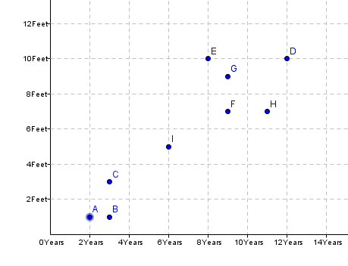
Circumference (ft)

- The graph shows the ages and circumferences of
several trees in my backyard. Predict the
circumference of a tree that is five years old.

Age (years)
Is “circumference of tree” a function of “age”? (yes/no)
Give a reasonable domain and range, OR describe why it is not a function.

- It is 73°F outside today. What is the temperature in degrees Celsius?

Is “temperature in degrees Celsius” a function of “temperature in degrees Fahrenheit”? (yes/no)?
Give a reasonable domain and range, OR describe why it is not a function.

- A-Plus Builders builds houses for $60 per square foot plus $43,500 for the land that the house is to be built on. Mr. & Mrs. Garcia can pay as much as $210,000 for their new home. What is the largest house they can afford to have built?

Is “number of square feet of a house” a function of “amount spent on the house”? (yes/no)

Give a reasonable domain and range, OR describe why it is not a function.

- It is customary to leave a 20% tip when you receive good service at a restaurant. Last night Sam’s dad took her and a few friends out. How much of a tip should he have left?

Is “amount of the tip” a function of “total amount of the bill”? (yes/no)
Give a reasonable domain and range, OR describe why it is not a function.

