Activity 1.2.2
What’s Reasonable?

Directions: Determine if each of the following examples describe a function. If so, define a reasonable domain and range for the function. (Hint: It may help you to write the equation that represents the problem.)

- Jonas just got his first afterschool job and can work up to 20 hours each week. He will earn $9.25 per hour. How much money can Jonas earn each week?

- The band is holding a spaghetti dinner fundraiser to buy uniforms. Instead of selling tickets, they are accepting donations and have decided that every donation will receive two dinners. They can make up to 300 dinners. How many dinners will Joe receive for his donation?

- Your math teacher asks you to draw a circle that has a radius of at least 3 inches. What is the area?

- In science class you created a spreadsheet with everyone’s age and height. What is the height of someone who is 14?

- The principal decided to let us go to Camp Horizon for a day to get to know everyone in the freshmen class. There will be up to 85 people going (including teachers). The parking fee is $60 total for the three buses and it costs $19.00 per person to get in. How much will the trip cost?

- Did you see that ball Mary threw? How high do you think it went?

- Mrs. Davis is buying t-shirts for the ninth grade trip. She found a store that advertised “$12.50 per shirt; any order of more than 20 and they are all half price!” If Mrs. Davis has to buy between 50 and 110 shirts, how much will she pay for each one?

- What is the width of a box that has a volume of 280cm³? The length is 4 cm and the height is 3 cm longer than the width.

- I’m planning a 5-day bike trip across New England that will be 332 miles long. If I ride from 8:00 am until 5:00 pm each day and only stop for one hour for lunch, what will my average speed be (in mph)?

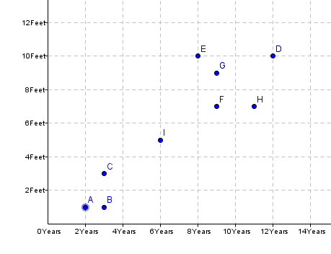
Circumference (ft)

- The graph shows the ages and circumferences of
Age (years)
several trees in my backyard. Predict the circum-
ference of a tree that is five years old.

- It is 73°F outside today. What is the temperature in degrees Celsius?

- A-Plus Builders builds houses for $60 per square foot plus 443,500 for the land that the house is to be built on. Mr. & Mrs. Garcia can pay as much as $210,000 for their new home. What is the largest house they can afford to have built?

- It is customary to leave a 20% tip when you receive good service at a restaurant. Last night Sam’s dad took her and a few friends out and the total bill was $89.46. How much of a tip should he have left?

