Module 5  Facilitator Guide | Focus on Sustaining Change

Introductory Activity

Connecticut Core Standards for Mathematics

Grades 6–12

Systems of Professional Learning

Connecticut Core Standards Systems of Professional Learning
The material in this guide was developed by Public Consulting Group in collaboration with staff from the Connecticut State Department of Education and the RESC Alliance. The development team would like to specifically thank Ellen Cohn, Charlene Tate Nichols, and Jennifer Webb from the Connecticut State Department of Education; Leslie Abbatiello from ACES; and Robb Geier, Elizabeth O’Toole, and Cheryl Liebling from Public Consulting Group.
The Systems of Professional Learning project includes a series of professional learning experiences for Connecticut Core Standards District Coaches in English Language Arts, Mathematics, Humanities, Science, Technology, Engineering, Mathematics (STEM), and Student/Educator Support Staff (SESS).
Participants will have continued support for the implementation of the new standards through virtual networking opportunities and online resources to support the training of educators throughout the state of Connecticut.
Instrumental in the design and development of the Systems of Professional Learning materials from PCG were: Sharon DeCarlo, Debra Berlin, Jennifer McGregor, Judy Buck, Michelle Wade, Nora Kelley, Diane Stump, and Melissa Pierce.

Published 2014. Available online at http://ctcorestandards.org/

Session at-a-Glance

Introductory Activity (20 minutes)
The facilitator will review project goals and activities, module outcomes, and the agenda for the session. Participants will complete a short self-assessment, which can be found in the Participant Guide on page 4. They will rate themselves on a scale of 1-4, depending on their knowledge or feelings about implementing the CCS-Math. Participants will complete the same assessment at the end of the session. Allow 3–4 minutes to complete.
Participants will then take part in an activity where they create a “Consensogram” chart for each of the six questions on the Pre-Assessment. After the Consensogram charts are completed, participants are asked to comment about what they see.

Supporting Documents:
Session Agenda
Pre-Assessment

Materials:
Chart paper, markers, sticky notes

PowerPoint Slides:
1–7

Session Implementation
Module 5 – Introductory Activity
Slide 1
(Slides 1–7, including the Pre-Assessment, will take about 10 minutes total.)
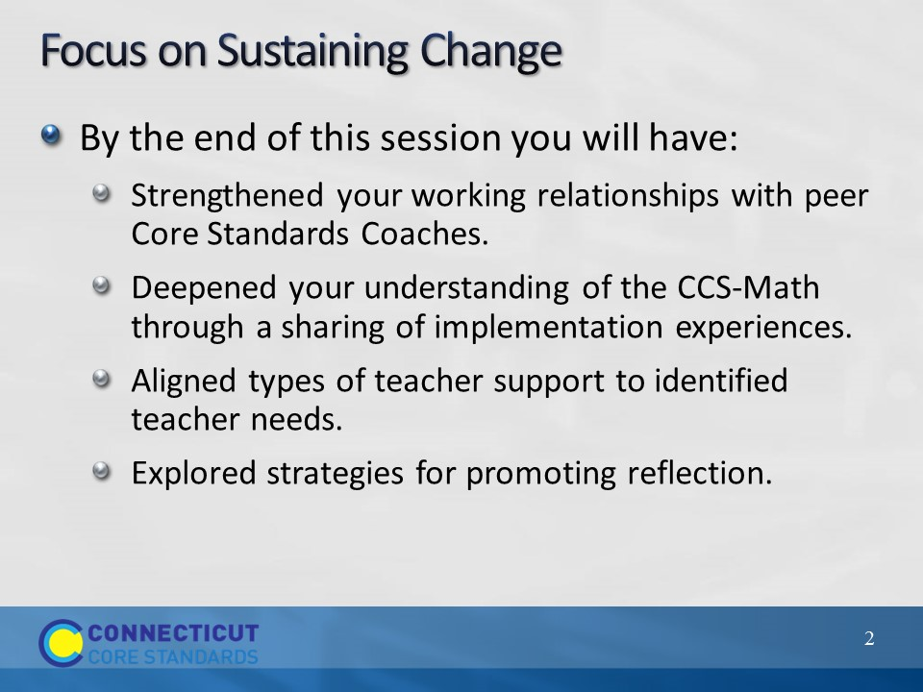Slide 2
Review the outcomes for the day, sharing what you hope to accomplish throughout the full day session. There are seven outcomes for this session. These are presented to the participants over two slides.
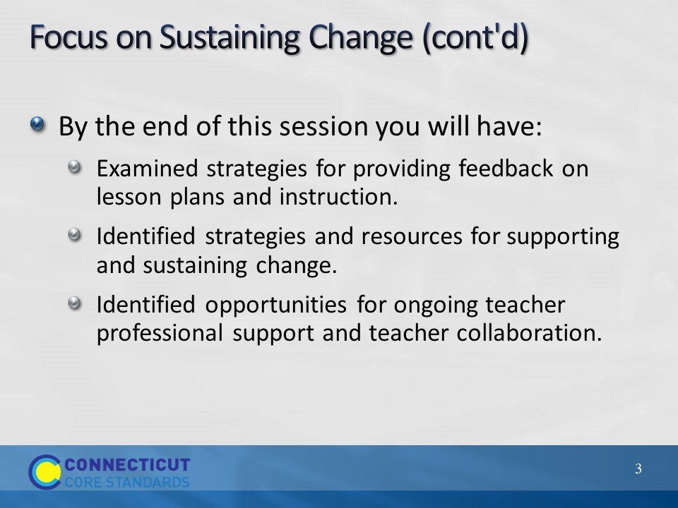Slide 3
Blank.
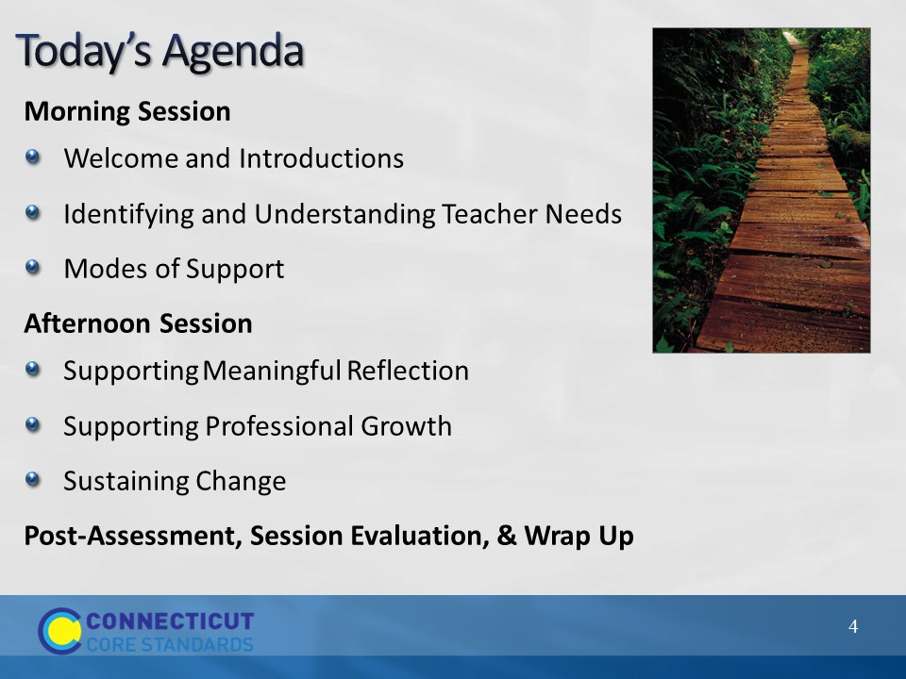Slide 4
Review the agenda letting participants know that this is the pathway they will travel in order to accomplish the seven outcomes discussed earlier. Note that in addition to the break for lunch, there will also be short breaks throughout the day, but participants should feel free to take a personal break as needed. Emphasize the importance of coming back from lunch and breaks on time to ensure enough time to complete all the work of the day.
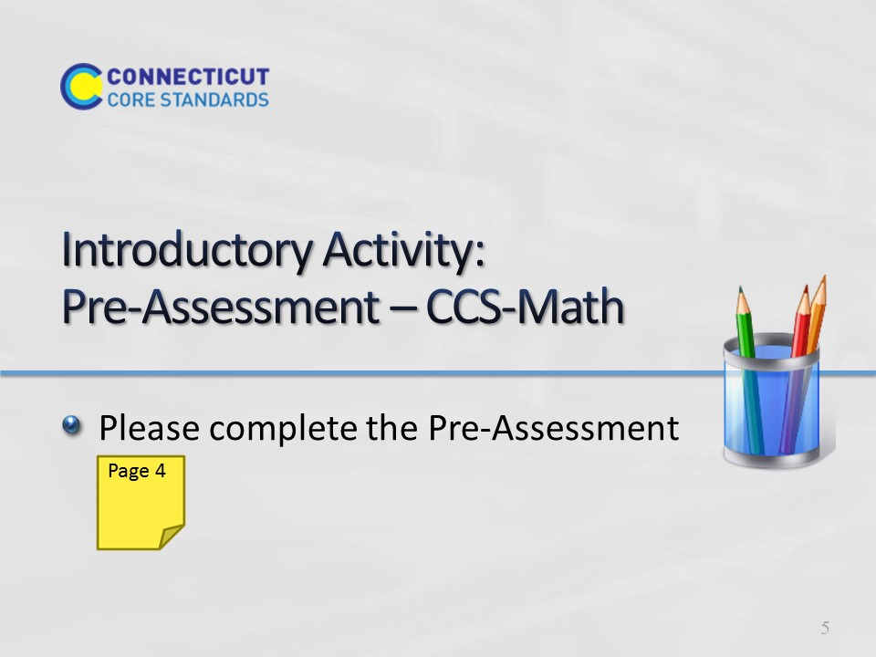Slide 5
Participants will complete a short self-assessment, which can be found in the Participant Guide on page 4. They will rate themselves on a scale of 1-4 , depending on their knowledge or feelings about implementing the CCS-Math. Participants will complete the same assessment at the end of the session. Allow 3–4 minutes to complete.
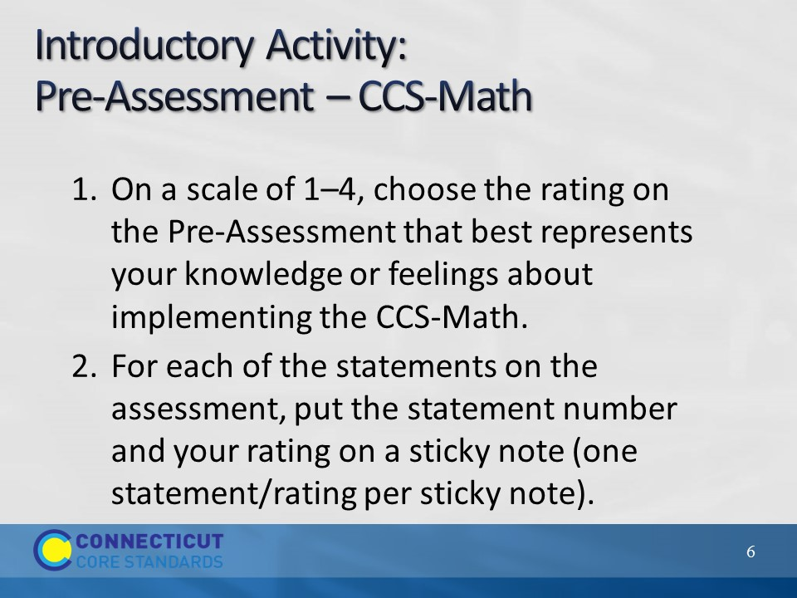Slide 6
Facilitator: Hang up 6 pieces of chart paper around the room. Label the top of each chart paper with Statement 1, or Statement 2, etc. Then add the number scale 4, 3, 2, 1 at the bottom (see example on next slide). Direct participants to place their ratings for Statements 1-6 on six individual sticky notes (they should also write the Statement number on each sticky). Choose one participant to collect all of the sticky notes for Statement 1 and another participant to collect sticky notes for Statement 2 and so forth until all of the sticky notes are collected. Now the collector can create a Consensogram for their Statement using the stickies. Sticky notes should be placed one above the other to create a bar graph.
Introductory Activity: 20 minutes total
Materials:
Pre-Assessment on Page 4 of Participant Guide
Sticky notes
Chart Paper
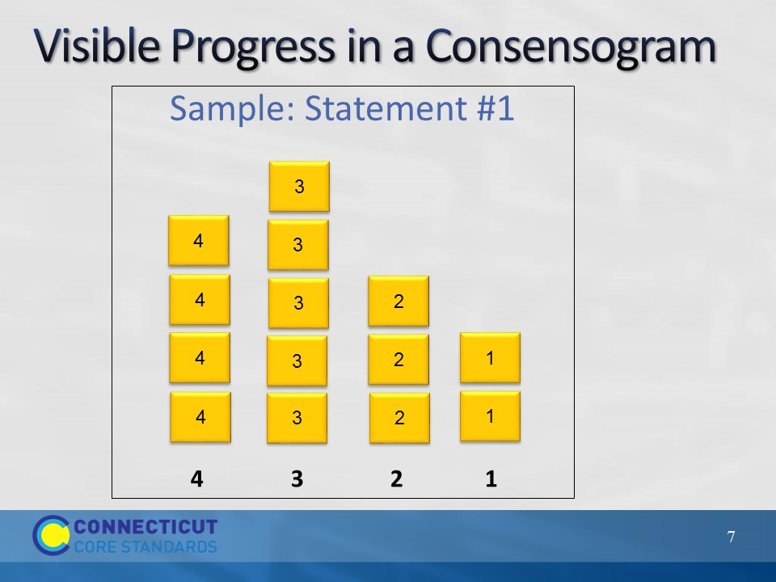Slide 7
A Consensogram chart should be created for each of the six statements. After the Consensogram charts are completed, either comment upon what you see, or invite participants to do so.

