Module 5  Facilitator Guide | Focus on Sustaining Change

Section 1

Connecticut Core Standards for Mathematics

Grades 6–12

Systems of Professional Learning

Connecticut Core Standards Systems of Professional Learning
The material in this guide was developed by Public Consulting Group in collaboration with staff from the Connecticut State Department of Education and the RESC Alliance. The development team would like to specifically thank Ellen Cohn, Charlene Tate Nichols, and Jennifer Webb from the Connecticut State Department of Education; Leslie Abbatiello from ACES; and Robb Geier, Elizabeth O’Toole, and Cheryl Liebling from Public Consulting Group.
The Systems of Professional Learning project includes a series of professional learning experiences for Connecticut Core Standards District Coaches in English Language Arts, Mathematics, Humanities, Science, Technology, Engineering, Mathematics (STEM), and Student/Educator Support Staff (SESS).
Participants will have continued support for the implementation of the new standards through virtual networking opportunities and online resources to support the training of educators throughout the state of Connecticut.
Instrumental in the design and development of the Systems of Professional Learning materials from PCG were: Sharon DeCarlo, Debra Berlin, Jennifer McGregor, Judy Buck, Michelle Wade, Nora Kelley, Diane Stump, and Melissa Pierce.

Published 2014. Available online at http://ctcorestandards.org/

Session at-a-Glance

Section 1: Identifying and Understanding Teacher Needs (80 minutes)

Training Objectives:
To reflect on the change process.
To identify teacher needs around the key ideas from Modules 1‒4.
To understand what is required for meeting the identified teacher needs.
Section 1 begins with the facilitator summarizing the key ideas from Modules 1‒4 and then having participants describe their vision of the teaching and learning taking place in a mathematics classroom that incorporates all of these key ideas. After volunteers share, the facilitator will explain that Module 5 is about bringing all of those key ideas together and making a plan for helping all teachers grow in their implementation of the CCS-Math. Participants are then asked to try to determine where they think teachers in their school are with making the overall change of teaching and learning with the CCS-Math. Participants will work in small groups to determine what teachers need based on the answers they have provided.

Supporting Documents:
Summary Statements
Stages of Change
Implementation Plan Template

Materials:
Chart paper, markers, sticky notes

PowerPoint Slides:
8-24

Session Implementation
Section 1
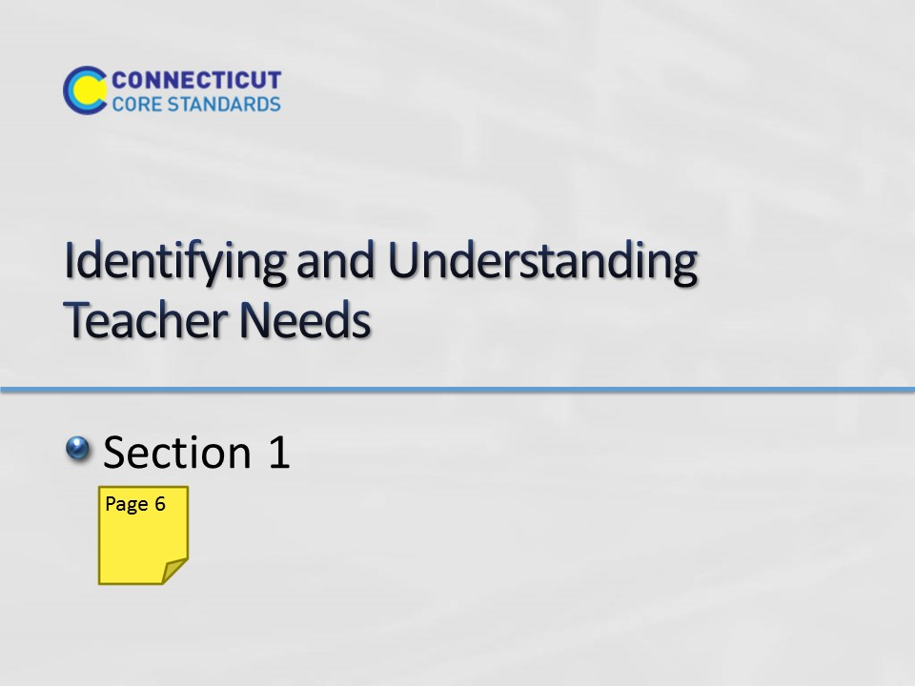Slide 8
Section 1: Identifying and Understanding Teacher Needs
Section 1 Time: 80 minutes

Section 1 Training Objectives:
- To reflect on the change process.
- To identify teacher needs around the key ideas from Modules 1‒4.
- To understand what is required for meeting the identified teacher needs.

Section 1 Outline:
- (15 minutes) Section 1 begins with the facilitator summarizing the key ideas from Modules 1‒4 and then having participants describe their vision of the teaching and learning taking place in a mathematics classroom that incorporates all of these key ideas.
- (5 minutes) After volunteers share, the facilitator will explain that Module 5 is about bringing all of those key ideas together and making a plan for helping all teachers grow in their implementation of the CCS-Math.
- (5 minutes) Participants are then asked to review the change process discussed in Module 1 and try to determine where they think teachers in their school are with making the overall change of teaching and learning with the CCS-Math.
- (20 minutes) Each of the following features of Modules 1-4 will then be addressed to determine where teachers are in the change process and what, specifically, teachers need in order to move to the next level. Features to be addressed include:
Understanding the Standards
Structure of the Standards
Importance of the Practice Standards
Content Knowledge
Instructional Practices
Designing CCS-Math Learning
To address each of the above and to make the determinations of where teachers are and what they need, participants will use the information collected on the questions generated at the end of Module 4 to describe where the teachers at their school are in terms of their knowledge and/or implementation of a specific feature and be asked to answer questions to assist in guiding their thinking. Participants enter their answers into the appropriate space on the Implementation Plan template. Note: This template will continue to be revisited through the module as new information and strategies are discussed.
- (20 minutes) After participants have answered all of the questions, they will work in small groups to determine what teachers need based on the answers they have provided. For example, if teachers do not understand the idea and importance of unit or chapter planning, what needs to happen? A possible answer may include something like: Teachers need to understand how the Standards were written and developed so as to not be broken into those ‘grain size’ pieces, but to develop the bigger mathematical understanding. There is space within the template for participants to consider how this need will be met, however, it is not expected that they will answer this question in Section 1, as Sections 2‒4 are designed to provide additional strategies and suggestions that would be helpful.
- (15 minutes) Section 1 wraps up with volunteers sharing some of the needs that they have identified and with the facilitator explaining that in Sections 2‒4 participants will focus on strategies that can be implemented to help coaches meet a majority of their teachers’ needs.

Section 1 Supporting Documents
Summary Statements
Stages of Change
Implementation Plan Template

Section 1 Materials
Chart paper
Markers
Sticky Notes
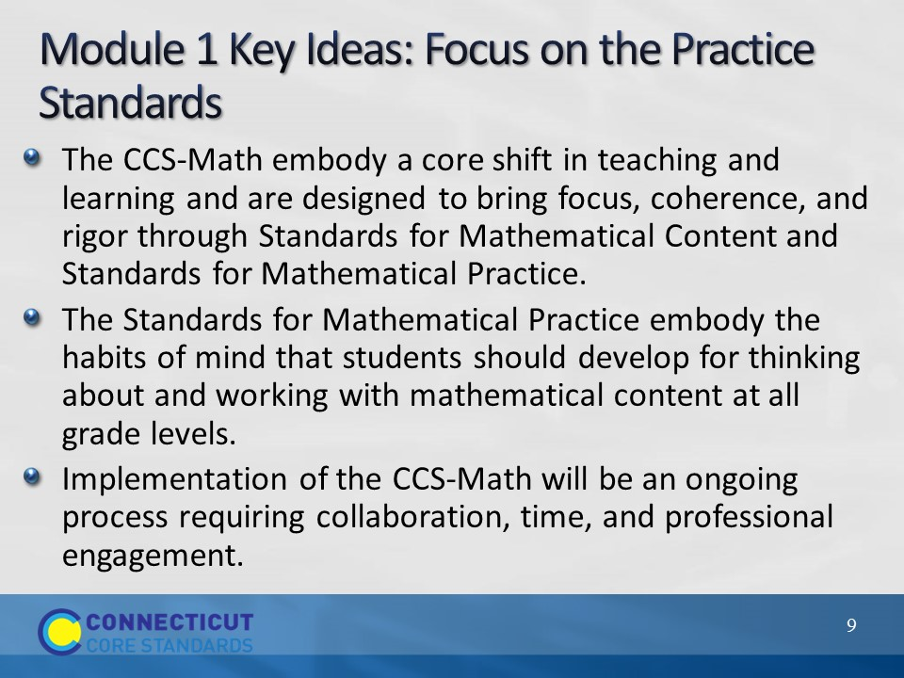Slide 9
Module 1 Key Ideas
Begin this section by explaining to participants that one of the main goals of this module is to bring all of the information presented in Modules 1-4 together into one cohesive, realistic plan for providing teachers support as they move forward in their CCS-Math implementation. To get started, focus everyone’s attention on the key ideas/messages from Module 1 and explain each further using the following notes:
- Bullet 1: Remind participants that in Module 1 they looked at the three shifts of focus, coherence, and rigor and they looked at how each of the shifts manifest themselves in the CCS-Math.
- Bullet 2: After looking at the three shifts, the remainder of the day focused on understanding the Standards for Mathematical Practice during which time they created ‘I Can’ statements for each of the practices and examined Practice 1, Make sense of problems and persevere in solving them, and Practice 2, Attend to precision, in more depth.
- Bullet 3: Module 1 wrapped up with participants beginning to examine strategies for making changes to instructional practice through discourse, collaboration, and use of multiple representations and how coaches could bring those strategies back to the teachers at their school.
Before moving to the next slide, ask participants to take a moment to reflect on Module 1 and to write, in their Participant Guide, a summary statement about Module 1 that depicts what they want to see in their own classroom and in their school when everyone is effectively addressing the Standards for Mathematical Practice. If participants have difficulty with this, provide the example of ‘Teachers are providing students with opportunities to solve challenging mathematics tasks and students are able to persevere in solving those tasks through thinking critically and flexibly about the mathematics they are being taught.’ After participants have completed their summary statement, move on to the summary of Module 2.
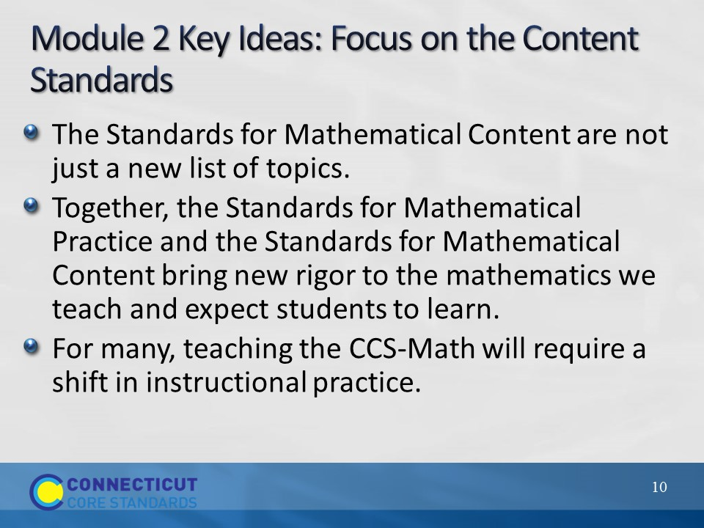Slide 10
Module 2 Key Ideas
Focus participants’ attention on the key ideas/messages from Module 2. Remind participants that in Module 2 they:
- Bullet 1: Began to look at the progression of the mathematics across and within each grade level as they examined the shift of coherence in more detail.
- Bullet 2: Looked at how rigorous mathematics tasks can bring together the Content and Practice Standards into meaningful, rich learning experiences for all students.
- Bullet 3: Examined strategies (Open Questions, Parallel Tasks) for providing multiple entry points into the mathematics so that all students benefit from the focus and rigor of the CCS-Math.
Pause now and allow participants to create their summary statement for Module 2. Then, move on to the summary for Module 3 on the next slide.
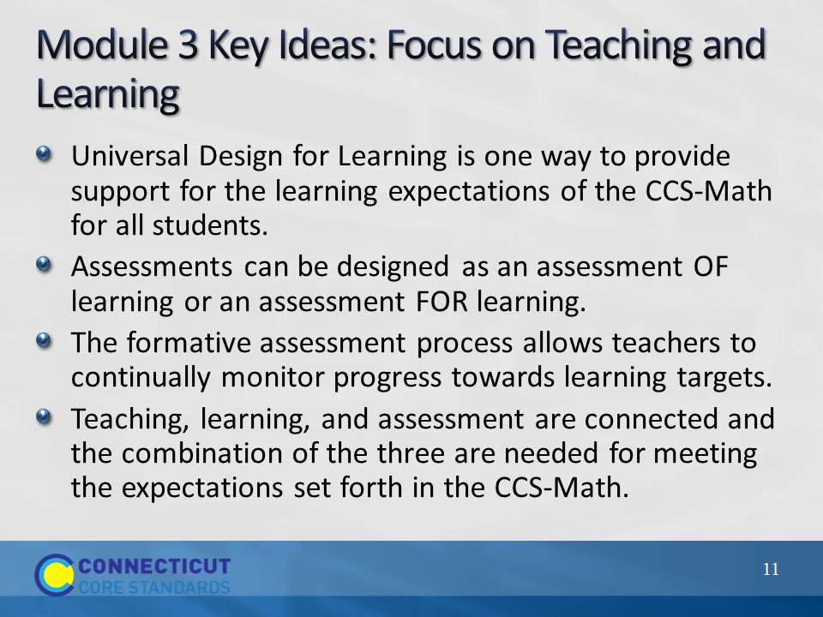Slide 11
Module 3 Key Ideas
Focus participants on the four key ideas/messages for Module 3 on the slide and provide the following additional details. Remind participants that in Module 3 they:
- Bullet 1: Examined Universal Design for Learning and the three UDL principles as another resource/option for strategies for providing multiple entry points and meeting the needs of all students.
- Bullet 2: Discussed assessment for learning and assessment of learning and the information that can be gained through each assessment type.
- Bullet 3: Focused on a process for addressing the important elements of formative assessment and how formative assessment can provide valuable information on, and a way to measure, students’ progress towards meeting learning targets.
- Bullet 4: Finally, Module 3 wrapped up with a discussion on helping teachers to understand how teaching, learning, and assessment are connected and the combination of the three are needed for meeting the expectations set forth in the CCS-Math.
Have participants quickly write their summary statement for Module 3 and then move directly on to the Module 4 summary on the next slide.
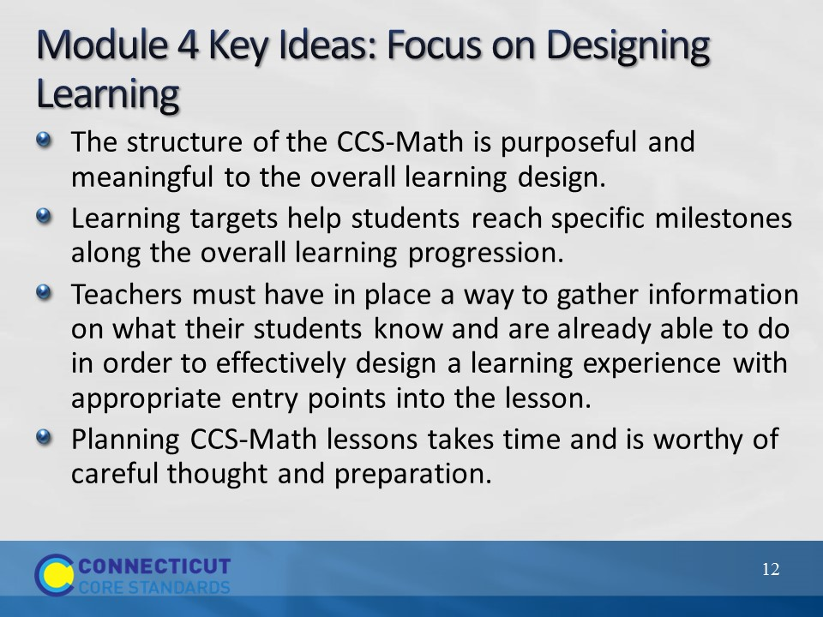Slide 12
Module 4 Key Ideas
Finally, ask participants to focus on the key ideas/messages from Module 4. Remind participants that in Module 4 they:
- Bullet 1: Examined, in depth, the structure of the CCS-Math and focused on the point that there is coherence among the domains, cluster headings, and individual standard statements. This coherence is central to determining how the mathematics is presented to students, because even though learning is presented at the lesson level, the unit level understandings are the main overarching goal. Each individual lesson should be thought of as a means to reach the unit level goal. The ‘unit level’ goal is important because the mathematics of the CCS-Math is developed on a learning progression.
- Bullet 2: Put the ideas from Bullet 1 into practice when they created their own learning targets.
- Bullet 3: Knowing that the mathematics develops along a learning progression, it is extremely important for teachers to be able to determine where their students are with prior learning in order to design their learning so that it starts at an appropriate entry point.
- Bullet 4: Examined questions to ask themselves as they began to plan lessons around specific learning targets, all the while keeping in mind the unit level goals.
Ask participants to complete their summary statement for Module 4 and then move on to the next slide where they will bring all of this information together into one coherent vision for mathematics in their own classroom and in their school.
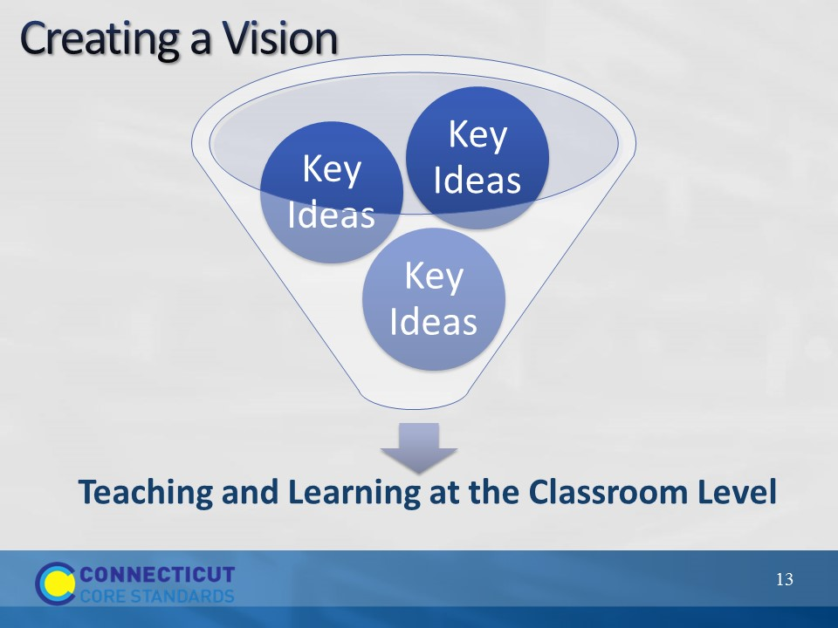Slide 13
Creating a Vision
Ask participants to now look at all four of the summary statements that they just created and, in the space provided in the Participant Guide, describe their overall vision for teaching and learning at the classroom level when the CCS-Math are effectively being implemented. Additional questions that can be asked to guide their thinking include: What are teachers doing? What are students doing? What does the mathematics work look like, sound like, and ignite thinking around? As participants think about these questions, prompt them to think about each question in the context of understanding the standards, content knowledge, instructional practice, and designing CCS-Math learning as these are the contextual areas that they will begin to work with throughout this section. After participants have described their vision in writing, ask for volunteers to share their vision either with the whole group or with others at their table. If there is time, briefly discuss commonalities of everyone’s vision before moving on to the focus of Module 5.
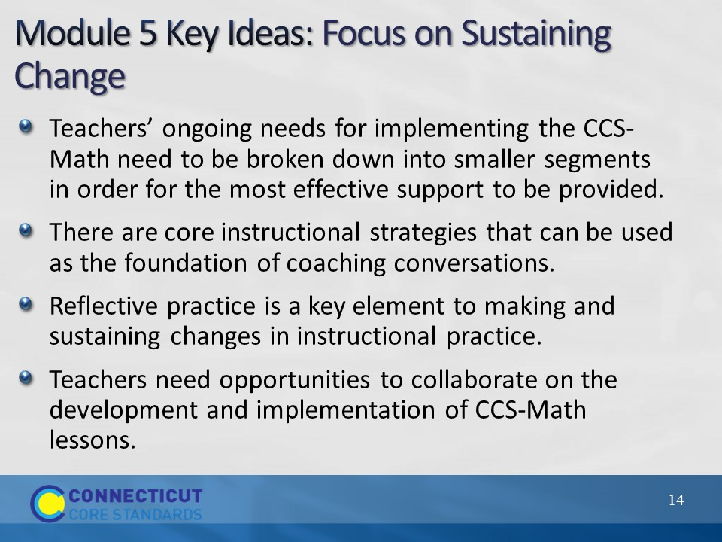Slide 14
Module 5 Key Ideas
Now focus participants’ attention on the key ideas/messages for Module 5. As participants review each bullet, explain that core to these is the idea that everyone in the school will need ongoing support as their implementation of the CCS-Math evolves and what we want to accomplish in this module is to provide resources, strategies, and ideas for providing that support in ways that address not only teachers’ needs but, also within the constraints of their own classroom and coaching duties. Because all participants are at different places with their coaching position duties (i.e. some are still classroom teachers, some are out of the classroom, etc.), as the module proceeds throughout the day they will be presented with strategies of varying complexity that require more or less time than another. This variety is in place so that each participant can take ideas and resources away that meet their current coaching constraints, but are also leaving with ideas that they can modify to fit their current duties and share with others or use when and if their duties change. Now, with that understanding, move on to reexamining the Stages of Change that was initially introduced in Module 1.
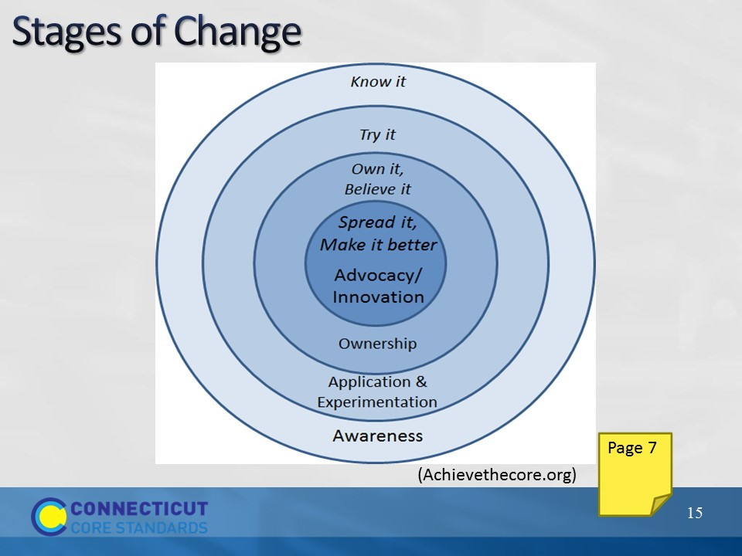Slide 15
Stages of Change
Remind participants that in Module 1 they reviewed the Stages of Change and thought about where the teachers at their school were during the beginning stages of their CCS-Math implementation. Now, review each stage again and then ask participants to reflect, in the space provided in the Participant Guide, on where they think the teachers in their school are now with their CCS-Math implementation. Have them think about everything that they have seen at their school and everything that they have learned during Modules 1-4, and their vision of teaching and learning at the classroom level that they just described.
Review the stages as follows:
Stage 1 is Awareness – simply knowing what is being asked and what it means
Stage 2 is Application and Experimentation – ‘Getting your toes wet’, trying out new strategies and perspectives
Stage 3 is Ownership – That’s the moment you get buy-in; you believe in the change and take it on personally
Stage 4 is Advocacy and Innovation – This is the point where you are proficient and can help others and make improvements in the work itself.

After participants have made their overall determination of where the teachers at their school are with their CCS-Math implementation, explain that they will now build off of this as they drill down into specific areas of a CCS-Math implementation.
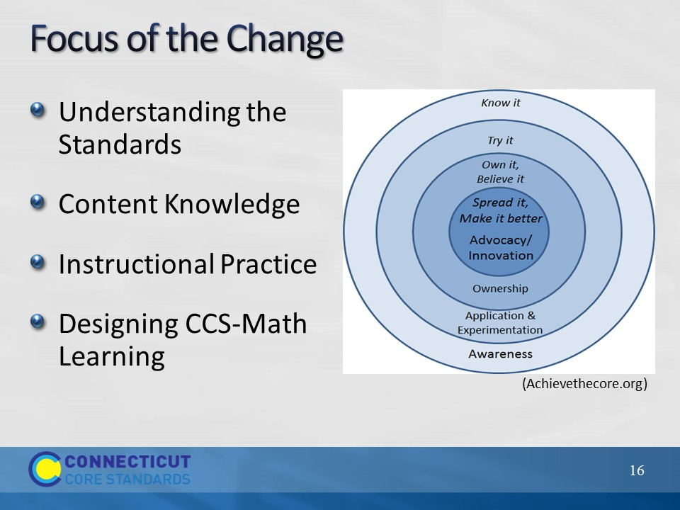Slide 16
Focus of the Change
For this next part, participants will need to access the answers to the questions that they sought out in their school after Module 4. Ask participants to get these out and then explain that they are going to reflect on where the teachers at their school are in terms of understanding the standards, their content knowledge, their instructional practice, and designing CCS-Math learning. Also explain that they will use the implementation plan found in the Participant Guide to record their thoughts. There are several parts to the implementation plan and they will complete each part as directed. For now, they will focus only on the column that answers the question ‘Where are teachers now?’ for each element that will be discussed. When everyone is ready, move on to the next slide to discuss the first element: Understanding the Standards.
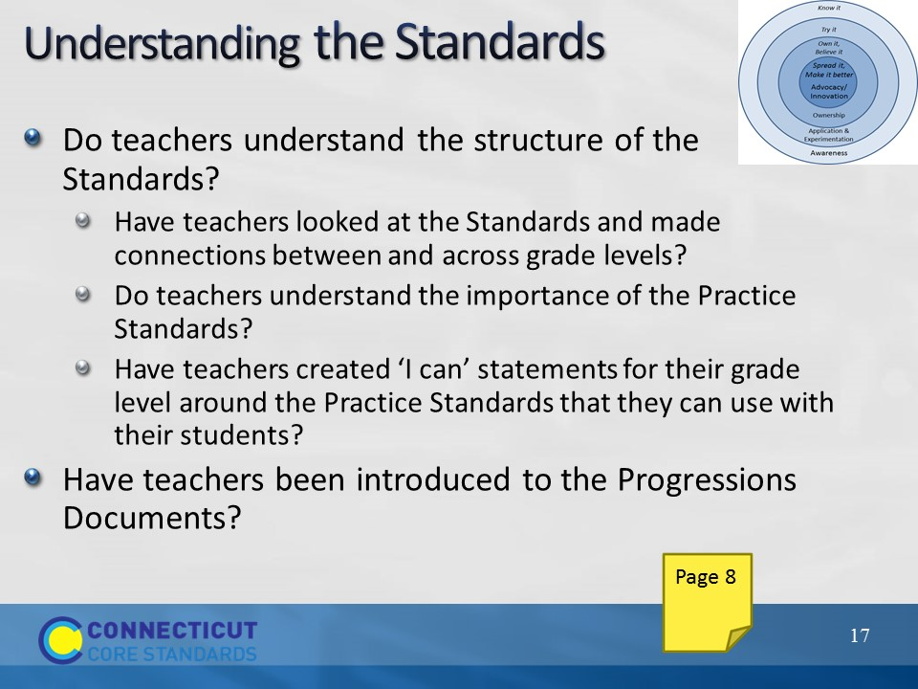Slide 17
Understanding the Standards
Remind participants that all teachers must have a clear understanding of the structure of the Standards and that this understanding must go deeper than simply knowing how to read the Standards. To determine where teachers are now with their understanding of the Standards have participants use the questions on the slide as a guide to make that determination, and then, later, they can also use those questions to determine what teachers need. As participants get ready to reflect on the teachers at their school, explain that the questions on the slide are also in their Participant Guide, and should be thought of in terms of a starting point, not a comprehensive list of questions that they should ask themselves. The questions that they use during their reflection may need to be different, based on where their teachers are and where their whole school is with their CCS-Math implementation. One question that may come up from participants during this work is ‘what if I don’t know where teachers are?’ and this is fine. Explain to participants that if they do not know, make a note of this as it is something that they will want to explore further back at their school. Allow approximately 5 minutes for participants to reflect on Understanding the Standards, and then move on to Content Knowledge. If someone does not finish within the 5 minutes, let them know that they can revisit this throughout the day. Note: Remind participants that they are only addressing where they are now, not all parts of the graphic organizer. The remaining sections will be completed throughout the remainder of the module.
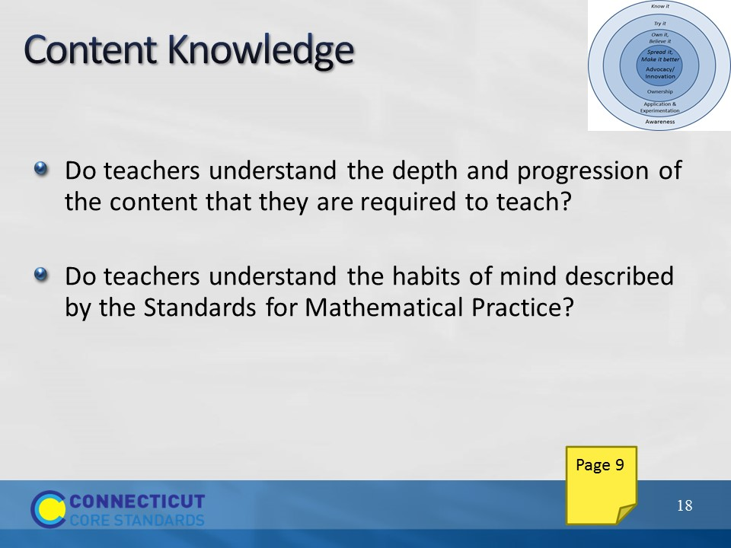Slide 18
Content Knowledge
Have participants reflect on where the teachers in their school are with the knowledge of the mathematics content and the Practice Standards of the CCS-Math. Allow 5 minutes for this reflection and then move on to Instructional Practice.
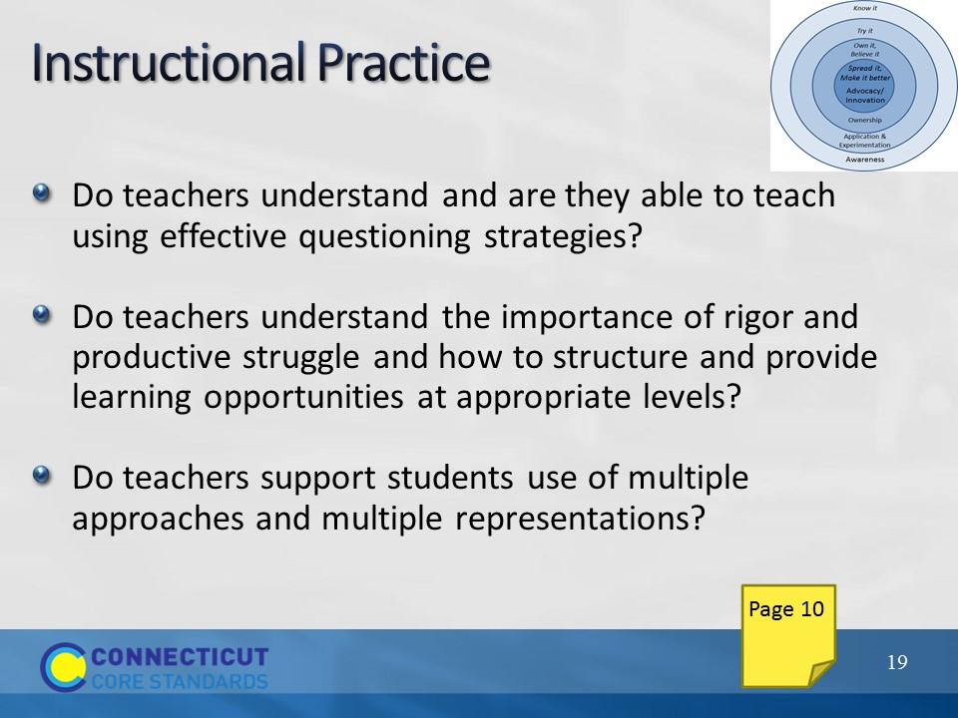Slide 19
Instructional Practice
Have participants reflect on where the teachers in their school are with the instructional practices needed to implement the CCS-Math using the questions here and on the following slide as a guide.
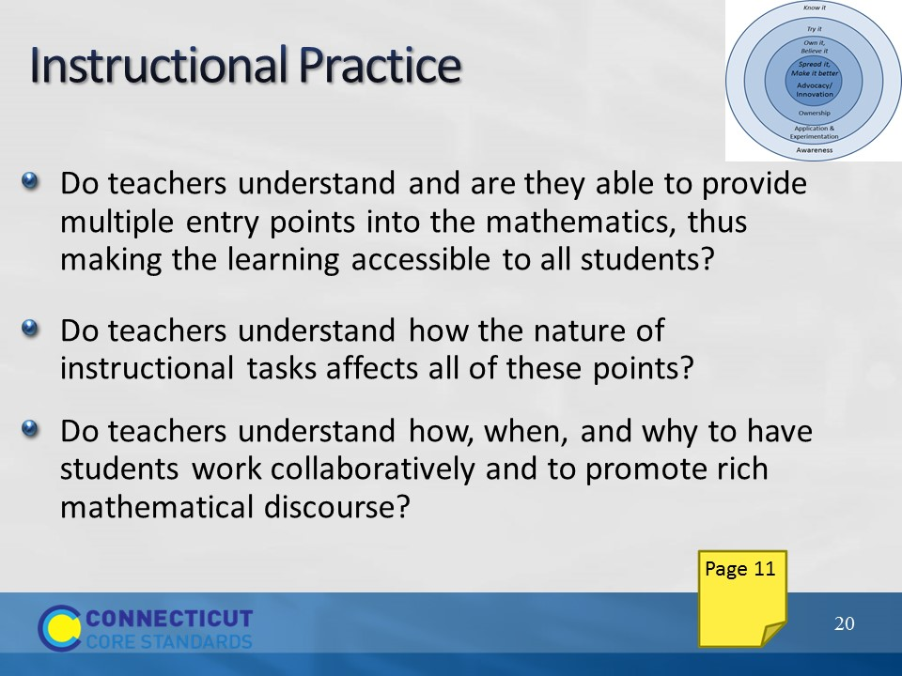Slide 20
Instructional Practices
Allow 5 minutes for this reflection and then move on to Designing CCS-Math Learning.
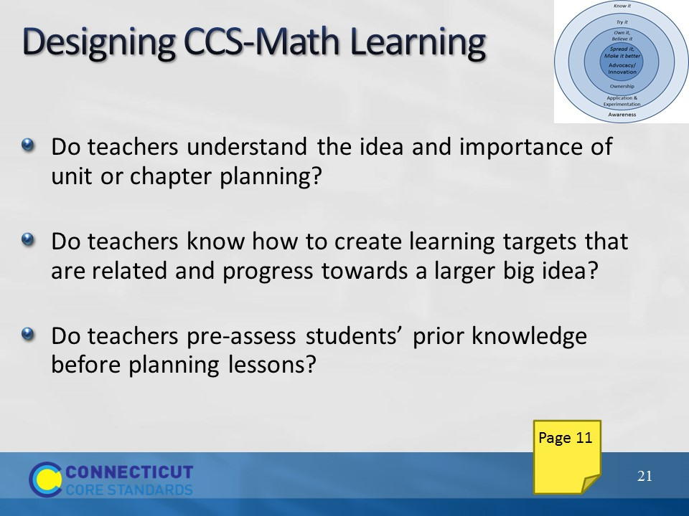Slide 21
Designing CCS-Math Learning
Have participants reflect on where the teachers in their school are with designing CCS-Math learning using the questions here and on the following slide as a guide.
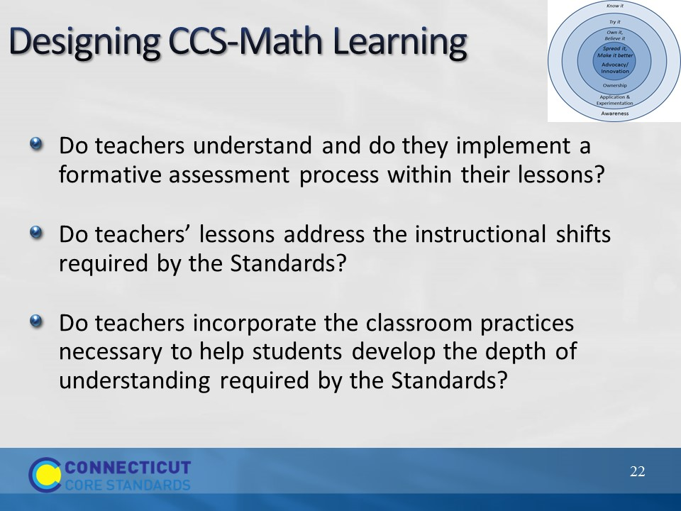Slide 22
Designing CCS-Math Learning
Allow 5 minutes for this reflection and then move on to the next part of this section during which participants will work together to begin identifying teachers’ needs.
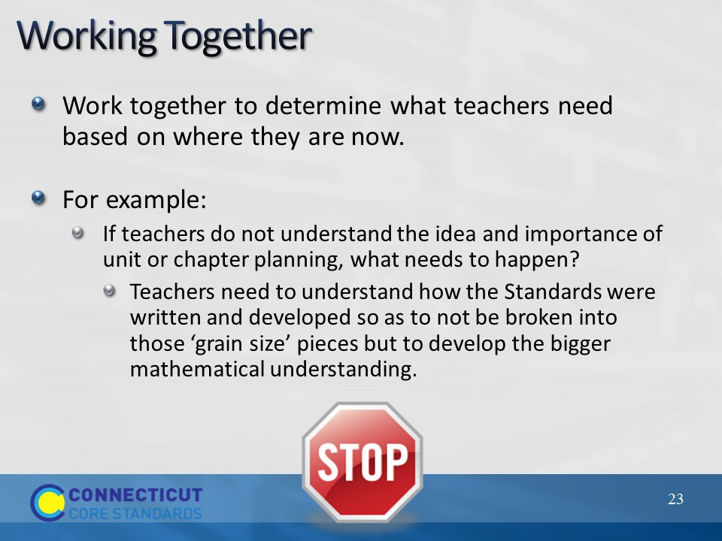Slide 23
Working Together
First ask participants if there are any questions about the reflections that they just completed. Then, explain that now that they each have a better idea of where the teachers in their school are with each of the four areas of their CCS-Math implementation, they will now work together to think through the more specific needs that teachers have that will need to be addressed, in order to move them to the next stage of change. Review the example on the slide and instruct participants to enter the specific needs of the teachers in their school in the space that answers the question ‘What do teachers need?’ Further explain that they should stop at that point and not worry yet about trying to answer the remaining two questions in the implementation plan as more information on that will come throughout the day. Allow participants to work for 20 minutes and, as they work, be sure to visit each group to answer and provide support for their specific questions. When time has been reached, bring the whole group back together and ask for volunteers to share some of the needs that they uncovered during their individual and group reflection time. After volunteers have shared, move on to the next slide to briefly discuss how the remaining two questions in the implementation plan will be addressed.
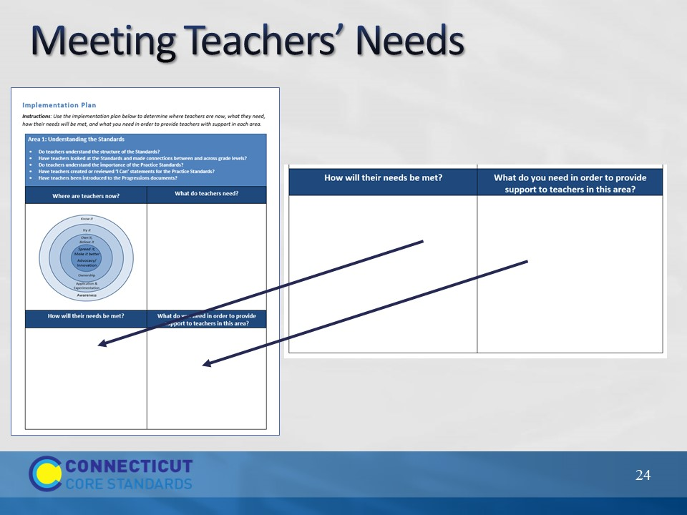Slide 24
Meeting Teachers’ Needs
Review with participants that they now have a better idea of where the teachers in their school are with the stages of change for each of the four areas of their CCS-Math implementation that have been discussed, and have begun to identify some of the specific teacher needs that must be addressed as their implementation moves forward. Explain that the remainder of this module, Sections 2-5 will provide them with the ideas, resources, and suggestions for determining how teachers’ needs can be met and what they need, in their current role, in order to provide support to teachers in each of these areas. Ask if there are any remaining questions. Answer those that are relevant at this immediate point, and place others on a piece of chart paper to make sure that they are answered at some point throughout the day. Then, release participants for a short break before beginning Section 2.

