Module 5 Facilitator Guide | Focus on Deepening Implementation

Activity 6b

Connecticut Core Standards for English Language Arts and Literacy

Grades K–5

Systems of Professional Learning

Connecticut Core Standards Systems of Professional Learning
The material in this guide was developed by Public Consulting Group in collaboration with staff from the Connecticut State Department of Education and the RESC Alliance. The development team would like to specifically thank Ellen Cohn, Charlene Tate Nichols, and Jennifer Webb from the Connecticut State Department of Education; Leslie Abbatiello from ACES; and Robb Geier, Elizabeth O’Toole, and Cheryl Liebling from Public Consulting Group.
The Systems of Professional Learning project includes a series of professional learning experiences for Connecticut Core Standards District Coaches in English Language Arts, Mathematics, Humanities, Science, Technology, Engineering, Mathematics (STEM), and Student/Educator Support Staff (SESS).
Participants will have continued support for the implementation of the new standards through virtual networking opportunities and online resources to support the training of educators throughout the state of Connecticut.
Instrumental in the design and development of the Systems of Professional Learning materials from PCG were: Sharon DeCarlo, Debra Berlin, Mary Ellen Hannon, Jennifer McGregor, Judy Buck, Michelle Wade, Nora Kelley, Diane Stump, and Melissa Pierce.
Published 2014. Available online at http://ctcorestandards.org/

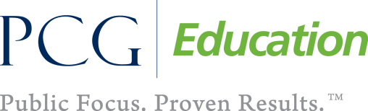

Session at-a-Glance

Activity 6b: Action Planning
After completing the Give One, Get One, Move On activity, participants will reflect on what key messages and strategies they would like to take back to their school and share with their colleagues. They will work with their school teams to develop the strategies.

Supporting Documents:
- Key Messages and Strategy Table

PowerPoint Slide:
- 67

Session Implementation
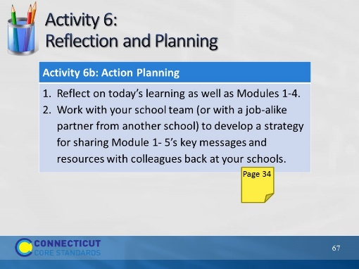Slide 67
(Allow 30 minutes for this activity; adjust time as needed.)

