Module 5 Facilitator Guide | Focus on Deepening Implementation

Activity 5b

Connecticut Core Standards for English Language Arts and Literacy

Grades K–5

Systems of Professional Learning

Connecticut Core Standards Systems of Professional Learning
The material in this guide was developed by Public Consulting Group in collaboration with staff from the Connecticut State Department of Education and the RESC Alliance. The development team would like to specifically thank Ellen Cohn, Charlene Tate Nichols, and Jennifer Webb from the Connecticut State Department of Education; Leslie Abbatiello from ACES; and Robb Geier, Elizabeth O’Toole, and Cheryl Liebling from Public Consulting Group.
The Systems of Professional Learning project includes a series of professional learning experiences for Connecticut Core Standards District Coaches in English Language Arts, Mathematics, Humanities, Science, Technology, Engineering, Mathematics (STEM), and Student/Educator Support Staff (SESS).
Participants will have continued support for the implementation of the new standards through virtual networking opportunities and online resources to support the training of educators throughout the state of Connecticut.
Instrumental in the design and development of the Systems of Professional Learning materials from PCG were: Sharon DeCarlo, Debra Berlin, Mary Ellen Hannon, Jennifer McGregor, Judy Buck, Michelle Wade, Nora Kelley, Diane Stump, and Melissa Pierce.
Published 2014. Available online at http://ctcorestandards.org/

Session at-a-Glance

Activity 5b: Debriefing a Lesson
In Activity 5b, participants will follow up the lesson review with an opportunity to develop and provide feedback on the lesson. Participants will use the Essential Skills for Coaches Guide to organize their feedback and review a debriefing protocol, which will help support a focused feedback session.

Supporting Documents:
- Connecticut Core Standards Classroom “Look Fors” Guide
- Essential Skills Coaches Guide
- Coaches’ Observation and Debriefing Protocol

PowerPoint Slide:
- 62

Session Implementation
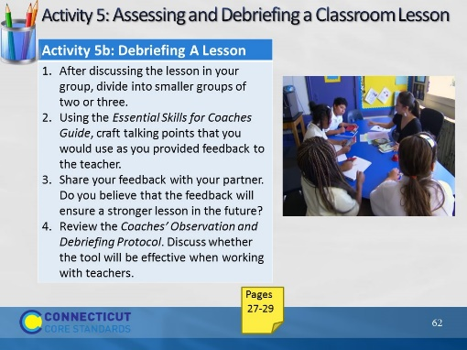Slide 62
Once they have discussed the lesson, they are going to practice providing coaching as if they were the instructional coach for this teacher. They will be using the same Essential Skills for Coaching Tool that they used earlier in the module. They will write down feedback, including questions, and then with a partner discuss how they would approach the teacher to improve instruction for the future. If there is time to share out with the big group, you may want to do that.

