Module 5 Facilitator Guide | Focus on Deepening Implementation

Activity 5a

Connecticut Core Standards for English Language Arts and Literacy

Grades K–5

Systems of Professional Learning

Connecticut Core Standards Systems of Professional Learning
The material in this guide was developed by Public Consulting Group in collaboration with staff from the Connecticut State Department of Education and the RESC Alliance. The development team would like to specifically thank Ellen Cohn, Charlene Tate Nichols, and Jennifer Webb from the Connecticut State Department of Education; Leslie Abbatiello from ACES; and Robb Geier, Elizabeth O’Toole, and Cheryl Liebling from Public Consulting Group.
The Systems of Professional Learning project includes a series of professional learning experiences for Connecticut Core Standards District Coaches in English Language Arts, Mathematics, Humanities, Science, Technology, Engineering, Mathematics (STEM), and Student/Educator Support Staff (SESS).
Participants will have continued support for the implementation of the new standards through virtual networking opportunities and online resources to support the training of educators throughout the state of Connecticut.
Instrumental in the design and development of the Systems of Professional Learning materials from PCG were: Sharon DeCarlo, Debra Berlin, Mary Ellen Hannon, Jennifer McGregor, Judy Buck, Michelle Wade, Nora Kelley, Diane Stump, and Melissa Pierce.
Published 2014. Available online at http://ctcorestandards.org/

Session at-a-Glance

Part 5: Introducing and Using the Connecticut Core Standards Classroom “Look Fors” Guide (75 minutes)

Activity 5a: Assessing a Video Lesson Using the “Look Fors” Guide
In Activity 5a, participants will use the CT Core Standards Classroom “Look Fors” to observe a reading lesson and determine how aligned the practices are to the CT Core Standards.

Supporting Documents:
- Discussion Prompts
- Connecticut Core Standards Classroom “Look Fors” Guide
- Connecticut Core Standards Classroom “Look Fors” Recording Sheet

Video
- Guided Reading with Jenna. (2011). Teaching Channel. Retrieved from: https://www.youtube.com/watch?v=KhJHzabXTSE

PowerPoint Slides:
- 56‒61

Session Implementation
Part 5
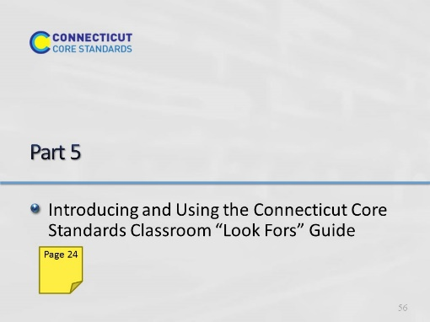Slide 56
Approximate start time 1:15
75 minutes.
Introductory slides take 15 minutes
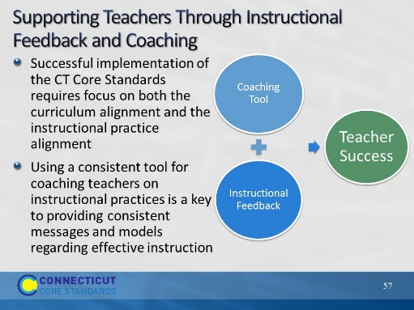Slide 57
This slide is intended as the introduction/rationale to the CT Core Standards Classroom “Look Fors” tool that CT has created for to both teachers and coaches to use when observing a well aligned lesson for feedback and coaching. The “Look Fors” tool was built from the Instructional Practice guide, used nationwide, and has been specially modified to guide CCS-aligned instruction in a non-evaluative way. Using a consistent tool that all staff are aware of provides for consistent messages and makes for deeper understandings of practice.
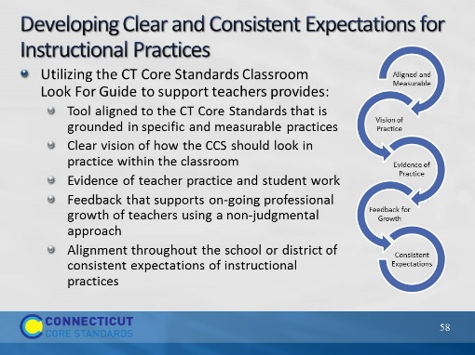Slide 58
Blank
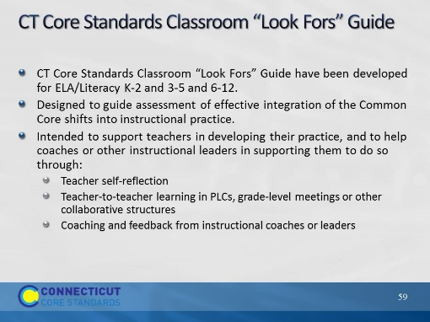Slide 59
This guide has been recently developed by the CSDE for all schools. The Classroom “Look Fors” Guide is based on the Instructional Practice Guide from Student Achievement Partners. However, let participants know that the state has made additions based on feedback from teachers and districts. The laminated version can be used as a flipbook that will provide additional supports for coaches as they observe lessons.
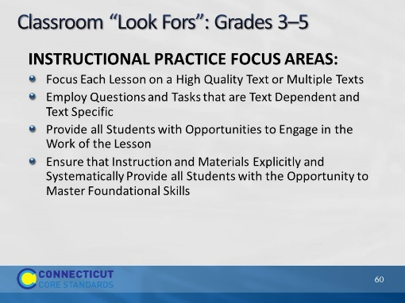Slide 60
Review the slide and briefly review each area. The participants will be taking a closer look before they observe the video lesson.
Remind participants that there is a specific rubric for Grades K-2 that addresses the foundational skills and the shared nature of literacy in the early grades.
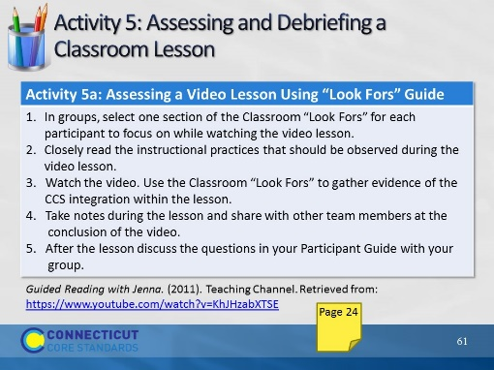Slide 61
30 minutes
Video Lesson: https://www.youtube.com/watch?v=KhJHzabXTSE
In this section, coaches will be using the Classroom “Look Fors” guide to observe a lesson. It is important not to expect the coaches to focus on all five areas so remind them to divide up sections amongst the members of their group. Since this is a fifth grade classroom, you should let the participants know that the foundational skills section would not be an appropriate focus area. After they have watched the video they should spend time discussing what they saw and what was put into their notes. Direct them to discussion questions in the Participant Guide.

