Module 5 Facilitator Guide | Focus on Deepening Implementation

Activity 4

Connecticut Core Standards for English Language Arts and Literacy

Grades K–5

Systems of Professional Learning

Connecticut Core Standards Systems of Professional Learning
The material in this guide was developed by Public Consulting Group in collaboration with staff from the Connecticut State Department of Education and the RESC Alliance. The development team would like to specifically thank Ellen Cohn, Charlene Tate Nichols, and Jennifer Webb from the Connecticut State Department of Education; Leslie Abbatiello from ACES; and Robb Geier, Elizabeth O’Toole, and Cheryl Liebling from Public Consulting Group.
The Systems of Professional Learning project includes a series of professional learning experiences for Connecticut Core Standards District Coaches in English Language Arts, Mathematics, Humanities, Science, Technology, Engineering, Mathematics (STEM), and Student/Educator Support Staff (SESS).
Participants will have continued support for the implementation of the new standards through virtual networking opportunities and online resources to support the training of educators throughout the state of Connecticut.
Instrumental in the design and development of the Systems of Professional Learning materials from PCG were: Sharon DeCarlo, Debra Berlin, Mary Ellen Hannon, Jennifer McGregor, Judy Buck, Michelle Wade, Nora Kelley, Diane Stump, and Melissa Pierce.
Published 2014. Available online at http://ctcorestandards.org/

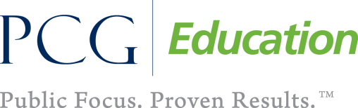 |  | 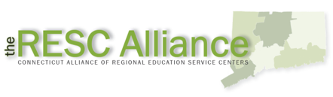

Session at-a-Glance

Part 4: Collaborative Examination of Student Work from Performance Tasks (70 minutes)

Activity 4: Examining Student Work from a Performance Task
Participants will deepen their understanding of performance tasks as evidence of student learning.

Supporting Documents:
- Discussion Prompts
- Modified EQuIP Student Work Protocol: *Modified for CT Core Standards Systems of Professional Learning from EQuIP Student Work Protocol - ELA/Literacy. Retrieved from http://www.achieve.org/files/ELA%20Student%20Work%20Protocol%20FINAL_1.pdf
- CCS-aligned Performance Task and Student Work - Grade 3 Literacy: Investigating Sharks. Retrieved from and http://schools.nyc.gov/NR/rdonlyres/0F4660F6-6E81-47F2-B0AC-42D85901CA85/0/NYCDOEG3LiteracySharks_Final.pdf and from http://schools.nyc.gov/NR/rdonlyres/6BA6C876-138F-4A86-A512-11A62158F124/0/NYCDOEG3LiteracySharksStudentWorkNoAnnotation.pdf

PowerPoint Slides:
- 44‒53

Session Implementation
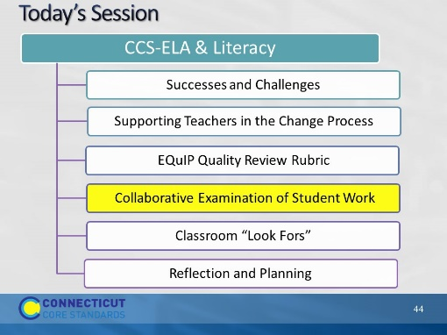Slide 44
40 minutes
Part 4
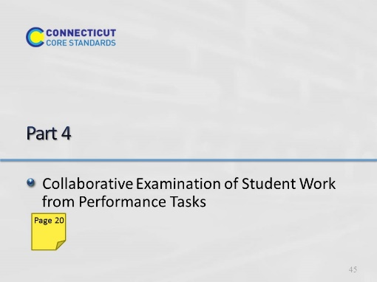Slide 45
Estimated Start time 11:20
Part 4, 70 minutes
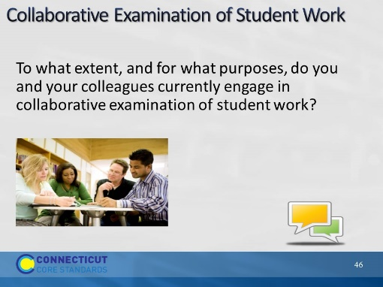Slide 46
Blank
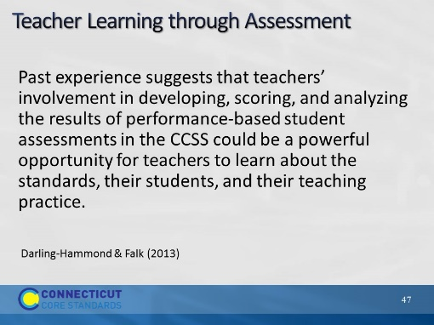Slide 47
Introduce the article by explaining that this paper was written by Linda Darling-Hammond (professor at Stanford University, known for her leadership and scholarly work in education policy and practice, specifically school restructuring, teacher education, and educational equity) and Beverly Falk (a professor at CCNY School of Education and a senior scholar at the Stanford Center for Assessment, Learning, and Equity.) Both are authors of numerous publications and hold distinguished positions on various editorial boards and national commissions.
The paper, written for the Center for American Progress, is intended to explain and promote the importance of collaborative examination of student work from performance assessments to the implementation of the CCSS.
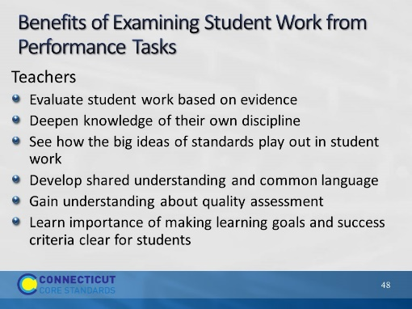Slide 48
Remind participants of information shared in Module 4.
Performance tasks reveal deep understanding and assess key knowledge and skills.
- Provides an authentic context with relevance for students
- Gives specific expectations and success criteria for students
- Emphasizes the application and use of knowledge and skills
- Reveals student understanding and transfer
- Rated with a rubric to measure different aspects of the task
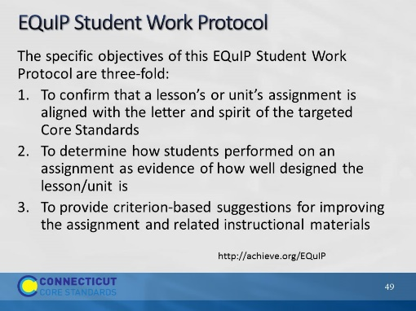Slide 49
- The ultimate goal of the CT Core Standards is to prepare all students with the knowledge and skills they need for postsecondary success.
- The EQuIP Student Work Protocol is designed to establish or articulate the relationship between student work and the quality and alignment of instructional materials that previously have been reviewed using the EQuIP quality review process.
- Focusing on this relationship enables educators to develop a common understanding of the challenging work required by the CCS.
- Furthermore, analyzing this relationship will also assist in closing the gap between what students are learning and the expectations embodied in assignments, as well as verifying what students are being taught and what they have learned, remembered, and incorporated into their knowledge and skills.
- (excerpt from http://www.achieve.org/files/ELA%20Student%20Work%20Protocol%20FINAL_1.pdf)
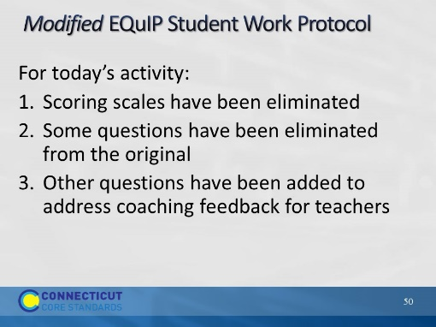Slide 50
- The ultimate goal of the Common Core State Standards (CCSS) is to prepare all students with the knowledge and skills they need for postsecondary success.
- The EQuIP Student Work Protocol is designed to establish or articulate the relationship between student work and the quality and alignment of instructional materials that previously have been reviewed using the EQuIP quality review process.
- Focusing on this relationship enables educators to develop a common understanding of the challenging work required by the CCS.
- Furthermore, analyzing this relationship will also assist in closing the gap between what students are learning and the expectations embodied in assignments, as well as verifying what students are being taught and what they have learned, remembered, and incorporated into their knowledge and skills.
- (excerpt from http://www.achieve.org/files/ELA%20Student%20Work%20Protocol%20FINAL_1.pdf)
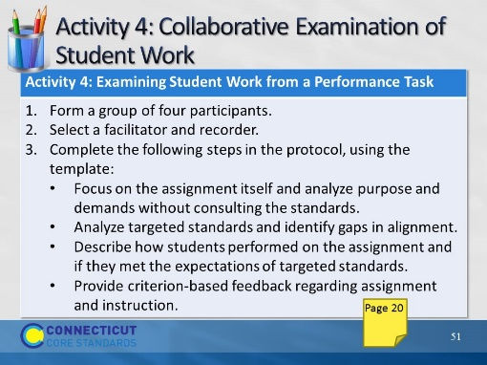Slide 51
55 minutes
Resources:
Modified EQuIP Student Work Protocol
CCS-aligned Performance Task and Student Work - Grade 3 Literacy: Investigating Sharks. Retrieved from and http://schools.nyc.gov/NR/rdonlyres/0F4660F6-6E81-47F2-B0AC-42D85901CA85/0/NYCDOEG3LiteracySharks_Final.pdf and from http://schools.nyc.gov/NR/rdonlyres/6BA6C876-138F-4A86-A512-11A62158F124/0/NYCDOEG3LiteracySharksStudentWorkNoAnnotation.pdf
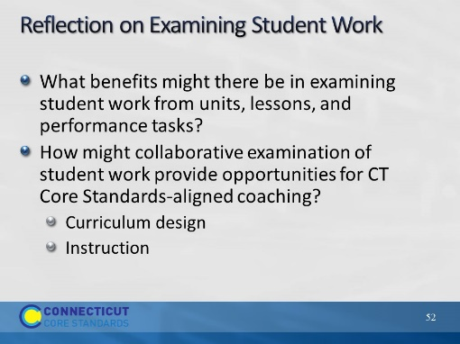Slide 52
Possible points from Darling-Hammond & Falk (2013) article:
- Providing teachers with more direct and valid information about student progress than is offered by traditional assessments, especially on the deeper learning skills that characterize the Common Core State Standards.
- Enabling teachers to engage in evidence-based work: reflecting more clearly and analytically on student work to inform their instructional decisions.
- Yielding information that enhances teachers’ knowledge of students, standards, curriculum, and teaching, especially when scoring is combined with debriefing and discussing next steps with other teachers.

