Module 5 Facilitator Guide | Focus on Deepening Implementation

Activity 2a

Connecticut Core Standards for English Language Arts and Literacy

Grades K–5

Systems of Professional Learning

Connecticut Core Standards Systems of Professional Learning
The material in this guide was developed by Public Consulting Group in collaboration with staff from the Connecticut State Department of Education and the RESC Alliance. The development team would like to specifically thank Ellen Cohn, Charlene Tate Nichols, and Jennifer Webb from the Connecticut State Department of Education; Leslie Abbatiello from ACES; and Robb Geier, Elizabeth O’Toole, and Cheryl Liebling from Public Consulting Group.
The Systems of Professional Learning project includes a series of professional learning experiences for Connecticut Core Standards District Coaches in English Language Arts, Mathematics, Humanities, Science, Technology, Engineering, Mathematics (STEM), and Student/Educator Support Staff (SESS).
Participants will have continued support for the implementation of the new standards through virtual networking opportunities and online resources to support the training of educators throughout the state of Connecticut.
Instrumental in the design and development of the Systems of Professional Learning materials from PCG were: Sharon DeCarlo, Debra Berlin, Mary Ellen Hannon, Jennifer McGregor, Judy Buck, Michelle Wade, Nora Kelley, Diane Stump, and Melissa Pierce.
Published 2014. Available online at http://ctcorestandards.org/

Session at-a-Glance

Part 2: Supporting Teachers in the Change Process (60 minutes)

Activity 2a: Supporting Teachers in Making the Change to CCS-aligned Instruction
Participants will use the Stages of Concerns Continuum to identify where a fictional teacher may be regarding implementation of the CT Core Standards. Participants will determine ways to support the teacher as she moves through the change process and discuss ways to support their own staff as they continue to implement the standards and a new curriculum.

Supporting Documents:
- Supporting Staff through the Stages of Concern Continuum. Adapted from: Hall, G.E. & Hord, S.M. (2006). Implementing change: Patterns, principles, and potholes (2nd ed). Boston: Allyn and Bacon.
- Stages of Change: Fictional Case Study. Adapted from Expeditionary Learning. July 2013 NTI: Grades 3-8 ELA Turnkey Kit - Session 3B. EngageNY.

PowerPoint Slides:
- 16‒30

Think-Pair-Share
Participants read the Seven Norms and select one they do well and one they would like to improve upon.

Supporting Documents:
- Supporting Staff through the Stages of Concern Continuum. Adapted from: Hall, G.E. & Hord, S.M. (2006). Implementing change: Patterns, principles, and potholes (2nd ed). Boston: Allyn and Bacon.
- Stages of Change: Fictional Case Study. Adapted from Expeditionary Learning. July 2013 NTI: Grades 3-8 ELA Turnkey Kit - Session 3B. EngageNY.
- Seven Norms of Collaboration. Adapted from Garmston, R., and Wellman, B. (2009) The Adaptive School: A Sourcebook for Developing Collaborative Groups, 2nd edition. Norwood, MA: Christopher Gordon. Retrieved from http://www.thinkingcollaborative.com/norms-collaboration-toolkit/

Session Implementation
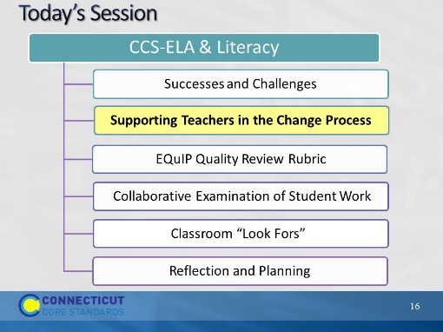Slide 16
Blank
Part 2
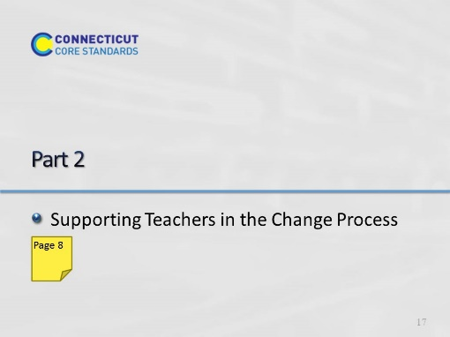Slide 17
60 minutes. Introductory and informational slides take 15 minutes. Activities 2a and 2b take 20 and 25 minutes respectively.
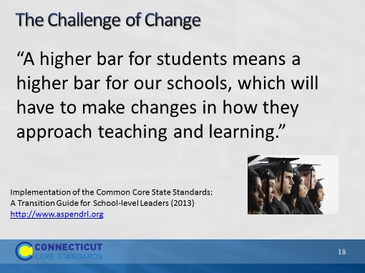Slide 18
Ask participants to reflect on the challenges that were discussed in Part 1.
What were the reasons for some of the challenges? How many of them had to do with staff who may be resistant to change? Why is change a challenge when implementing new policies, curriculum, or standards?
Full quote and source: “The Common Core State Standards (CCSS) build on the highest state standards in the United States, defining the knowledge and skills students need to succeed in college and careers and increasing our expectations to the level of other high-performing countries. A higher bar for students means a higher bar for our schools, which will have to make changes in how they approach teaching and learning.”
Implementation of the Common Core State Standards
A Transition Guide for School-level Leaders
Developed by the Aspen Institute Education and Society Program, Education First, Insight Education Group, Student Achievement Partners and Targeted Leadership Consulting
September 2013 http://www.aspendrl.org/portal/browse/DocumentDetail?documentId=1882&download
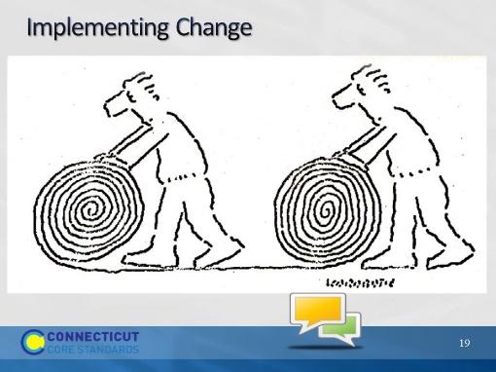Slide 19
Have participants discuss this image.
Ask, “How does this image represent what sometimes happens when change is implemented? Can you think of an example?”
Follow-up: “Why does that happen? How does this relate to implementing CCS?”
Possible talking points:
Most of us can think of a time that made us feel or act this way.
- We purchase or train in a program, and the standards change.
- We start heading in one direction, and the administration or the policies change.
- We are so overloaded with initiatives, we don’t know which way to go first.
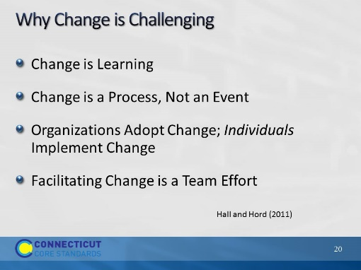Slide 20
From G.E. Hall & S.M. Hord (2011) Implementing change: Patterns, principals, and potholes (4th ed.). Retrieved from https://www.aea267.k12.ia.us/assessment/concerns-based-adoption-model-cbam/important-components-of-cbam/principles-of-change/
There are actually 10 principles, but detail is provided here for the 4 bulleted above.
Change is Learning:
When change is introduced, learning needs to occur to make the change possible.
Those involved need to learn about the change, and learn new skills to make the change possible.
Change is a Process, Not an Event:
According to Hall and Hord (2011) "Change is a process through which people and organizations move as they gradually learn, come to understand, and become skilled and competent in the use of new ways."
When change is thought of as an event, time for learning is no longer available and the change may not be implemented 100% effectively.
Change can take up to, if not more than, five years to become implemented effectively. If one is thinking of change as an event, they may expect the change to occur overnight, and become discouraged and give up when this doesn't happen.
Organizations Adopt Change - Individuals Implement Change:
Successful change starts and ends at the individual level.
People will adjust to and learn aspects of the change at different levels of understanding, investment, and time.
Hall and Hord (2011) stress the importance of moving slowly from the current practice to the new practice (practice that includes the change initiative) rather than leaping from one to the other. In their text, Implementing Change, they refer to this idea as an implementation bridge. Individuals need to start at one side of the bridge, and with support from leaders, slowly move to the other side of the bridge.

Facilitating Change is a Team Effort
It is important to make sure that everyone involved in the change initiative is doing their part. The process of change will go a lot smoother if everyone is doing their share and their part.
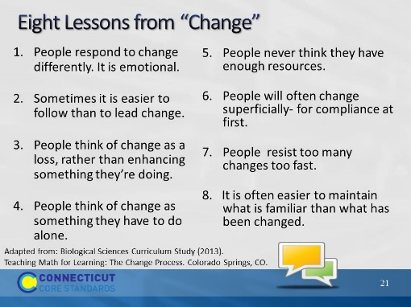Slide 21
Consider these “lessons” through the lens of implementing the CCS. Ask the participants to choose the “lesson from change” that most resonates with them. Discuss at their table which lesson they chose and why. Ask them to discuss what an effective teacher or school leader could do to change that thinking. If you have time, share out with the big group and discuss if there are any ‘trends’ they could identify.
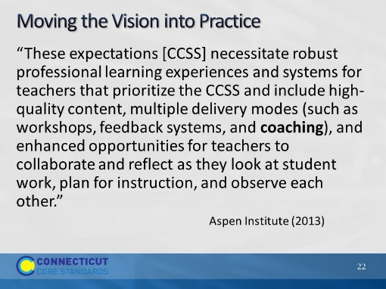Slide 22
Slide provides a transition to CBAM.
Ask participant to read the quote.
Relate back to “higher bar” (slide 13), and the change process. Ask, “How must we consider the change process in professional learning about the Common Core? How can we gauge where teachers are and what they need next?”
Reference: Implementation of the Common Core State Standards: A transition guide for school-level leaders. (September 2013). Washington, DC: Aspen Institute.
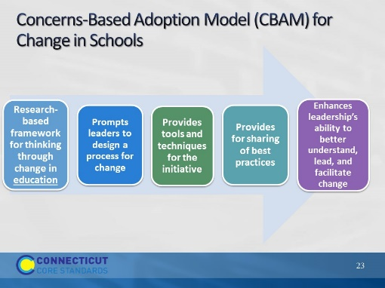Slide 23
Explain that CBAM is a highly respected framework that has been used for nearly 25 years for thinking through change in school. While much of it is aimed at a management level, there are tools within the framework that are useful for those in coaching positions.
A change management model can help assist in successfully driving change by:
- Introducing a framework for thinking through change
- Prompting leaders to design a process for change and creating conditions for success
- Providing tools and techniques for the initiative
- Providing for sharing of best practices
- Enhancing leadership’s ability to lead and facilitate change
Reference: http://www.sedl.org/cbam/
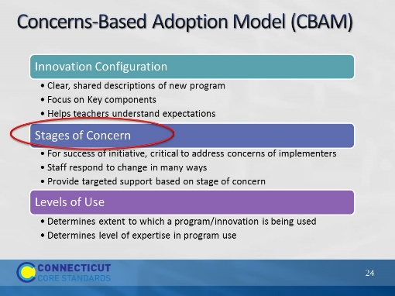Slide 24
CT Core Coaches may find one piece of the three-part framework particularly useful in thinking about where teachers are with regard to change, and how our responses can be guided by their level of concern.
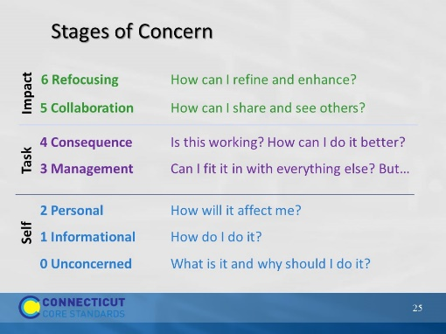Slide 25
Staff members (and teams) go through stages of change and concerns at different rates until they finally get to a stage of impact (i.e., acceptance, enhancement, and collaboration). Some staff members can get “stuck” and not move off of a stage.
- The lower three stages are focused on oneself, a clue of which might be the use of "I” and "me“, as in "I am frustrated.” For educators, the “Why” really needs to focus on why the change will benefit students.
- The middle stages (management/consequence) are focused on mastery of tasks to the point they become routines and are easier to do, a clue of which might be the use of "it” or a reference to the activity, not the self. An example that a person is struggling at the management level could be a statement like, "Prioritizing my use of time and the management of paper work is killing me!”
- The upper Stages of Concern are focused on the results and impact of the activity, a clue of which might be the use of pronouns which refer to clients, protégés, or participants who receive the benefits of the activity. Examples might include, "The students are really learning better since I started using that strategy. “
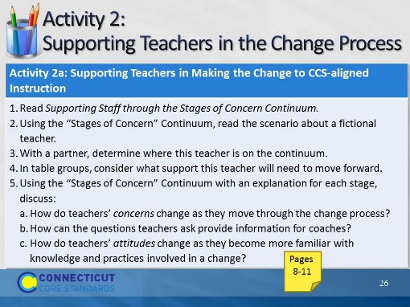Slide 26
20 minutes. Resource: http://www.sedl.org/cbam/actions_to_support_change.html
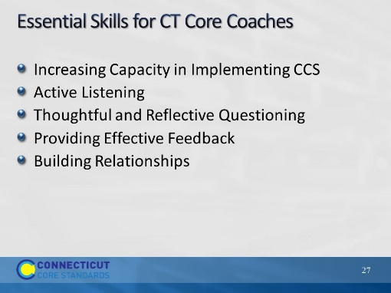Slide 27
The information on this slide is an amalgam of coaching skills from various sources that relate to the role of a CCS coach.
Acknowledge that CT Core Coaches may be experienced coaches, or they may be teacher leaders or administrators who find themselves in a coaching role. The following slides describe the roles of coaches. Encourage the “professional” coaches to share insights and experiences to help those who do not coach on a regular basis.
The next 5 slides are informational. Be sure to encourage experienced coaches to add to the list or to reflect on the importance of each skill.
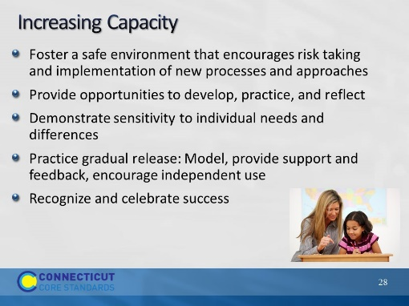Slide 28
Review the ways for increasing capacity.
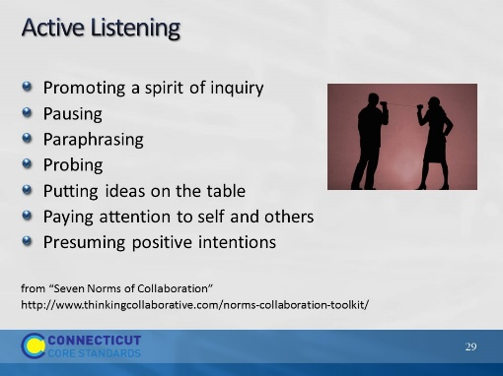Slide 29
Explain that these “norms,” while intended as tools for collaborative groups, are equally useful for facilitators and coaches to incorporate and reflect on in their work. If a coach or facilitator practices these active listening/collaboration “norms,” it often brings the other participants into the same mode without introducing them as norms.
1. Promoting a Spirit of Inquiry
Exploring perceptions, assumptions, beliefs, and interpretations promotes the development of understanding. Inquiring into the ideas of others before advocating for one’s own ideas is important to productive dialogue and discussion.
2. Pausing
Pausing before responding or asking a question allows time for thinking and enhances dialogue, discussion, and decision-making.
3. Paraphrasing
Using a paraphrase starter that is comfortable for you – “So…” or “As you are…” or “You’re thinking…” – and following the starter with an efficient paraphrase assists members of the group in hearing and understanding one another as they converse and make decisions.
4. Probing
Using gentle open-ended probes or inquiries – “Please say more about…” or “I’m interested in…” or “I’d like to hear more about…” or “Then you are saying…” increases the clarity and precision of the group’s thinking.
5. Putting ideas on the Table
Ideas are the heart of meaningful dialogue and discussion. Label the intention of your comments. For example: “Here is one idea…” or “One thought I have is…” or “Here is a possible approach…” or “Another consideration might be…”.
6. Paying Attention to Self and Others
Meaningful dialogue and discussion are facilitated when each group member is conscious of self and of others, and is aware of what (s)he is saying and how it is said as well as how others are responding. This includes paying attention to learning styles when planning, facilitating, and participating in group meetings and conversations.
7. Presuming Positive Intentions
Assuming that others’ intentions are positive promotes and facilitates meaningful dialogue and discussion, and prevents unintentional put-downs. Using positive intentions in speech is one manifestation of this norm.
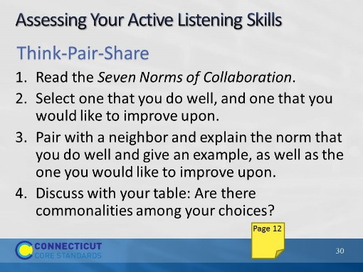Slide 30
Facilitator, you may give an example to start the activity. It may be a skill that you have actively worked to increase and how it has improved your meetings, etc.
This activity should take no more than 10 minutes. Remind participants to keep their discussion in the context of CCS coaching.

