Module 5 Facilitator Guide | Focus on Deepening Implementation

Activity 6a

Connecticut Core Standards for English Language Arts and Literacy

Grades 6–12

Systems of Professional Learning

Connecticut Core Standards Systems of Professional Learning
The material in this guide was developed by Public Consulting Group in collaboration with staff from the Connecticut State Department of Education and the RESC Alliance. The development team would like to specifically thank Ellen Cohn, Charlene Tate Nichols, and Jennifer Webb from the Connecticut State Department of Education; Leslie Abbatiello from ACES; and Robb Geier, Elizabeth O’Toole, and Cheryl Liebling from Public Consulting Group.
The Systems of Professional Learning project includes a series of professional learning experiences for Connecticut Core Standards District Coaches in English Language Arts, Mathematics, Humanities, Science, Technology, Engineering, Mathematics (STEM), and Student/Educator Support Staff (SESS).
Participants will have continued support for the implementation of the new standards through virtual networking opportunities and online resources to support the training of educators throughout the state of Connecticut.
Instrumental in the design and development of the Systems of Professional Learning materials from PCG were: Sharon DeCarlo, Debra Berlin, Mary Ellen Hannon, Jennifer McGregor, Judy Buck, Michelle Wade, Nora Kelley, Diane Stump, and Melissa Pierce.
Published 2014. Available online at http://ctcorestandards.org/

Session at-a-Glance

Part 6: Reflection and Planning (55 minutes)

Activity 6a: Focus on Deepening Implementation
In this final section, participants will look back on the entire module series and identify content or activities that will have the highest impact in their school with colleagues to implement the CCS-ELA & Literacy. Participants will share their thoughts with their colleagues.

Supporting Documents:
- Topics and Activities from Modules 1–5
- Give One, Get One, Move On tool

PowerPoint Slides:
- 63‒66

Session Implementation
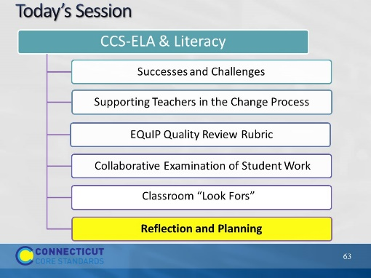Slide 63
40 minutes
Part 6
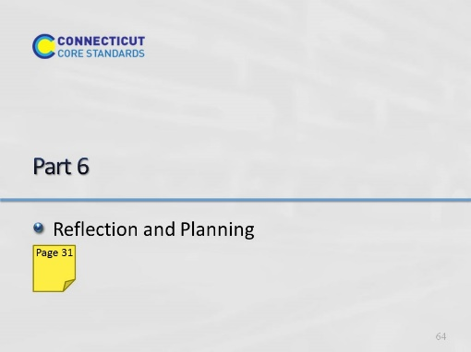Slide 64
55 minutes
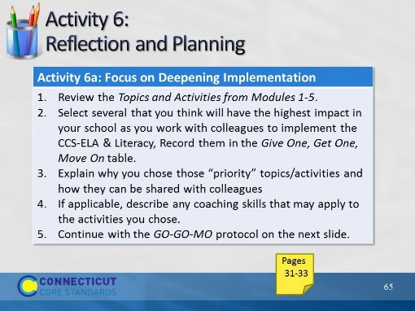Slide 65
30 minutes with GO GO MO (Slide 60)
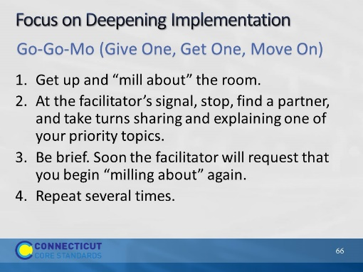Slide 66
Facilitator, adjust time for your group.

