Multiplying Polynomials

Vocabulary:

Polynomial: A mathematical expression containing one or more terms.

Monomial: A mathematical expression with ________ term.

Binomial: A mathematical expression with ________ terms.

Trinomial: A mathematical expression with ________ terms.

Use an area model to show the product of two binomials. Then combine like terms to form a trinomial. You may, if you choose, use algebra tiles to assist you.
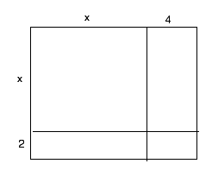
- (x + 2)(x + 4)

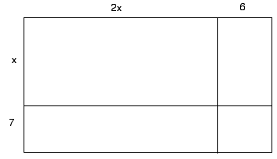
- (x + 7)(2x + 6)

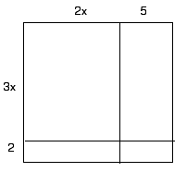
- (3x + 2)(2x + 5)

Continue to use area models, even when some terms are negative. (At this point you may not want to continue using algebra tiles.)
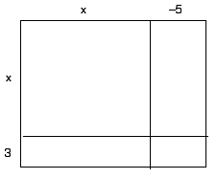
- (x + 3)(x – 5)

- (x – 9)(2x – 8)

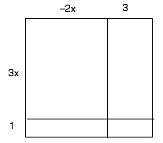

- (3x + 1)(–2x +3)

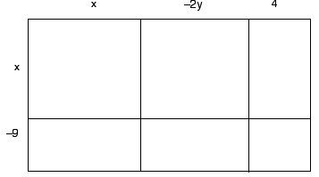
Here is the product of a binomial and a trinomial

- (x – 9)(x – 2y + 4)

Now try the method of applying the distributive property twice:

- $\left(x-5\right)\left(x+7\right)=\left(x-5\right)x+\left(x-5\right)7=x^{2}$ – ____ x + ____ x – ____
= $x^{2}$ + ____ x – ____

- $\left(x+4\right)\left(3x-10\right)=$( ) 3x – ( )10 = _____ + _____ – ______ – _____
=

You may check your work for problems 8 & 9 by drawing an area model if you like.

Expand these products by any method you like. Show your work.

- 6x (x – 5)

- x ($x^{2}$ + 4x – 15)

- (5x – 1)(2x – 3)

- (x – 4)(x + 4)

- ${(x+3)}^{2}$

- Which of problems 10–14 shows a monomial multiplied by a trinomial?

- Which of the problems 10–14 has a binomial product?

- In which of the problems 10–14 are the two binomial factors the same?

