Exploring Growth Patterns: A Comparison

The following pictures show walls being built section by section. They are called ‘growth patterns’ because the heights of the walls grow with each section.

Pattern A. Complete the table below based on pattern A shown to the right. | 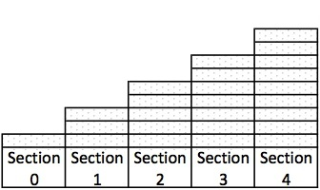  Pattern A
Section # (x)
# of Bricks N_{A}(x)

Write a recursive rule for pattern A.

Pattern B. Complete the table below based on pattern B shown to the right. | 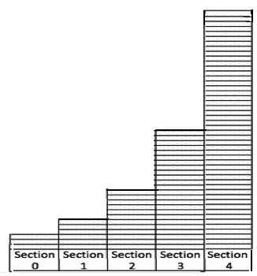  Pattern B
Section # (x)
# of Bricks N_{B}(x)

Write a recursive rule for pattern B.

Pattern C. Complete the table below based on pattern C shown to the right. | 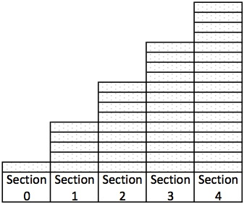  Pattern C
Section # (x)
# of Bricks N_{C}(x)

Write a recursive rule for pattern C.

Pattern D. Complete the table below based on pattern D shown to the right. | 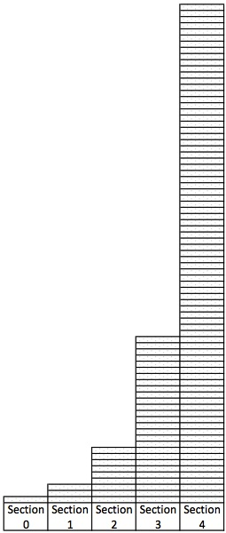  Pattern D
Section # (x)
# of Bricks N_{D}(x)

Write a recursive rule for pattern D.

- Describe how the patterns are similar.

- Describe how the patterns are different from each other.

- Decide whether each pattern shows linear growth or exponential growth and explain why.

Pattern A:

Pattern B:

Pattern C:

Pattern D:

- Find the initial value for each pattern.

Pattern A:

Pattern B:

Pattern C:

Pattern D:

- For each linear growth pattern find the rate of change.

Pattern _______ Rate of change ___________

Pattern _______ Rate of change ___________

- For each exponential growth pattern find the growth factor.

Pattern _______ Growth factor ___________

Pattern _______ Growth factor ___________

- Write an explicit rule (function) for each pattern.

Pattern A:

Pattern B:

Pattern C:

Pattern D:

- If you had trouble writing an explicit rule for any of the patterns, write down which ones and why.

- For a linear function $f\left(x\right)= mx+b$

- Which parameter (m or b) represents the initial value?

- Which parameter (m or b) represents the rate of change?

- For an exponential function $f\left(x\right)=ab^{x}$

- Which parameter (a or b) represents the initial value?

- Which parameter (a or b) represents the growth factor?

