U.S. Postal Service Rates

The table below shows first-class mail postage charges based on the weights of large envelopes.

Large Envelopes
Weight, w  (in ounces) | Postage charged  (in $)
$$0<w≤1$$ | 0.90
$$1<w≤2$$ | 1.10
$$2<w≤3$$ | 1.30
$$3<w≤4$$ | 1.50
$$4<w≤5$$ | 1.70
$$5<w≤6$$ | 1.90
$$6<w≤7$$ | 2.10
Source: USPS.com, April 2012

The relationship between postage charge and weight is a function. This particular function is an example of a step function.

- Identify the independent variable.

- Identify the dependent variable.

- If your letter weighs 1.8 oz. the postage charge is _____.

- If your letter weights 4.3 oz. the postage charge is _____.

- If your letter weighs 5 oz. the postage charge is _____.

- If your letter weighs 6.6 oz, the postage charge is _____.

- Is weight a function of postage charge? Hint: Look at your answers from question (4) and question (5).

- Complete the graph below.
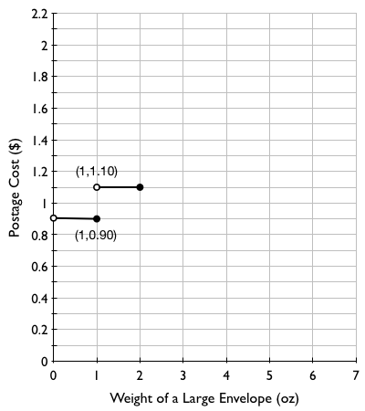

- Explain why there is a closed circle at the point (1, 0.90) on the graph.

- Explain why there is an open circle at the point (1, 1.10) on the graph.

- Explain why there is an open circle at the point (0, 0.90) on the graph.

- Could there be two different closed points with the same input value on the graph of a function? Explain.

