Geoboard Squares

- Use a five-by-five geoboard (or dot paper) and find as many squares of different sizes as you can.

- For each square you find on the geoboard, record the area and the length of a side (to the nearest 0.1 unit) in the table.

Area of Square (square units) | Length of Side  (units)

- Graph the length of a side as a function of the area of the square.

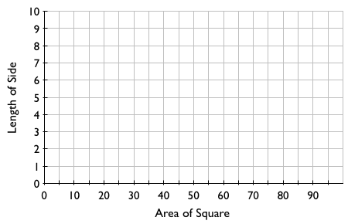
- Describe the shape of this function. Use the Parent Function Reference Sheet.

