Hartford Precipitation

A function is a _______________ between two sets, a first set and a second set, where each element from the first set is paired with ____________________ element from the second set.

The values we use for the first set are called ___________________ and are the same as the __________________ variable. The values in the second set are often called ___________________ and are the same as the ___________________________ variable.

The set of all possible inputs is called the __________________ of the function.

The set of all possible outputs is called the __________________of the function.

When we present a relation in a table the left column always contains the inputs, also called the ______________________________________. The dependent variable is always in the right column.
- Look at Table 1 below. Does the data in the table describe a function? Why or why not?  Table 1  Average Precipitation for Hartford, Connecticut  Month Inches  1 3.66  2 2.65  3 3.61  4 3.82  5 3.99  6 3.83  7 3.93  8 3.83  9 3.83  10 3.91  11 3.79  12 3.44 | - The independent variable is:  - The dependent variable is:  - Plot the data on the graph below.  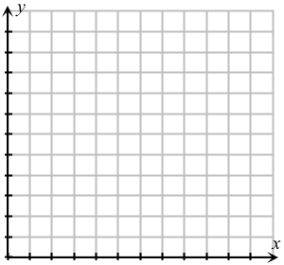
Suppose we change the table. The independent variable and dependent variable have been interchanged. In the previous relation, the input is the month and the output is the average precipitation. In the new relation, the input is the average precipitation and the output is the month.  - (a) Do we ever get nearly 4 inches of rain in a month?  (b) If so, in what month does that happen?  Usually we organize our tables so the values of the domain, the inputs, are listed in increasing order. We list an input only once. Fill in the data into Table 3.  - Does Tables 2 and 3 represent a function? Explain.  - Plot the data in (Table 2 or Table 3) on the graph below.  8. How does this graph differ from the graph of the data in Table 1? |  | Table 2  Average Precipitation for Hartford, CT  Inches Month  3.66 1  2.65 2  3.61 3  3.82 4  3.99 5  3.83 6  3.93 7  3.83 8  3.83 9  3.91 10  3.79 11  3.44 12  Table 3  Average Precipitation for Hartford, CT  Inches Month(s)  2.65  3.44  3.61  3.66  3.79  3.82  3.83  3.91  3.93  3.99

