Solving Equations with Balance Scales

To explore equations with variable terms on both sides, go to the Algebra Balance Scales Applet on the National Library of Virtual Manipulative (NLVM) website at:
http://nlvm.usu.edu/en/nav/frames_asid_324_g_4_t_2.html?open=instructions&from=category_g_4_t_2.html

Here is an example of an equation being solved with the applet. The rectangles represent x, the squares represent one, and the red balloons represent negative one.
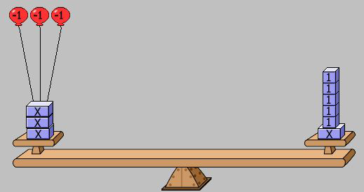
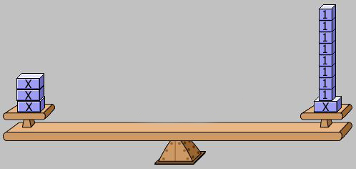
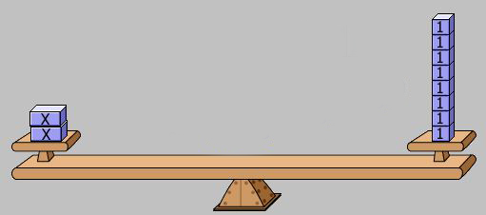
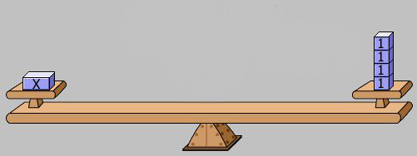
The equation is:

$$3x-3=x+5$$

Step 1: Add 3 to both sides.

The equation is now:

$$3x=x+8$$

Step 2: Subtract x from both sides.

The equation is now:

$$2x=8$$

Step 3: Divide both sides by 2.
(Remove half of each side.)

The equation is now:

$$x=4$$

This is the solution.

As you have seen, sometimes you will have variable terms on both sides of the equation. To solve these equations, we must get all the variable terms on one side, get all the constant terms on the other side, and then combine like terms.

Solve each equation below. Show your work at each step. You may use Algebra Balance Scales to model and solve the equations.

1. $6w=2w-8$ 2. $5-3m=2m$

3. $k+4k=3k+6$ 4. $7a-9=8a-4$

5. $–y+8=3y+4$ 6. $2+3u+1=4u+3$

