Equations in Education

The bar graph below shows the increase in elementary and secondary per pupil spending from 2005 to 2010. Elementary and secondary education refers to kindergarten through high school. Per pupil spending is the amount of money a school district spends on each student.

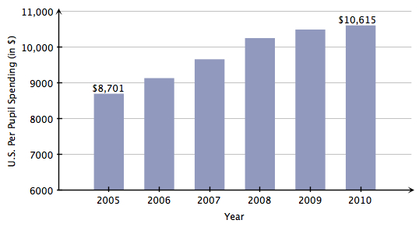
The data is described by the mathematical model

$$P=406.9t+8795.7$$

where P is the per pupil spending for elementary and secondary students in the United States and t is the number of years since 2005.

- Use the formula to estimate United States per pupil spending in the year 2008. (Hint: 2008 corresponds to t = 3, since 2008 is 3 years after 2005.)

- Let’s use this model to make some predictions. We would like to know when per pupil spending in the United States will reach $15,000. To find this, set P = 15000, then solve the equation for t. Identify the actual year.

- When will per pupil spending in the United States reach $20,000? Identify the actual year.

In 2010, Connecticut was the 7th highest state in the nation in per pupil spending. Connecticut’s per pupil spending from 2005 to 2010 can be described by the mathematical model

$$P=690.4t+11634$$

where P is Connecticut’s elementary-secondary per pupil spending and t is the number of years since 2005.

- Use the formula to estimate Connecticut’s per pupil spending in 2010.

- Use the formula to predict Connecticut’s per pupil spending in 2014.

- When will per pupil spending in Connecticut reach $18,000? Identify the actual year.

For each situation below, identify the unknown quantity and assign it a variable, create an equation, solve the equation, and then check your solution.

- In a recent year, the number of elementary and secondary students in Connecticut decreased by 3800 students. If there are 543,000 elementary and secondary students in Connecticut, and the number of students decreases by 3800 per year, how many years will it take for the number of students to fall to 516,400?

Identify the unknown:

Write an equation:

Solve the equation:

Check your solution:

- Wyoming has the lowest number of elementary and secondary students in the nation. If there are 87,900 students, and the number of students increases by 950 each year, how many years will it take for the number of students to reach 99,300?

Identify the unknown:

Write an equation:

Solve the equation:

Check your solution:

- Maine has 188,700 elementary and secondary students. This population is 7300 more than two times Vermont’s elementary and secondary student population. What is Vermont’s elementary and secondary student population?

Identify the unknown:

Write an equation:

Solve the equation:

Check your solution:

- Kansas has 470,000 elementary and secondary students. A member of the state department of education in Kansas would like to see the student population grow to 485,000 over the next twelve years. How much should the population increase by each year?

Identify the unknown:

Write an equation:

Solve the equation:

Check your solution:

