Applications of Geometric Sequences

- You drop a ball from the bleachers which are 16 feet high. Each time the ball bounces, the height decreases by half of the previous height. After 1 bounce, the height of the ball is 8 feet.

- Complete the table below by identifying height of the ball after each bounce.

Bounces | Height | Recursive Pattern
0 | 16 | 16
1 | 8 | 16 ( 1/2 )
2
3
4
5

- What is the recursive rule for the sequence of heights?

- Graph the relationship between the ball’s height and the number of bounces on the coordinate plane below. Label and scale the axes appropriately.

- Write an explicit rule for the sequence of heights. Let h represent the height of the ball after each bounce and b represent the number of the bounce.

- Find the height of the ball after the 11th bounce.

- A certain type of bacteria cell splits into two bacteria cells every hour. Suppose a culture of bacteria begins with 3 bacteria cells.

- Complete the table below by identifying the number of bacteria cells at the beginning of each hour.
Hours | Bacteria Cells | Recursive Pattern
0 | 3 | 3
1 | 6 | 3 ( 2 )
2
3
4
5

- What is the recursive rule for the sequence of bacteria cells?

- Graph the relationship between the number of hours that have passed and the number of bacteria cells on the coordinate plane below. Label and scale the axes appropriately.
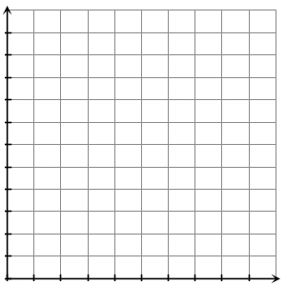
- Write an explicit rule for the sequence of bacteria cells. Let b represent the number of bacteria cells and h represent the number of hours.

- Find the number of bacteria cells after 7 hours.

- Find the patterns in the geometric sequences below. Write a recursive rule to describe each sequence, and find the next three terms.

- 5, 30, 180, ______, ______, ______

- -2, 6, -18, 54, ______, ______, ______

- 9$,\frac{9}{2},\frac{9}{4},\frac{9}{8},$ ______, ______, ______

- Each of these problems involves a geometric sequence. How would you describe the difference between a geometric sequence and an arithmetic sequence?

