Exit Slip – Corn Stalks

- In July, you begin measuring the height of a corn stalk in a nearby field. You collect the following data.

Number of Days | 0 | 1 | 2 | 3 | 4
Height of Corn Stalk (cm) | 20 | 22.5 | 25 | 27.5 | 30

- Make a graph showing the relationship between the number of days and the height of the corn stalk. Label and scale the axes appropriately.
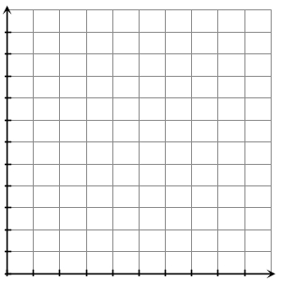

- Write a recursive rule to explain the pattern.

- Write an explicit rule for the height of the corn stalk, h, after any number of days, n.

- How tall is the stalk after 10 days? Explain how you arrived at your answer.

- Do the heights of the corn stalk form an arithmetic sequence? Explain why?

