Organic Alcohols

You are researching the possibility of life forms on a planet orbiting a neighboring twin star. In the chemical spectra from the system, you discover organic alcohols that would point to the presence of oxygen and perhaps living organisms. Molecules of specific organic alcohols are pictured below. The gray atoms are carbon, the red atoms are oxygen, and the white atoms are hydrogen.

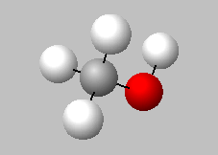  Methanol (Methyl alcohol) | 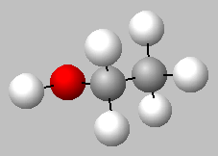  Ethanol (Ethyl alcohol)
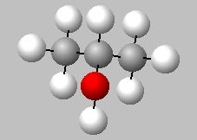  Isopropanol (Rubbing alcohol) | 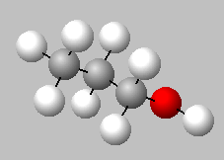  Propanol (Propyl alcohol)

- Use the images above to complete the following table. For each molecule, identify the number of carbon atoms and the number of hydrogen atoms attached to the carbon atoms. Do not count the hydrogen atom attached to the oxygen.

Organic Alcohol | Carbon Atoms | Hydrogen Atoms Attached to Carbon Atoms
Methanol
Ethanol
Propanol
Isopropanol
Butanol

- Does the number of hydrogen atoms in a molecule follow a rule that is based on the number of carbon atoms? Write a verbal description of the pattern or rule.

- The organic alcohol with four carbon atoms is butanol. Using your answer in Question 2, how many hydrogen atoms are attached to carbon atoms in a butanol molecule? Add the information for butanol into the table on the previous page.

- Create a rough stick drawing of a molecule of butanol. If available, create a physical model of a butanol molecule. Similar to propanol, butanol has two possible arrangements. Draw two different arrangements below.

- Graph the relationship between the number of carbon atoms and the number of hydrogen atoms attached to carbon atoms in the organic alcohols listed in the table. Label and scale the axes appropriately.
Basic Organic Alcohol Molecules

- If you extend the graph, how many hydrogen atoms would be attached to carbon atoms in an alcohol with five carbon atoms?

- How many hydrogen atoms would be attached to carbon atoms in an organic alcohol with eight carbon atoms?

- What would happen if you extended the graph to the left? Is this meaningful?

- We see a pattern emerging. If we know the number of hydrogen atoms attached to carbon in an alcohol with nine carbon atoms, how many will there be in an organic alcohol with ten carbon atoms?

- See if you can figure out a formula that will work for any organic alcohol. Going from a pattern to a formula is a guess and check process. You have some practice guessing, so give it a try!

Chemical formulas are used to represent the formulas for alcohol molecules. For example, ethanol can be represented as $C_{2}H_{5}OH$. In this formula, $H_{5}$ represents the five hydrogen atoms that are connected to the two carbon atoms.

If C represents the number of carbon atoms in an organic alcohol molecule, then the expression for the number of hydrogen atoms attached to carbon atoms is given by the equation H = 2C + 1.

- Let’s look at octanol. It has eight carbon atoms, so C=8. How many hydrogen atoms are attached to carbon atoms in octanol?

- Can you determine the missing value in the formula for decanol $C_{10}H_{?}OH$ ?

