Using eChem to Model Molecules

eChem is a free online software that allows students to create virtual, three-dimensional models of molecules. eChem was created by the Center for Highly Interactive Classrooms, Curricula & Computing in Education (Hi-Ce) at the University of Michigan. It is available at:
- eChem Structure Building Applet: http://www.sciencegeek.net/eChem/eChem.html
- hi-ce.org: http://hi-ce.org/echem/index.html

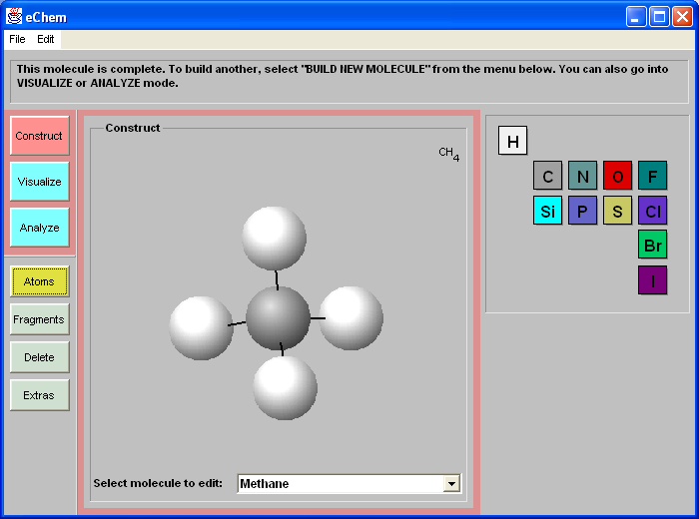

eChem Instructions:

- Run eChem from one of the websites listed above (or from the computer if installed).
- To construct the model of methane (CH₄), start on the left side of the screen. When you see “Construct,” “Visualize,” and “Analyze.”
- Click “Construct.”
- In the popup window, enter the name of molecule: methane.
- Click “Atoms,” and select “C” (carbon) from element table on the right side of the screen.
- Select bond arrangement. In this case, select “tetrahedral” as the hybridization of carbon and click on the canvas (the large area in the middle of the window).
- Select “H” (hydrogen) from the atom table.
- Add hydrogen atoms to the carbon’s bond by clicking on the bonds of carbon.

Notes:

- You can see a rotating structure; just hold down the mouse button and move the cursor.
- Did you attach a wrong atom on carbon (like adding an oxygen atom for methane)? Select “Delete” on the left side of screen, and click the atom ball you want to erase.
- If you are going construct a new model, pull down the bottom menu on the canvas, and select “build a new molecule.”
- The “Visualize” button allows you to view the molecule in three different ways.
- If you entered multiple molecules, the “Analyze” button allows you to check the pattern by choosing “Carbon Count” and “Atom Count” as column headers.

Enjoy!

