Module 3  Facilitator Guide | Focus on Teaching and Learning

Section 3

Connecticut Core Standards for Mathematics

Grades K–5

Systems of Professional Learning

Connecticut Core Standards Systems of Professional Learning
The material in this guide was developed by Public Consulting Group in collaboration with staff from the Connecticut State Department of Education and the RESC Alliance. The development team would like to specifically thank Ellen Cohn, Charlene Tate Nichols, and Jennifer Webb from the Connecticut State Department of Education; Leslie Abbatiello from ACES; and Robb Geier, Elizabeth O’Toole, and Cheryl Liebling from Public Consulting Group.
The Systems of Professional Learning project includes a series of professional learning experiences for Connecticut Core Standards District Coaches in English Language Arts, Mathematics, Humanities, Science, Technology, Engineering, Mathematics (STEM), and Student/Educator Support Staff (SESS).
Participants will have continued support for the implementation of the new standards through virtual networking opportunities and online resources to support the training of educators throughout the state of Connecticut.
Instrumental in the design and development of the Systems of Professional Learning materials from PCG were: Sharon DeCarlo, Debra Berlin, Jennifer McGregor, Judy Buck, Michelle Wade, Nora Kelley, Diane Stump, and Melissa Pierce.

Published 2014. Available online at http://ctcorestandards.org/

Session at-a-Glance

Section 3: Teaching and Learning with the UDL Principles (90 minutes)

Training Objectives:
To provide participants with an opportunity to observe a mathematics lesson in order to identify UDL Principles in use.
To provide participants with an opportunity to examine a mathematics lesson outline in order to identify UDL Principles in use.
To provide participants with an opportunity to practice planning portions of a lesson in order to incorporate UDL strategies using specific planning questions as a guide.
Section 3 begins with participants viewing the Teaching Channel video Multiplying Whole Numbers and Fractions with an understanding that even though the lesson is seen being carried out within a 4th grade gifted classroom, the focus is on the UDL strategies being used that are applicable to all grade levels. While they watch, participants will make notes of the strategies they observe on the Video Observation page in their Participant Guide. After the video, participants will discuss the strategies observed, the benefit for students, and any further opportunities to apply additional strategies.
Participants will then examine a lesson outline of a 5th grade lesson design around a task that addresses standards 5.NF.1, 5.NF.2, and SMPs 1, 3, and 6. To examine the outline, the facilitator will go over each of the activities and questions planned for the set-up of the task. A discussion will then take place around how each of the UDL Principles and their corresponding Guidelines were addressed in the outline. This discussion takes place in order to model the type of thinking needed when planning a lesson and to provide additional ideas for addressing the guidelines within a lesson. The task used in the lesson is Stuffed with Pizza and the UDL strategies were adapted for this task from NYC Department of Education found here: New York City Department of Education. (2014). Stuffed with Pizza. Retrieved from OER Commons at http://www.oercommons.org/courses/stuffed-with-pizza.
The final activity of this section involves participants having the opportunity to practice planning a lesson outline that includes the application of UDL strategies within a specific grade level. Participants are asked to work in groups to first select the standard(s) they wish to address. After making their selection, participants go online to illustrativemathematics.org and select a task that aligns with their standard(s). Groups then use specific questions for planning UDL lessons (adapted from NYC Department of Education and found here: http://schools.nyc.gov/Academics/CommonCoreLibrary/ProfessionalLearning/UDL/default.htm) to determine where, when, and which strategies they would use within the lesson. Note: Participants are given a choice in standards and tasks in order to model a flexible strategy and to also provide guided experience with selecting tasks that align to standards. The activity will conclude with volunteers sharing what their group has planned.

Supporting Documents:
- Identifying UDL Strategies - Video Observation
- 5th Grade Lesson Outline
- Questions to Guide Your Thinking (Outlining a Lesson)
Video
Multiplying Whole Numbers and Fractions found here: https://www.teachingchannel.org/videos/multiplying-fractions-by-whole-numbers-lesson

Materials:
Chart paper, markers

PowerPoint Slides:
31–36

Session Implementation
Section 3
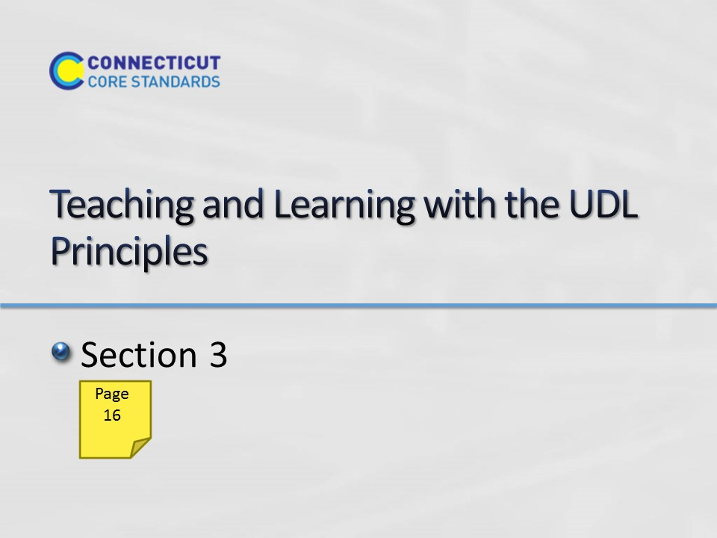Slide 31
Section 3: Teaching and Learning with the UDL Principles
Section 3 Time: 90 minutes
Section 3 Training Objectives:
- To provide participants with an opportunity to observe a mathematics lesson in order to identify UDL Principles in use.
- To provide participants with an opportunity to examine a mathematics lesson outline in order to identify UDL Principles in use.
- To provide participants with an opportunity to practice planning a lesson outline in order to incorporate UDL strategies using specific planning questions as a guide.
Section 3 Outline:
- Section 3 begins with participants viewing the Teaching Channel video Multiplying Whole Numbers and Fractions with an understanding that even though the lesson is seen being carried out within a 4th grade gifted classroom, the focus is on the UDL strategies being used that are applicable to all grade levels. While they watch, participants will make notes of the strategies they observe on the Video Observation page in their Participant Guide. After the video, participants will discuss the strategies observed, the benefit for students, and any additional opportunities to apply additional strategies. (15 minutes)
- Participants will then examine a lesson outline of a 5th grade lesson design around a task that addresses standards 5.NF.1, 5.NF.2, and SMPs 1, 3, and 6. To examine the outline, the facilitator will go over each of the activities and questions planned for the set-up of the task. A discussion will then take place around how each of the UDL Principles and their corresponding Guidelines were addressed in the outline. This discussion takes place in order to model the type of thinking needed when planning a lesson and to provide additional ideas for addressing the guidelines within a lesson. The task used in the lesson is Stuffed with Pizza and the UDL strategies were adapted for this task from NYC Department of Education found here: http://schools.nyc.gov/academics/commoncoreLibrary/tasksUnitsStudentWork/default.htm (15 minutes)
- The final activity of this section involves participants having the opportunity to practice planning a lesson outline that includes the application of UDL strategies within a specific grade level. Participants are asked to work in groups to first select the standard(s) they wish to address. After making their selection, participants go online to illustrativemathematics.org and select a task that aligns with their standard(s). Groups then use specific questions for planning UDL lessons (adapted from NYC Department of Education and found here: http://schools.nyc.gov/Academics/CommonCoreLibrary/ProfessionalLearning/UDL/default.htm to determine where, when, and which strategies they would use within the lesson. Note: Participants are given a choice in standards and tasks in order to model a flexible strategy and to also provide guided experience with selecting tasks that align to standards. (40 minutes)
- The activity will conclude with volunteers sharing what their group has planned. (20 minutes)
Supporting Documents:
Video Observation worksheet
5th Grade Lesson Outline
Questions to Guide Your Thinking worksheet
Materials
Chart paper
Markers
Video
Multiplying Whole Numbers and Fractions found here: https://www.teachingchannel.org/videos/multiplying-fractions-by-whole-numbers-lesson

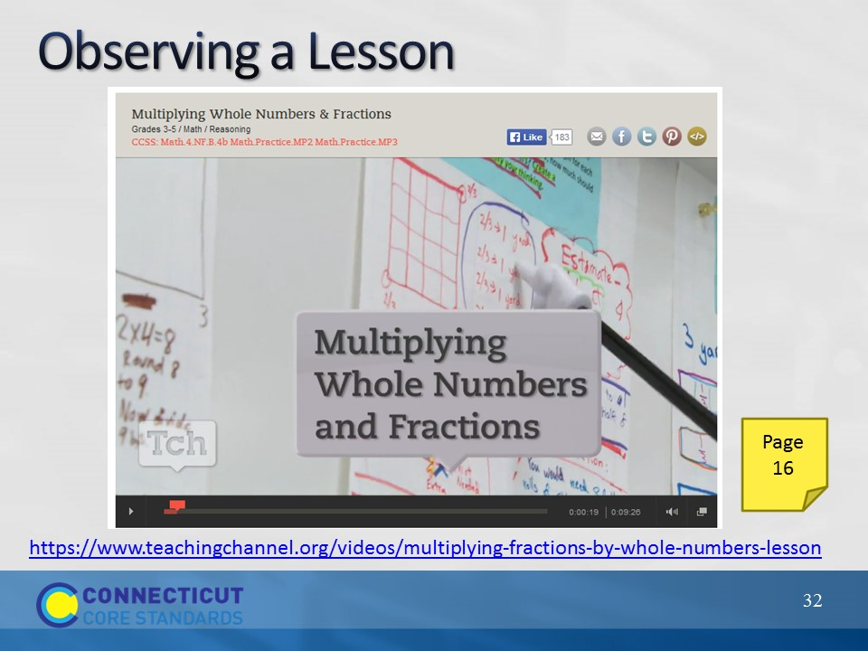Slide 32
Observing a Lesson
Begin the discussion of incorporating UDL Principles into classroom lessons by having participants first watch the Teaching Channel video Multiplying Whole Numbers and Fractions. Explain to participants that while this lesson is being carried out within a 4th grade gifted classroom, the focus is on the UDL strategies being used that are applicable at all grade levels. While participants watch, have them take notes on each of the three UDL Principles using the Video Observation page in their Participant Guide. After the video has been watch, debrief the strategies that participants highlighted in their notes and discuss any additional strategies or opportunities to apply strategies that participants would suggest to this teacher. Examples of strategies to point out if they are not highlighted by participants include:
Principle 1: Provide Multiple Means of Representation
- Guideline 1: Used ribbon and other props and drawings to explain the situation
- Guideline 2: Prompted students to attend to precision
- Guideline 3: Connected the current task to previous work, student presentations of work provided multiple representations of solutions
Principle 2: Provide Multiple Means of Action and Expression
- Guideline 4: Used student created charts as tools, allowed students to sit and work in various areas for group work
- Guideline 5: Provided card activity
- Guideline 6: Students created their own solution strategy
Principle 3: Provide Multiple Means of Engagement
- Guideline 7: Created a coaching environment in which students discussed, asked questions of each other, and assisted each other in understanding thinking
- Guideline 8: Students worked in groups, students critiqued the reasoning of the solutions on the cards
- Guideline 9: Provided prompting with guidance for journal entry
Transition to the next activity by explaining to participants that they will now go through an example of a lesson and examine the thinking behind a teacher’s planning.
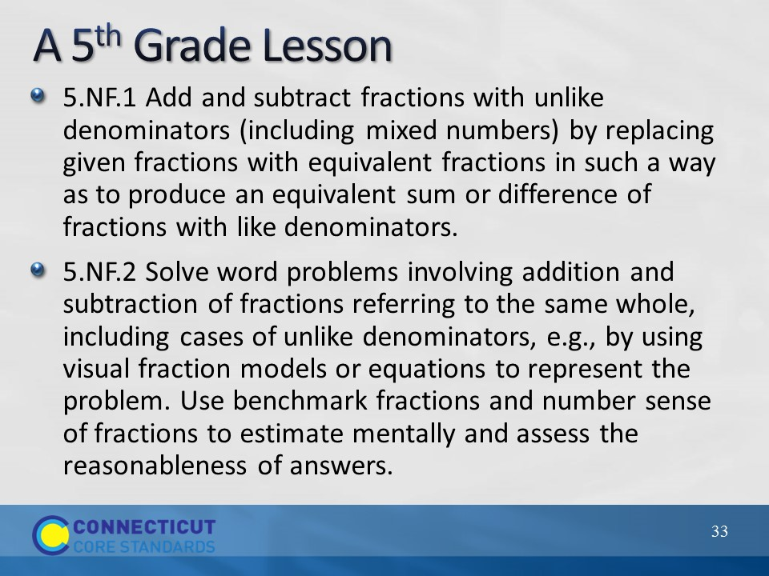Slide 33
A 5th Grade Lesson
To help participants gain a better understanding of what the UDL strategies look like when implemented in a CCS-Math- aligned lesson, have participants put themselves in the role of a 5th grade teacher as they consider each part of a lesson that will now be described. Explain that as a 5th grade teacher they want to plan a lesson around standards 5.NF.1 and 5.NF.2. They will also incorporate SMP 1: Make sense of problems and persevere in solving them, SMP 3: Construct viable arguments and critique the reasoning of others, and SMP 6: Attend to precision.
Go through the lesson outline by using both the slides and pages 17–20 in the Participant Guide.
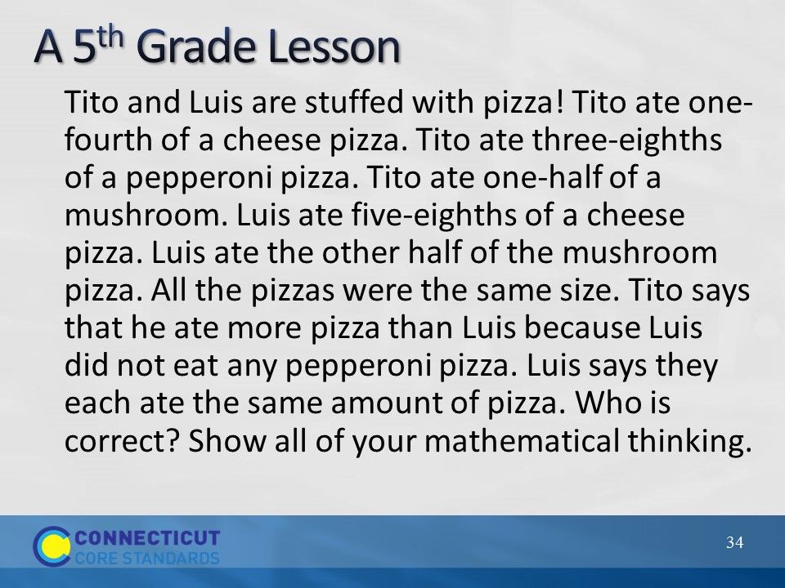Slide 34
A 5th Grade Lesson
Go over the task that is being used to as the main lesson task to address the identified standards.
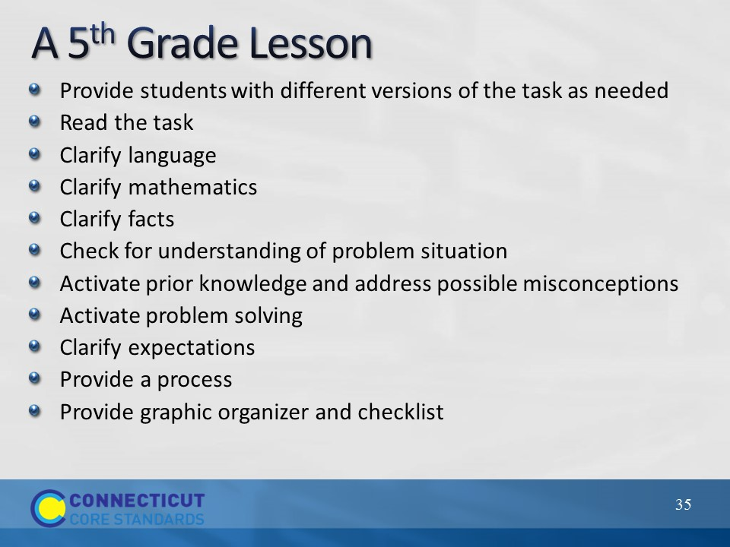Slide 35
A 5th Grade Lesson
Explain that before students began to work the task the following steps were taken. Go through each step using the information in the Participant Guide. After going through each step, discuss as a large group how each of the nine UDL guidelines were addressed.
Guideline 1: Problem was read and different versions of the problem were provided (version 1: original problem/no change, version 2: underling used to separate who was eating which pizza, version 3: text was broken up so that students would work with each piece of information separately).
Guideline 2: Language was clarified.
Guideline 3: Activated prior knowledge and problem solving.
Guideline 4: Discussed tools and strategies that may be used.
Guideline 5: Students allowed to solve their own way.
Guideline 6: Graphic organizer and checklist provided.
Guideline 7: Partial solutions were allowed to be discussed.
Guideline 8: Students allowed to work in groups.
Guideline 9: Process provided with time limits along with checklist for self-assessment.
Before moving on, ask participants if there is anything that they might add or change to further address the guidelines? Also, have participants think about and discuss whether or not addressing the guidelines in the manner they were addressed decreased the level of rigor of the problem. If participants say that the level of rigor was decreased, ask how an alternative action might maintain the level of rigor. If participants say that the level of rigor was not decreased, ask in what ways addressing the guidelines in the manner they were addressed provided all students with equal access to the learning.
Finally, wrap up this part of Section 3 by asking participants if it was necessary to address all nine Guidelines. The answer here is that it really depends on the students. Some teachers may find that the students do not need all nine Guidelines addressed as the implementation of any UDL strategy for any of the Guidelines is based on the needs of the students.
Transition to the next part of Section 3 by explaining that participants will now have the opportunity to create a similar lesson outline around standards and a task that they will choose.
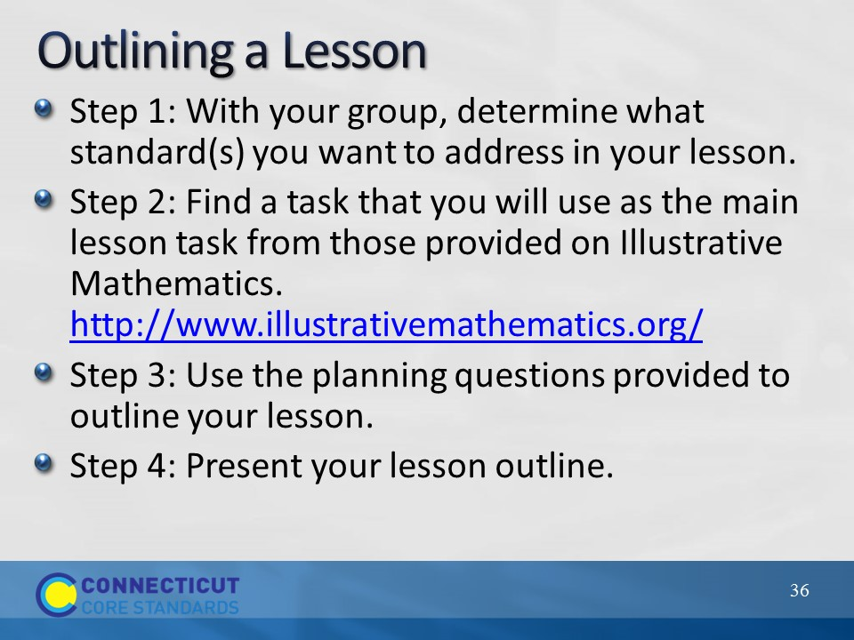Slide 36
Outlining a Lesson
In this activity participants will work in grade level groups so that there is at least one group per grade level, K–5. Participants can either self-select into a group or be assigned a specific grade level group. Explain that with their group they will be outlining a lesson similar to the lesson outline that was just discussed. As groups work, they will first determine what standard(s) they want to address in their lesson. Remind participants to include both Content and Practice Standards. Then, participants will go online and find a task that they will use as the main lesson task. Participants can choose a task from those provided on Illustrative Mathematics. http://www.illustrativemathematics.org/ After identifying their task, participants will answer the planning questions provided on page 21 in the Participants Guide. These questions will help participants think through how they will address the UDL Principles and, as answers are generated, will develop the lesson outline. Allow participants 40 minutes to work. Note: While groups are planning, hang three pieces of chart paper with one labeled “Provide Multiple Means of Representation,” one labeled “Provide Multiple Means of Action and Expression,” and one labeled “Multiple Means of Engagement.” These three pieces of chart paper will be used to capture strategies discussed during group presentations of their outlines.
Once the lesson outlines are completed, each group will have the opportunity to present their outline. While groups present each part of their outline, chart their suggested strategies for each Principle so that participants have a master list for each from which to pull additional ideas when they complete the work in Section 4. Allow 20 minutes for presentations as each group should only need 3–4 minutes to discuss their outline.
Wrap up Section 3 and transition to Section 4 by explaining to participants that after lunch they will use their work generated in Sections 2 and 3 to begin making plans for how they will introduce teachers to Universal Design for Learning. As the discussion begins to come to a close remind participants that, as they work with teachers, it is important to understand that every Guideline may not be addressed in every lesson. It is beneficial to think through each guideline to determine if addressing that Guideline will benefit students, as this is the ultimate goal. We do not want teachers to look at the UDL guidelines as a check point, but to be very purposeful in those that they address within any given lesson. This is similar to the way that we think about the Standards for Mathematical Practice. Each practice is extremely important, however not every lesson will explicitly address every Practice Standard. Dismiss participants for lunch.

